Stanford University Center for Probing the Nanoscale

NSF NSEC Grant 0830228

Director: Kathryn A. Moler, Deputy Director: David Goldhaber-Gordon

Stanford University

The Center for Probing the Nanoscale (CPN) at Stanford University is an NSF-supported Nanoscale Science and Engineering Center (NSEC) focused on the development of new measurement tools for nanoscale research. Such tools are an urgent priority to enable nanoscale science and engineering: as the National Research Council pointed out, “One must be able to measure and quantify phenomena in order to understand and use them, which is true also for nanoscale phenomena.” Our NSEC addresses five overriding goals:
- To develop novel probes that dramatically improve our capability to observe, manipulate, and control nanoscale objects and phenomena.
- To educate the next generation of scientists and engineers regarding the theory and practice of these probes.
- To apply these novel probes to answer fundamental questions and to shed light on technologically relevant issues.
- To disseminate our knowledge and to transfer our technology so that other research scientists and engineers can make use of our advances, and so that corporations can manufacture and market our novel probes.
- To inspire thousands of middle school students by training their teachers at a Summer Institute.
Stanford and IBM have distinguished histories and programs in nanoprobe research, and formed the Center for Probing the Nanoscale to propagate this legacy into the next generation. In year five, CPN includes fifteen core investigators (including three IBM Investigators who are Consulting Professors at Stanford), over twenty-eight affiliated faculty members and dozens of students and postdocs from eight academic departments and one industry research campus. Research at CPN is now organized into four tightly knit theme groups.

1) Nanoscale Electrical Imaging
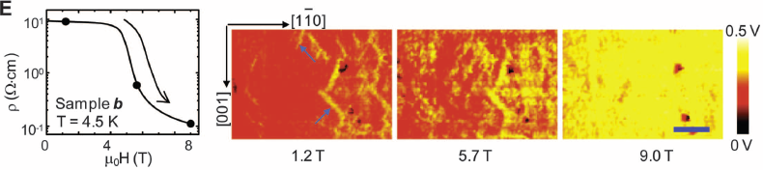
With the rapid advancement in electronic devices, lithographically-patterned structures such as transistors now commonly have electronic properties that vary on scales of a few to tens of nanometers. Novel materials also exhibit local electronic variations, due to patterns in the underlying atomic structure, inhomogeneity in structure or doping, or spontaneous organization of electrons. These local variations have important implications for the behavior of the materials or structures and ultimately determine the properties and performance of advanced electronic devices. CPN is developing Scanning Gate Microscopy and Scanning Microwave Microscopy in order to measure electrical properties at the nanoscale. Both developments are enabled by center-developed design and production of specialized scanning probe cantilevers.
Figure: Electrical transport measurements performed on MnO thin films using the developed Microwave Impedance Microscope at different magnetic fields (scale bar 1 um).
K. Lai, et al., Science, 329 (2010)

2) Individual Nanomagnet Characterization
Magnetic nanoparticles have a number of present and proposed applications spanning various areas in information technology, biology and medicine. For example, magnetic nanoparticles are crucial in increasing the density of information storage, have been clinically approved for use as MRI contrast agents and have the potential to be successfully used for treatment and removal of cancer cells. The properties of magnetic nanoparticles are inherently sensitive to small variations in volume, shape, and structure, and therefore it is vital to characterize them individually. Our theme group develops and advances a variety of nanoprobes, such as Magnetic Force Microscopy, Scanning Sagnac Microscopy and Scanning SQUID Microscopy, with the spatial resolution and magnetic sensitivity to detect and characterize individual nanomagnets for nano-biotechnology applications.

3) BioProbes
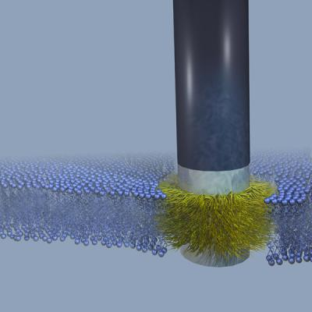
Understanding the principle and processes that govern the functions of cell membranes will help us tailor drugs to effectively penetrate the membrane for efficient treatment. The novel BioProbes will directly study the membrane and measure the forces, mechanical stiffness, electrostatics, and sequence of biological processes to replace and complement more traditional remote sensing techniques. Our theme adapts unique cantilever designs for aqueous solution, based on recently invented torsional and dual-cantilever AFM cantilevers that have extremely high force sensitivity together with kHz sampling frequencies, ideal for biological samples. Functionalized probe tips on the cantilevers provide specific biomolecular functionality, enabling us to attack the biologically important processes of viral peptide penetration and ion channel activity. These metrologies will unlock the real time mechanical and electronic processes at and within biological membranes that are currently inaccessible by any other technique.
Figure: Schematic of biomimetic stealth probe inserted into a lipid bilayer.The developed probe enables in-situ study of biological systems.
B. Almquist, et al., PNAS, 107 (2010)

4) Nanoscale Magnetic Resonance Imaging
Extending the sensitivity of magnetic resonance imaging to the level of individual nuclear spins would enable the development of a “molecular structure microscope” capable of imaging the atomic structure of molecules in three dimensions. Such a capability would have revolutionary impact on structural molecular biology since it would allow atomic structures to be obtained for proteins that cannot be crystallized for x-ray diffraction analysis. Recent work sponsored by CPN has proven that magnetic resonance force microscopy (MRFM) can achieve three-dimensional imaging with spatial resolution of about 4 nm. We are currently focusing our efforts on extending MRFM resolution to below 1 nm – or roughly an order of magnitude improvement over today’s capability. If sub-nanometer can be achieved, then MRFM’s true 3D imaging capability, lack of radiation damage and elementally specific contrast would make it a powerful tool for structural biologists.

Nanotechnology is being increasingly adopted by industry, and current and future generations will encounter a significant amount of nanotechnology in their day-to-day products. Educating the public about nanotechnology is therefore at the core of CPN’s outreach activities with the goal of creating a diverse science literate workforce.
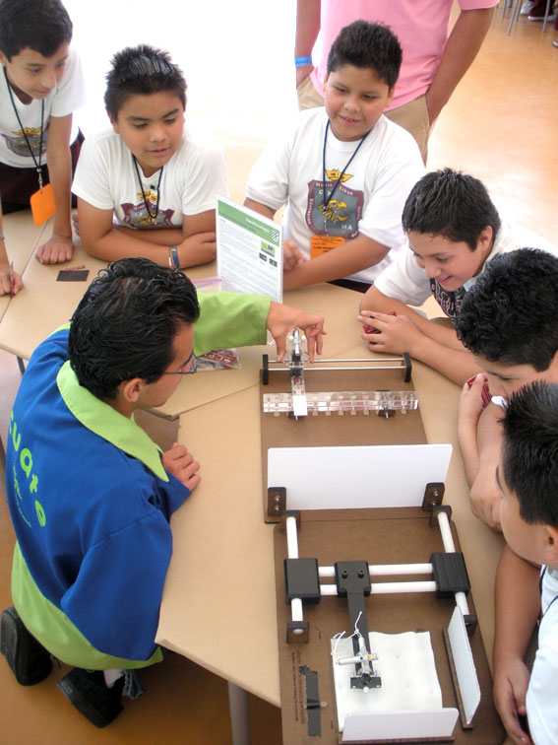
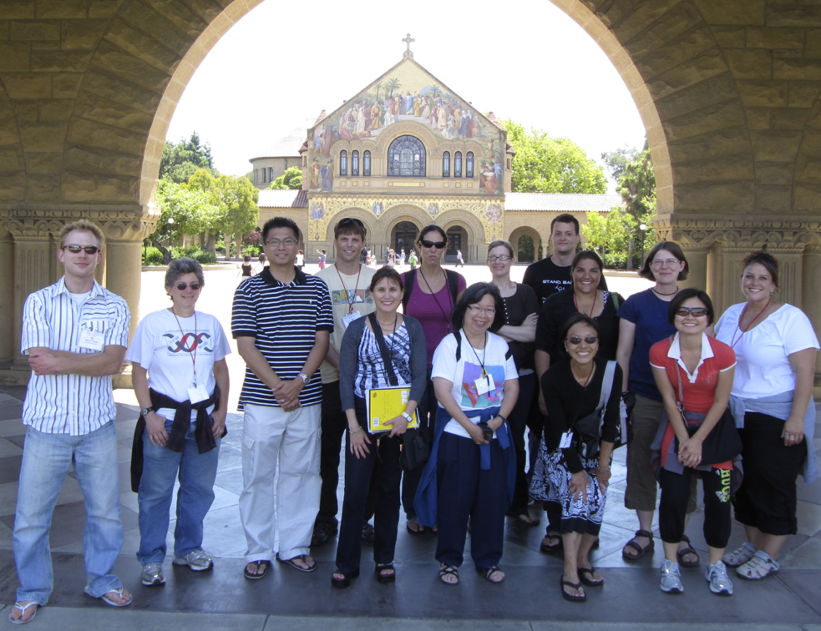
It is known that middle school students lose interest in science and therefore CPN’s outreach program is targeting this particular age group to retain and foster students’ interest and excitement about nanotechn ology and nanoscience. A successful approach for reaching middle school students has been the Summer Institute for Middle School Teachers (SIMST). Middle school teachers participate in an intensive week-long program of content lectures, hands-on activities and curriculum development exercises. The CPN helps the teachers to apply their new knowledge by having them create nanoscience lessons that are shared among participants for use during the school year. Activities are available through CPN’s teacher website (http:// teachers.stanford.edu) as well as through CPN’s partner organization, Resource Area for Teachers (RAFT), which distributes ready-to-use, low-cost classroom kits of the developed nanoactivities to Bay Area Teachers.
Figure: CPN’s large-scale nanoprobe models and fridge magnets in action at Papalote Museum (Mexico City).
Figure: Teachers participating in SIMST 2010 in front of Stanford’s Memorial Church.
CPN also organizes a range of educational workshops, partners with formal and informal educational organizations (NISENet, National Hispanic University, Children’s Museum of Mexico, Exploratorium …) in the pursuit of creating a diverse and scientific literate workforce to benefit current and future generations.
An Annual Nanoprobe Workshop, which features 8-10 world-class nanoscience researchers as speakers, provides an excellent opportunity for academic and industrial scientists to exchange knowledge and ideas and to broaden the horizons of our students. The 6th workshop was held in May 2010 and attracted about 200 participants from academia and industry. CPN’s Industrial Affiliates program offers companies an opportunity to engage with Center participants to collaborate on research programs or just stay informed on Center developments through newsletters. CPN is engaged with companies, like Agilent Technologies, Applied Materials, Asylum Research, IBM, Park Systems, Veeco Instruments, among others.

References
[1] For further information about this project visit http://cpn.stanford.edu
[2] For a list of publications visit http://cpn.stanford.edu/research/pubs.html

“Small Wonders, Endless Frontiers: Review of the National Nanotechnology Initiative,” report from the National Research Council, June 2002.

