NANO HIGHLIGHT

Multiplexed Polymer Pen Lithography of Biomolecules
NSF NSEC Grant 0647560
PI: Chad A. Mirkin
Northwestern University
Some of the most important and fundamental biological processes take place on the nanoscale, such as communication between cells, protein synthesis, and cell differentiation. In order to understand and manipulate these processes, it is necessary to develop techniques that mimic and reflect these natural systems with nanoscale dimensions. Creating biomolecule arrays with nanoscale and microscale dimensions can help researchers investigate and understand various cell processes ranging from adhesion and differentiation, to programmed cell death.
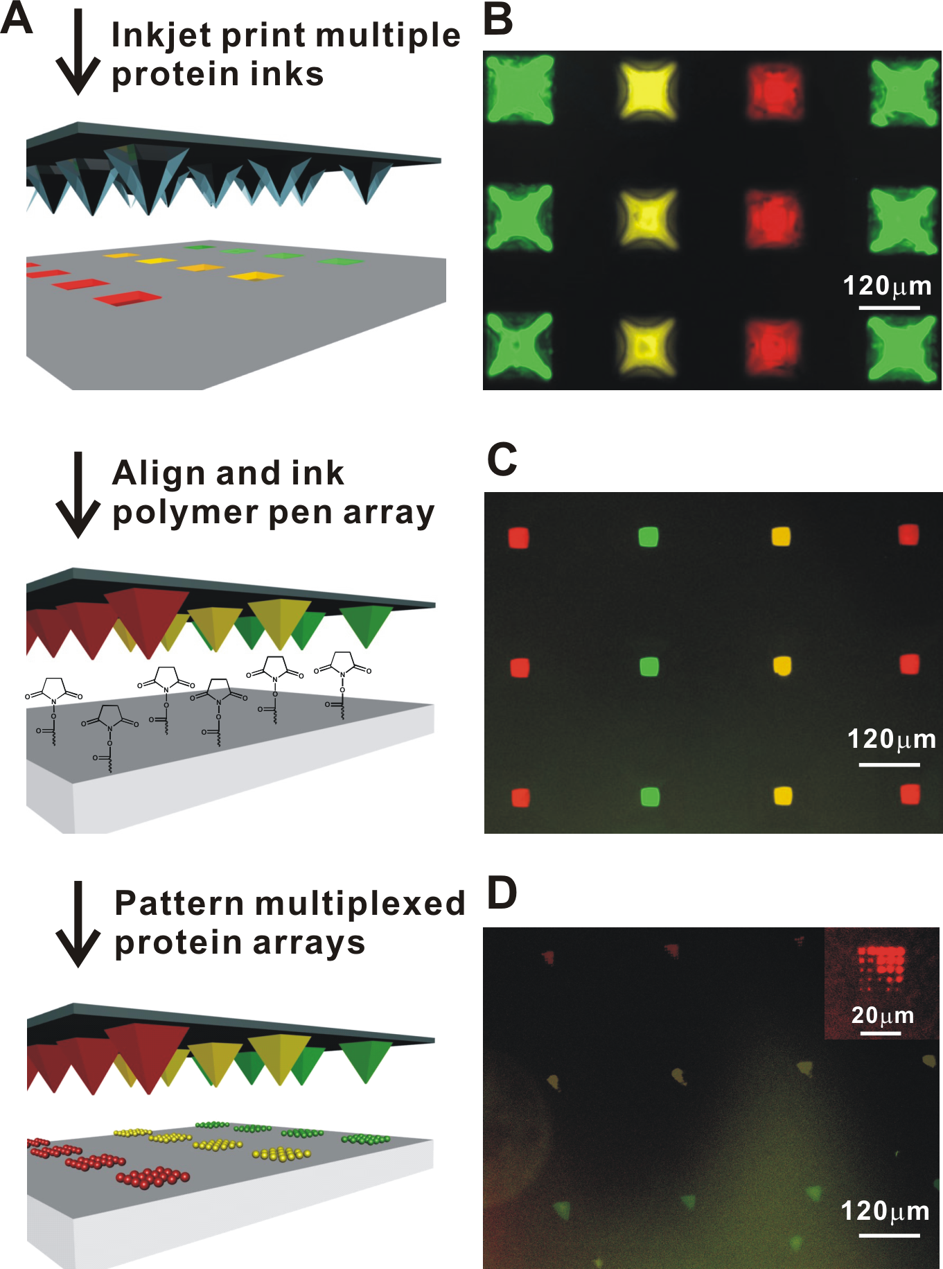

Polymer pen arrays inked with multiple protein inks are used to generate multiplexed biomolecule arrays useful for fundamental biological studies.
Credit: Northwestern University. Zheng Z, et al. Angew. Chem. Int. Ed. 2009.
In this research, multiplexed polymer pen lithography of several proteins was demonstrated as a first step towards addressing such scientific issues. Researchers were able to control the size of protein features from tens of nanometers to several microns in diameter, while maintaining the proteins’ bioactivity and function. An inkjet printer was used to individually address and fill inkwells with various proteins. An array of pens were brought into contact with these inkwells and used to print features on a surface in a direct-write manner because the proteins attach to the surface.
Though the initial demonstrations used protein inks, this technique can be easily extended to the deposition of DNA and other molecules. This could lead to the development of new biomarker detection systems or novel materials at the nanoscale, with potential applications from healthcare diagnostics to consumer electronics.

Reference
[1] For further information about this project link to www.nsec.northwestern.edu or email nanotechnology@northwestern.edu
[2] Z. Zheng, W.L. Daniel, L.R. Giam, F. Huo, A.J. Senesi, G. Zheng, C.A. Mirkin. Angew. Chem. Int. Ed., 2009, 48, 7626.

