Exploiting Protein Cage Dynamics for Engineering Active Nanostructures
NSF NIRT CBET-0709358
PIs: Trevor Douglas (PI), Brian Bothner, Yves Idzerda, Mark Young
Montana State University

The focus of this Montana State University (MSU) NIRT builds upon a strong multidisciplinary team in the development of protein cage architectures as size and shape constrained templates for nanomaterials synthesis [1]. A deepening understanding of these systems has led to an appreciation that protein cage dynamics plays an important role in the overall properties of the nanomaterials. The central focus of this NIRT is to examine how particle confinement and protein cage dynamics at active interfaces controls nanomaterials synthesis and material functionality. The long-term goal is to use this knowledge to guide the development of a new generation of active and responsive nanomaterials.

The project is divided into three integrated components: Active Interfaces, Cage Dynamics, and Confinement.
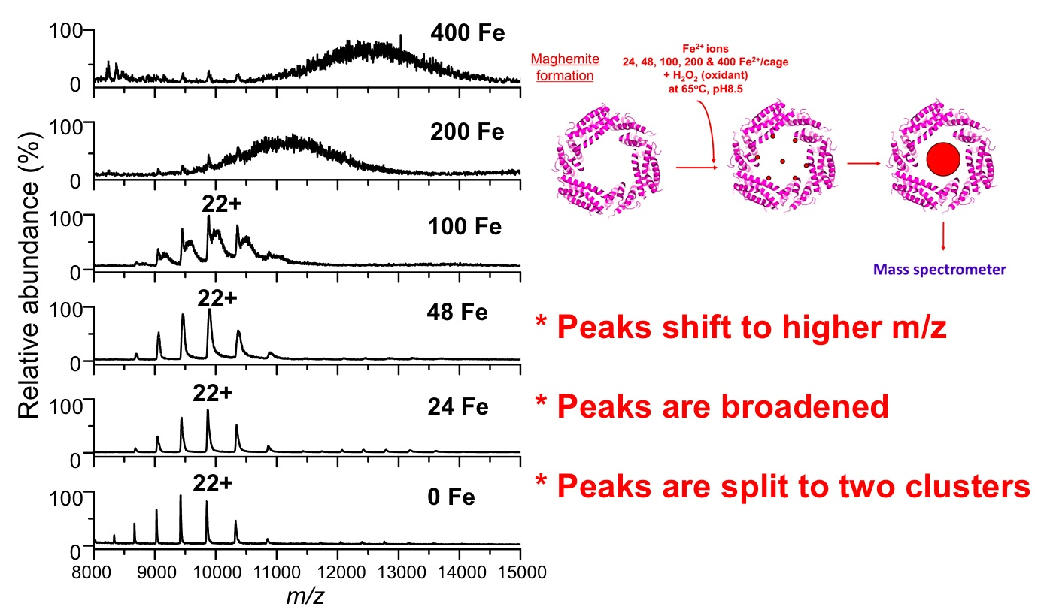
Fig 1. ESI Mass spectrometry was used to monitor Fe₃O₄ synthesis within a the Dps protein cage architecture. Peaks shift to higher m/z and broaden as the reaction proceeds giving us information about particle mass (size) and distribution.
Protein cage architectures, such as viruses and ferritins have three active interfaces can be manipulated, both chemically and genetically. These include the exterior surface, the interior surface, and the interface between the subunits that comprise the protein cage architecture.

Active Interfaces is focused on directing interactions for defined chemical synthesis using hard-soft interfaces, particle-surface interactions and controlled hierarchical assembly .
We have shown that we can use mass spectrometry to monitor metal ion binding and nanoparticle growth within a protein cage architecture [2,3]. We have demonstrated that interactions between protein macromolecules and metal ions or nanoclusters can be preserved and metal deposition can be monitored by following mass increases of the protein-metal composite. Our state-of-art mass spectrometry has a sufficient mass accuracy and resolution to discriminate a few metal ions depending on atomic masses of metal ions. Therefore, it is possible to concurrently detect multiple populations distributed within an ensemble and monitor their changes individually instead of averaging all signals. Using a combination of electrospray ionization (ESI) and time-of-flight (TOF) mass analyzer, the mass measurement of giant non-covalent macromolecular complexes has been possible and preservation of non-covalent interactions and solution structures in the gas phase inside mass spectrometer has been well demonstrated.

Cage Dynamics is centered around understanding and directing inherent and engineered cage dynamics to control material confinement, directed self-assembly, and particle-particle interactions [4-6].
Protein cages are assembled from identical individual subunits to form the overall architecture. The dynamics of the cages can arise either from the collective motions of these individual subunits or from individual components of the structure. We have investigated the change in modulus that occurs when a virus capsid undergoes a structural transition between a closed and an open conformation resulting in a roughly 10% increase in diameter. Shown in Fig 2 is the structural transition and the modulus, measured by quartz crystal microbalance (QCM).
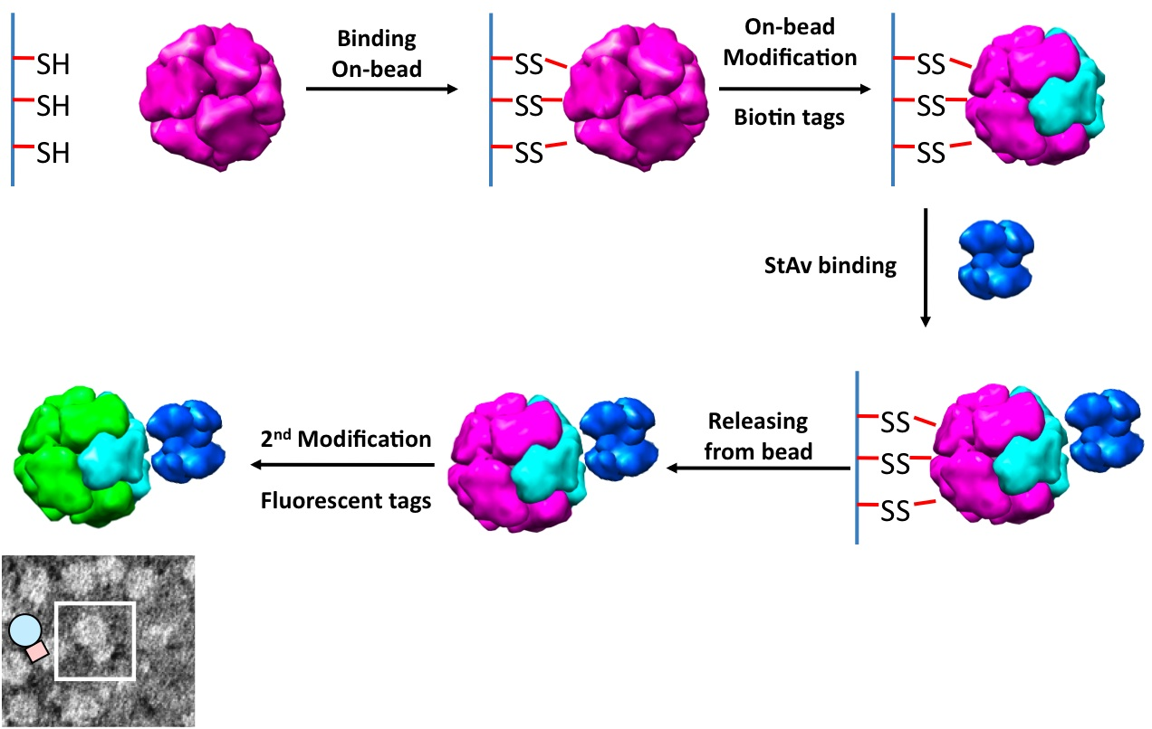

Fig 3. Janus particle formation scheme. Using the Dps protein cage we have shown that we can differentially modify two subunits in a spatially defined way using immobilization on a solid support. TEM (bottom left) shows individual Dps-streptavidin assembly[8].

Using our ability to break the symmetry of the cages, we can assemble chimeric forms composed of multiple modified subunits with a specific spatial orientation. This has been achieved by using a solid immobilization approach to modify selected exposed subunits (Fig 3). The ensemble distribution of the cages can be determined using native mass spectrometry. Modification with biotin (b) allows us construct a asymmetric Dps-b-streptavidin complex that can be used to control and cap Lbl growth and for attachment of antibodies [7-9].
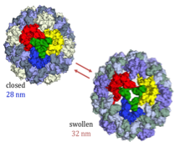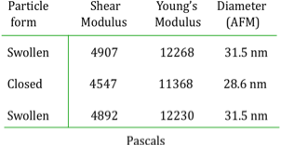
Fig 2. The CCMV virus undergoes a swelling transition, which has been probed by QCM to determine the elastic modulus of these two conformations. Environmental triggers (pH and [Metal ion] switch between these two conformations.

The Confinement thrust integrates the Active Interfaces and Cage Dynamics to explore their consequences on the physical properties of protein encapsulation. Mn oxide nanoparticles (Mn₃O₄) grown inside Human Ferritin show clearly the influence of the protein-mineral interface on the properties. The protein encapsulated nanoparticles yielded electron diffraction patterns consistent with the mineral hausmanite. While Pair Distribution Function analysis from the total x-ray scatterin showed a good fit to the bulk crystal structure, the Mn L-edge XAS spectrum is dramatically different from the bulk material. This suggests that the electronic structure of the nanoparticles (specifically the energy levels of Mn d-orbitals) is affected by the constrained protein environment. Mn metalloproteins (such as photosystem II) are vital to biological energy generation, and this shift in electronic properties raises the intriguing possibility that protein-encapsulated Mn nanoparticles may have similar catalytic properties.

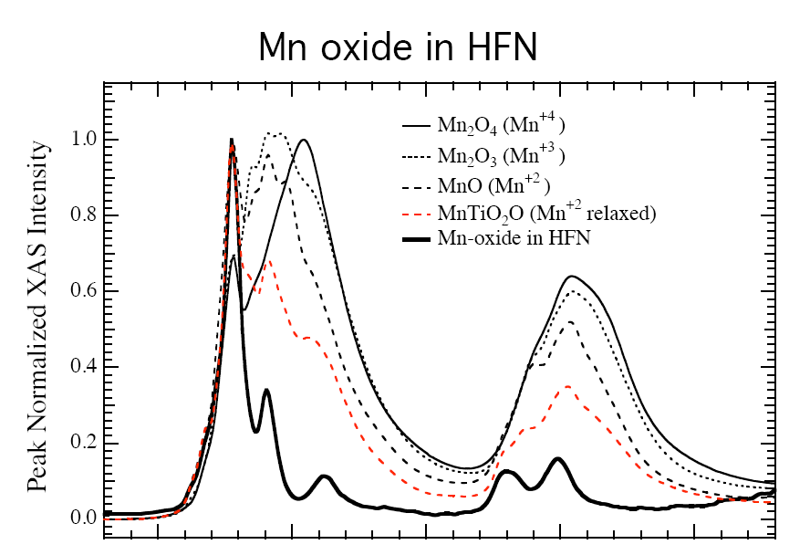
Fig. 4. The Mn L-edge XAS spectrum is dramatically different from the bulk material, suggesting that the electronic structure of the nanoparticles is affected by the constrained protein environment.

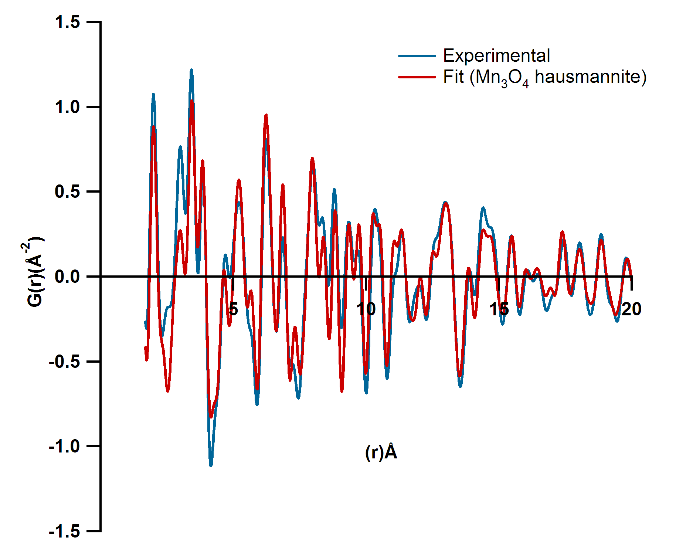
Fig. 5. The experimental PDF data was fit well by a hausmannite (Mn₃O₄) inverse spinel crystal phase with a crystalline domain size of about 4.3 nm. The crystalline domain size is of the same order as the interior cage diameter (8 nm), indicating that each cage is likely to contain a small number of crystalline domains.

Outreach
During this year a science outreach effort reached over 600 local school children from preschool through high school through interactions of NIRT researchers directly with schools and through a new program “MSU Science Saturdays”. This program has successfully brought the researchers to local students between the ages of 8 - 14. The goals of the program are two-fold. First, to excite kids about science and careers in science through rich and meaningful hands-on science experiences and second, to provide more public interaction with MSU scientists and the ongoing research in MSU labs. Both goals have been achieved as measured by interest and feedback from participants about the programs.

Fig. 6. Participants in MSU Science Saturdays enjoy playing with slime and building chemical models.
Five Science Saturday programs were held and over 450 children participated. The program is targeted at 10-14 year olds, with most of the kids in the age of 8-12. After the overwhelming response to the first program in November, a cap for the programs was set at 100 kids with pre-registration required. At least twenty to thirty parents attended each month as well. The programs have easily reached capacity each month with a waiting list of 10-20 people, so the interest in the community is evident. Feedback from the kids participating indicate they “have fun” at the programs. They give the programs an average rating of 8 on a 10 point scale and evaluation responses indicate that they learned key concepts at each session. Formative evaluation to date has focused on refining the program to be more effective and interesting to participants. Program planners review the feedback each month and make adjustments and plan new programs based on responses.

In October 2009 a group of NIRT researchers (including faculty, post-docs, graduate and undergraduate students) travelled to the Crow Reservation in eastern Montana to initiate the Sci Program. We had 25 enthusiastic Crow middle school students and the event was a huge success. In Nov, students from the reservation will travel to Bozeman to participate in the next Science Saturday event at MSU. Several Science Saturday videos, including a commercial created by youth participants, are available on the Science Saturdays Web site (http://eu.montana.edu/SciSat).

References
- For further information about this project link to < http://www.cbin.montana.edu/research/NIRT.html >
- Sebyung Kang, Janice Lucon, Zachary B. Varpness, Lars Liepold, Masaki Uchida, Debbie Willits, Mark J. Young, and Trevor Douglas “Monitoring Biomimetic Platinum Nanocluster Formation using Non-covalent Mass Spectrometry and Cluster Dependent H₂ Production” Angewandte Chemie (2008) 47, 7845 – 7848.
- Sebyung Kang, Craig C. Jolley, Lars O. Liepold, Mark Young, and Trevor Douglas, “From Metal Binding to Core Formation; Monitoring Biomimetic Iron Oxide Synthesis within Protein Cages using Mass Spectrometry”, Angew. Chemie. (2009) 48, 1-6.
- M. Klem, P. Suci, D. Britt, M. Young, T. Douglas “In plane ordering of CCMV” Journal of Adhesion (2009) 85, 69-77.
- J.A. Speir, B. Bothner, Q. Qu, D.A. Willits, M.J. Young, J.E. Johnson, “Enhanced Local Symmetry Interactions Globally Stabilize a Mutant Virus Capsid that Maintains Infectivity and Capsid Dynamics” J. Virology (2006) 80(7):3582-3591.
- V. Rayaprolu, B. Manning, T. Douglas, B Bothner “Virus particles as active nanomaterials that can rapidly change their viscoelastic properties in response to dilute solutions” submitted
- Sebyung Kang, Luke M. Oltrogge, Chris C. Broomell, Lars O. Liepold, Peter E. Prevelige, Mark Young, and Trevor Douglas "Controlled Assembly of Bifunctional Chimeric Protein Cages and Composition Analysis using Non-covalent Mass Spectrometry" J. Amer. Chem. Soc. (2008) 130, 16527-16529.
- Sebyung Kang, Peter A. Suci, Chris C. Broomell, Ichiro Yamashita, Mark Young, and Trevor Douglas “Janus-like Protein Cages; Spatially Controlled Dual-functional Surface Modifications of Protein Cages” Nano Letters (2009), 6, 2360-2366.
- P. Suci, S. Kang, M. Young, T. Douglas “A streptavidin-protein cage Janus particle for polarized targeting and modular functionalization “ J. Amer. Chem. Soc. (2009) 131, 9164–9165.

