NANO HIGHLIGHT
QUANTITATIVE CHARACTERIZATION AND EVOLUTION OF NANOSCALE POROSITY
NSEC Grant EEC – 0647560
PIs: Tao Sun, S. Donthu, Arvind Srivastava, Jin Wang, and Vinayak P. Dravid
Northwestern University

Nanoscale porosity is a very important microstructural parameter that has profound influence on many technologies, ranging from catalysis to gas storage to sensing devices. Since porosity represents “missing material”, it is very difficult to characterize. This is especially true at the nanoscale due to the complex evolution of porosity with varying material processing parameters.
Grazing incidence small angle X-ray scattering (GISAXS) with synchrotron radiation was used to both quantitatively characterize nanoscale porosity in nanostructured oxides and monitor temporal evolution with processing parameters.
The results reveal that nanoscale porosity evolution is an important characteristic in understanding gas sensing devices.
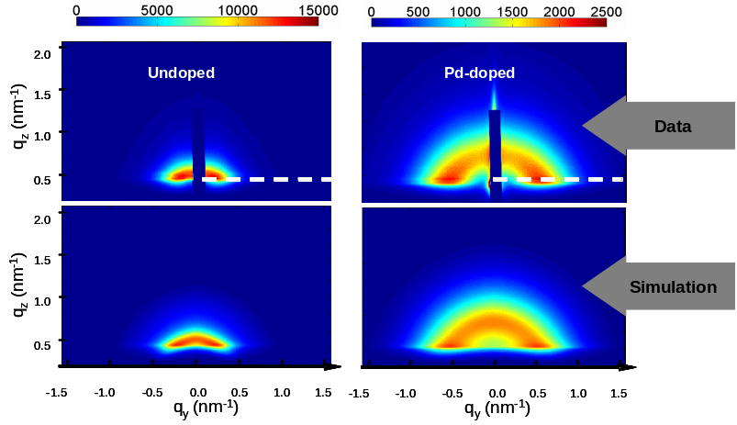
2D GISAXS patterns and simulations @ T = 600°C, undoped vs Pd-doped SnO₂.

References
[1] For further information about this project link to <www.nsec.northwestern.edu> or email <nanotechnology.northwestern.edu>
[2] Acta Materialia 2009, 57, 1095-1104.
NANO HIGHLIGHT
MICROCANTILEVER-BASED SIGNAL TRANSDUCTION PLATFORM FOR BIOCHEMICAL DETECTION AND DIAGNOSIS
NSEC Grant EEC – 0647560
PIs: Soo-Hyun Tark, Arvind Srivastava, Gajendra Shekhawat, and Vinayak P. Dravid
Northwestern University

Among several emerging sensing and diagnostics approaches, the microcantilever detection paradigm has attracted considerable attention. One of the key challenges for wider deployment of these detection systems is the limitation imposed by currently available means for signal transduction and detection based on either optical or piezoresistive feedback.
NU-NSEC researchers have developed an entirely new electronic transduction paradigm comprising two-dimensional microcantilever arrays with geometrically configured metal-oxide-semiconductor field-effect transistor (MOSFET)-embedded microcantilever.
This new signal transduction platform will bridge the current gap between integration of nano-bio nanostructures with microelectronics, and promises a universal and widely deployable bio-chem diagnosis platform.
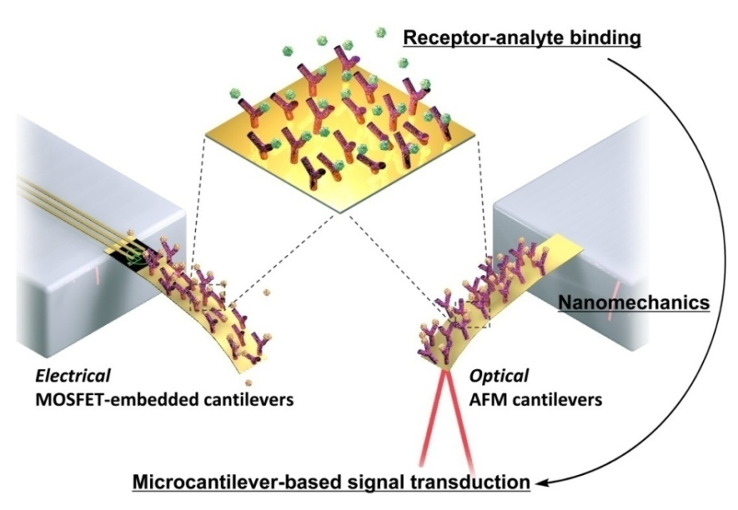

References
[1] For further information about this project link to <www.nsec.northwestern.edu> or email <nanotechnology.northwestern.edu>
[2] Applied Physics Letters 2009, 94(10), 104101/1-104101/3.
NANO HIGHLIGHT
ROOM TEMPERATURE SENSING OF EXPLOSIVE GASES WITH NANOPATTERNED OXIDES
NSEC Grant EEC – 0647560
PIs: Arvind Srivastava, Shanwei Fan, Vinayak P. Dravid, and Steve Semancik
Northwestern University
Operating metal-oxide gas sensors at high temperatures is often undesirable due to the risk of explosion (e.g., hydrogen, volatile compounds) and the potential for compromised structural stability.
NU-NSEC researchers have demonstrated that UV photo-illumination of a nanopatterned oxide sensor allows for room temperature sensing while satisfying many required performance attributes, including sensitivity, stability, and reproducibility. Further development and system integration of this detection approach could make it suitable in a battery-operated, hand-held chemical sensor.
An NU disclosure has been filed for this technology and licensing discussions with sensor companies are currently underway.
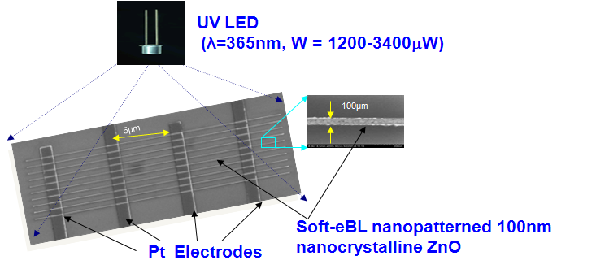
SEM image of soft-eBL patterned 1D ZnO nano-sensor with top Pt contact for four-probe measurement. Sensor is illuminated with 365 nm UV light to provide room temperature sensitivity.

References
[1] For further information about this project link to <www.nsec.northwestern.edu> or email <nanotechnology.northwestern.edu>
[2] Applied Physics Letters 2009, 95(14), 142106/1-142106/3.
NANO HIGHLIGHT
WRITING WITH PROTEINS USING A NANO FOUNTAIN PROBE
NSEC Grant EEC – 0647560
PIs: Horacio Espinosa, Owen Loh, and Jee Rim
Northwestern University

With functions very similar to a highly miniaturized fountain pen, NU-NSEC researchers are using the Nano Fountain Probe (NFP) to: create protein and DNA arrays; investigate nanomaterial-mediated cancer drug delivery; and build large-scale arrays of carbon nanotube-based devices.
The ability to precisely deliver biomolecules is of particular interest in biology and the life sciences. By patterning materials in nanoscale arrays, ultra-sensitive bio-detection and novel single-cell studies are possible.
Sub-100 nm patterns were written using an ‘ink’ consisting of proteins in solution. By applying an electric field between the substrate and the on-chip NFP ink reservoir, the protein deposition rate was greatly enhanced.

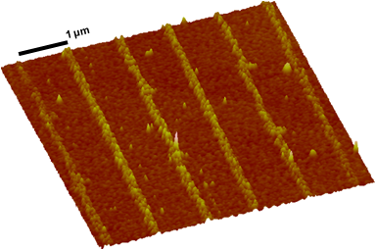
Linear protein array patterned at a rate of 80 µm/sec using the NFP assisted by an electric field.

References
[1] For further information about this project link to <www.nsec.northwestern.edu> or email <nanotechnology.northwestern.edu>
[2] Proceedings of the National Academy of Sciences 2008, 105, 16438-16443.
NANO HIGHLIGHT
VERTICAL ORGANIC NANOWIRE ARRAYS: CONTROLLED SYNTHESIS AND CHEMICAL SENSORS
NSEC Grant EEC – 0647560
PIs: Yong Sheng Zhao, Jinsong Wu, and Jiaxing Huang
Northwestern University
NU-NSEC researchers developed a simple method to grow organic nanowires with enhanced capabilities as optical sensor materials.
Vertical nanowire arrays of a small organic dye [1,5-diaminoanthraquinone (DAAQ)] were prepared by a facile physical vapor transport method on solid substrates. The color and fluorescence of the DAAQ nanowires were bleached and quenched by acid vapor and rapidly regenerated by base vapor.
The ease of the oriented vertical growth process should make it possible to directly integrate these nanowires into portable photonic sensing devices.
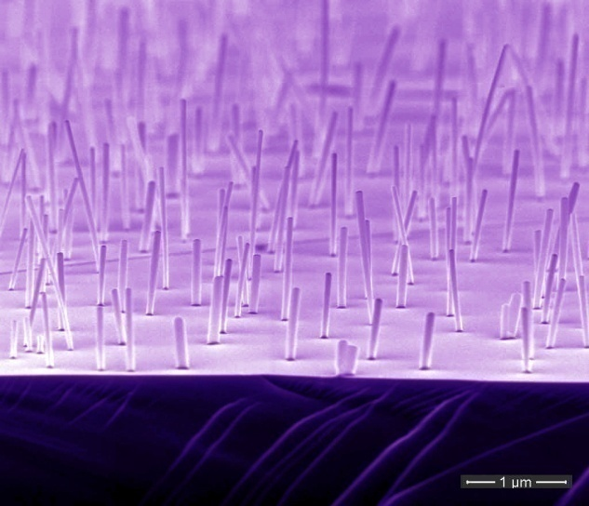
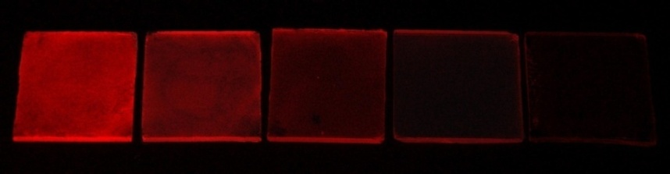
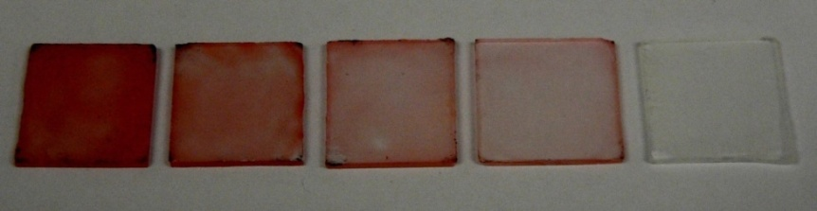

References
[1] For further information about this project link to <www.nsec.northwestern.edu> or email <nanotechnology.northwestern.edu>
[2] Journal of the American Chemical Society 2009, 131, 3158-3159.
NANO HIGHLIGHT
A NEW APPROACH FOR HIGHLY SENSITIVE DETECTION OF THE CANCER MARKER TELOMERASE
NSEC Grant EEC – 0647560
PIs: Gengfeng Zheng, Weston L. Daniel, and Chad A. Mirkin
Northwestern University

NU-NSEC researchers developed a novel assay to detect human telomerase, a cancer marker. The assay uses polyvalent oligonucleotide nanoparticle conjugates as probes and amplification units.
Gold nanoparticles functionalized with specific oligonucleotide sequences capture telomerase enzymes and are subsequently elongated, with both the elongated and unmodified oligonucleotide sequences simultaneously measured. The two strands not only serve as internal positive controls for each other, but also provide a way of amplifying the signal.
This assay provides a novel form of amplification and allows detection of hundreds of unmodified strands per single elongation event. Telomerase activity could be detected from as few as 10 cancer cells.

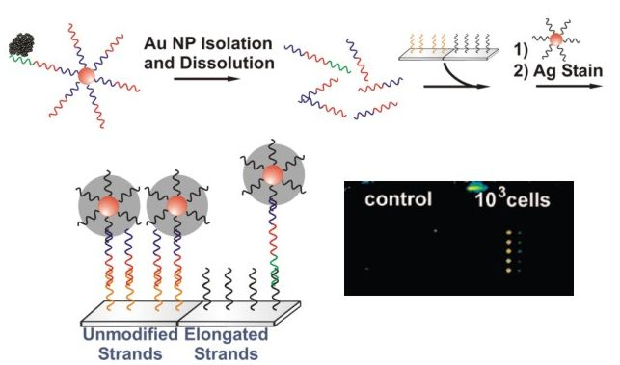

References
[1] For further information about this project link to <www.nsec.northwestern.edu> or email <nanotechnology.northwestern.edu>
[2] Journal of the American Chemical Society 2008, 130, 9644–9645.
NANO HIGHLIGHT
POLYMER PEN LITHOGRAPHY
NSEC Grant EEC – 0647560
PIs: Fengwei Huo, Zijian Zheng, Gengfeng Zheng, Louise Giam, Hua Zhang, and
Chad A. Mirkin
Northwestern University
NU-NSEC researchers invented a low-cost, high-throughput lithography technique that merges the feature size control of dip-pen nanolithography with the large-area capability of contact printing.
Polymer Pen Lithography uses arrays of pyramid-shaped polymer pens whose tips are dipped in solutions of chemicals that may feature almost any molecule, including proteins and acids. The pens are then traced over a surface by a mechanical arm to create millions of structures in parallel. The width of the lines drawn by each pen can be carefully controlled by varying the force exerted on the flexible pen tips.
Because ink delivery is time and force dependent, features on the nanometer, micrometer, and macroscopic length scales can be formed with the same tip array. Arrays with as many as 11 million pyramid-shaped pens can be brought into contact with substrates and readily leveled optically to ensure uniform pattern development.
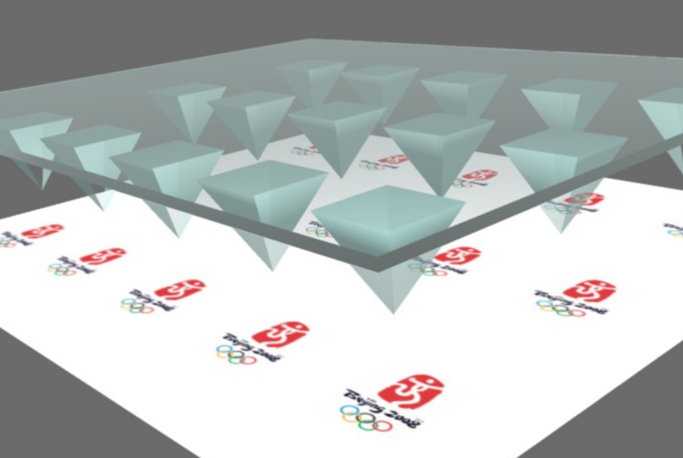

References
[1] For further information about this project link to <www.nsec.northwestern.edu> or email <nanotechnology.northwestern.edu>
[2] Science 2008, 321, 1658-1660.

NANO HIGHLIGHT
CRYSTALLIZATION OF FUNCTIONALIZED NANOPARTICLES
NSEC Grant EEC – 0647560
PIs: G. Vernizzi and M. Olvera de la Cruz
Northwestern University

These NU-NSEC researchers have shown via theoretical modeling that DNA-functionalized nanoparticles assemble into BCC or FCC crystalline structures via programmable base-pairing interactions.
Computer simulations of nanoparticles grafted with chains containing end-reactive groups revealed that a series of structures can be assembled by tuning the molecular interactions of the grafted chains. Further analysis, including the use of effective interactions between nanoparticles in water, confirmed that only FCC crystallization is possible in charged nanoparticles with homogeneous surfaces or interactions. The ability to control the assembly of these structures is a critical component in the development of powerful diagnostic tools.

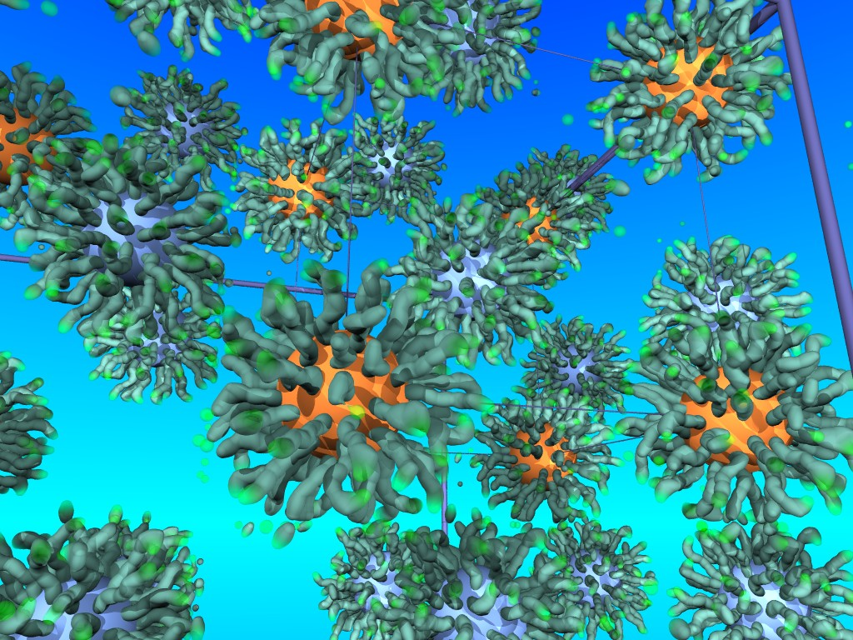

References
[1] For further information about this project link to <www.nsec.northwestern.edu> or email <nanotechnology.northwestern.edu>
[2] Soft Matter 2009, 5(4), 736-739.
NANO HIGHLIGHT
BOTTOM-UP MEETS TOP-DOWN FOR SILVER NANOPARTICLES
NSEC Grant EEC – 0647560
PIs: Christine Aikens, Shuzhou Li, and George C. Schatz
Northwestern University

The vivid colors of colloidal nanoparticles in stained glass have been a source of fascination for many centuries. More recently, these particles have found use in medical diagnostics.
The colors of these particles are for the most part well-described using classical electromagnetic wave theory. However, wave theory fails for very small particles (< 3 nm) and small features on bigger particles, making it necessary to use quantum mechanics. NU-NSEC researchers have developed quantum methods that enable a bridging of the gap between bottom-up (quantum) and top-down (wave) results.
The results for silver tetrahedral particles obtained from the two approaches reveal surprisingly close comparisons, especially with regard to optical shifts and broadening with particle size.
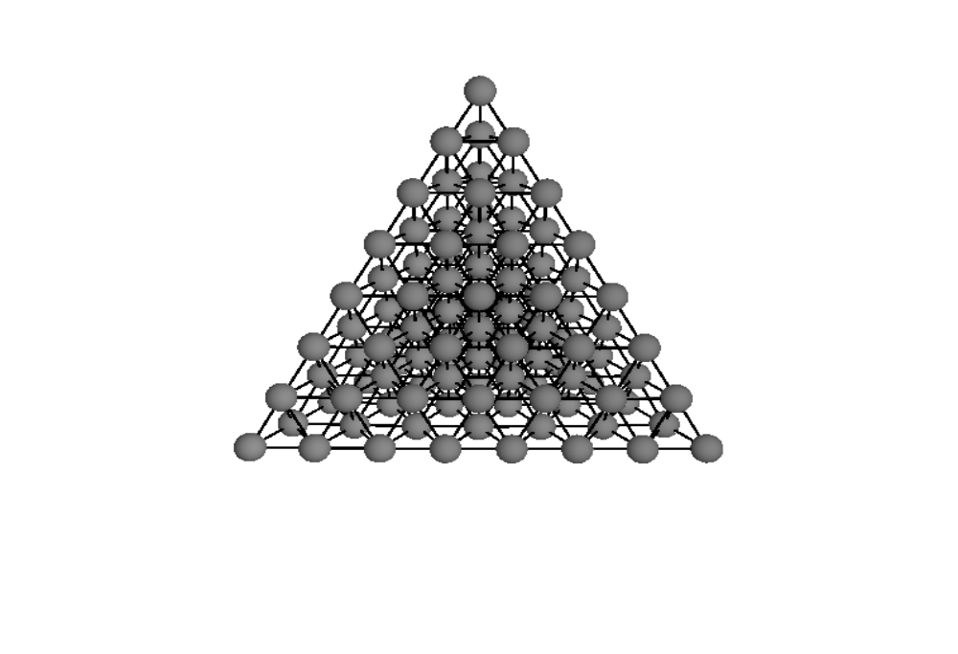

References
[1] For further information about this project link to <www.nsec.northwestern.edu> or email <nanotechnology.northwestern.edu>
[2] Journal of Physical Chemistry C 2008, 112, 11272-11279.

NANO HIGHLIGHT
SUB-CELLULAR TARGETING WITH FUNCTIONALIZED NANOPARTICLES
NSEC Grant EEC – 0647560
PIs: C. Shad Thaxton and Dale Shumaker
Northwestern University

Human cells compartmentalize various functions, including protein synthesis and DNA replication. As certain functions go awry in disease states, it is important to be able to directly target therapeutic agents to the diseased cell compartments.
While gold nanoparticles are promising therapeutic agents, targeting them to the nucleus – where they may demonstrate enhanced therapeutic efficacy – has been difficult.
NU-NSEC researchers have shown that gold nanoparticles (green), with both DNA and peptide sequences on their surface, have the ability to target the nucleus. The DNA is responsible for taking the nanoparticle conjugate inside the cell, while the peptide is responsible for targeting the cell nucleus (red rings).
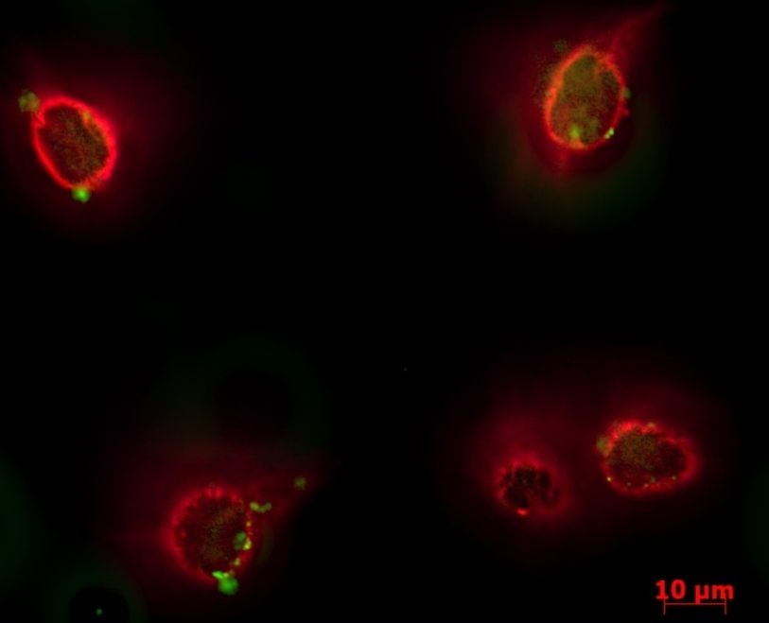

References
[1] For further information about this project link to <www.nsec.northwestern.edu> or email <nanotechnology.northwestern.edu>
[2] Manuscript in preparation, 2009.
NANO HIGHLIGHT
A CALCIUM-MODULATED PLASMONIC SWITCH
NSEC Grant EEC – 0647560
PIs: W.P. Hall, J.N. Anker, Y. Lin, J. Modica, M. Mrksich, and R.P. Van Duyne
Northwestern University

Making use of a cellular protein that changes shape in response to the presence of calcium, NU-NSEC researchers developed a nanoparticle-protein-conjugate whose plasmonic color varies with the presence of calcium.
The new device can be used as a sensor both for both calcium and protein conformational changes, and illustrates the capacity of nanoparticles to be used as plasmonic switches for wave-guide applications.

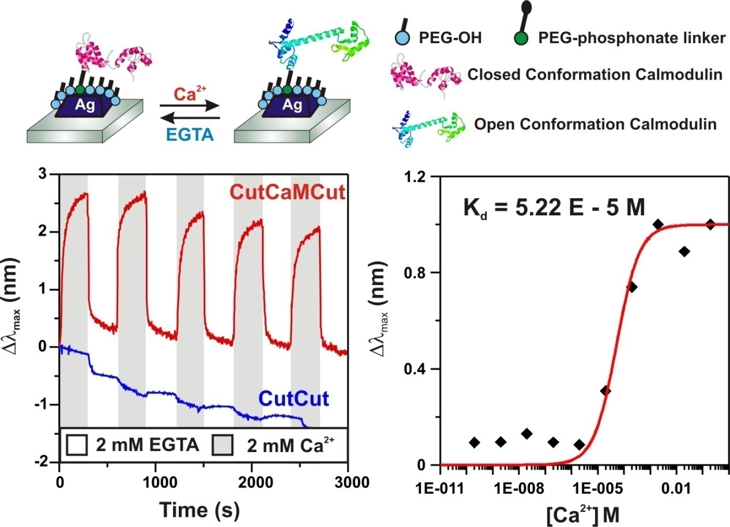

References
[1] For further information about this project link to <www.nsec.northwestern.edu> or email <nanotechnology.northwestern.edu>
[2] Journal of the American Chemical Society 2008, 130, 5836-5837.
NANO HIGHLIGHT
DETECTING AND IDENTIFYING BIOANALYTES WITH TANDEM LSPR SPECTROSCOPY AND MALDI MASS SPECTROMETRY
NSEC Grant EEC – 0647560
PIs: Jeffrey N. Anker, W. Paige Hall, Mary P. Lambert, Pauline T. Velasco, William L. Klein, and Richard P. Van Duyne
Northwestern University

Detecting and identifying small quantities of biomolecules are essential for diagnosing disease. For the first time, nanotechnology-based sensors taking advantage of LSPR were combined with specialized mass spectrometry (MALDI-MS) for the rapid detection and identification of small quantities of biomolecules.
Applied to the initial causative agent in Alzheimer’s disease (i.e., ADDLs), the tandem LSPR–MALDI-MS results identified two ADDL-constituent molecules. The nature of these molecules, which differ by the mass of one oxygen atom, influences the rate of toxin production.
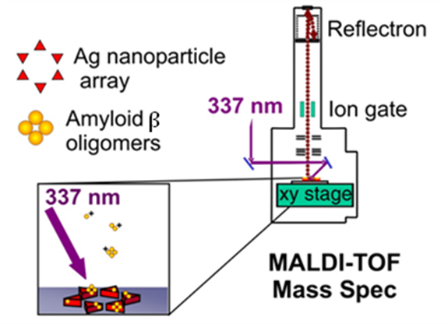
Schematic of MALDI-MS setup with LSPR substrates.

References
[1] For further information about this project link to <www.nsec.northwestern.edu> or email <nanotechnology.northwestern.edu>
[2] Journal of Physical Chemistry C 2009, 113(15), 5891-5894.
NANO HIGHLIGHT
SMALL BUSINESS EVALUATION AND ENTREPRENEUR PROGRAM (SBEE)
NSEC Grant EEC – 0647560
PIs: Chad A. Mirkin, Barry Merkin
Northwestern University

Rapid commercialization of new technologies helps ensure key discoveries have immediate impact. Unfortunately, the design of a compelling business plan to launch these technologies into the marketplace can be a significant road block for scientists and engineers. The Small Business Evaluation and Entrepreneur (SBEE) program addresses this need for NU-NSEC researchers.
Through the SBEE program, researchers with viable technologies make presentations to MBA students at open forums. The students help evaluate the commercial potential of the technologies presented and work with the researchers to develop viable business plans.
Since 2000, 16 start-up companies have been launched resulting in over $450 million in venture capital support. Some notable examples include: NanoInk, Inc. founded by Mirkin is commercializing dip-pen nanolithography; Nanodisc founded by Sligar is providing mechanisms for delivery of novel therapeutics; NanoSonix, Inc. founded by Dravid offers a solution to finding small yet critical microchip defects buried underneath surfaces; Nanotope, Inc. founded by Stupp is utilizing self-assembling amphiphilic molecules to enable tissue regeneration; and Nanosphere, Inc. founded by Mirkin is commercializing nanoparticle-based diagnostic systems.

Kellogg School of Management MBA students attend the March 12, 2009 SBEE meeting and listen to presentations by Chad Mirkin and Guillermo Ameer.
NANO HIGHLIGHT
NANOSCAPE: JOURNAL OF UNDERGRADUATE NANOSCIENCE
NSEC Grant EEC – 0647560
PIs: Mark Hersam, Kathleen Cook, Denise Dooley
Northwestern University

In 2003, the Northwestern University NSEC published Nanoscape, the first undergraduate journal of nanoscience and nanotechnology in the country. The journal is structured with a peer-review process that is modeled after professional journals. Aspiring authors gain valuable experience preparing and submitting articles for publication, as well as learning about and participating in the review process.
Six volumes have been published to-date featuring the work of 78 undergraduates from schools across the country. Each volume is mailed to over 1,000 university departments and libraries and the Center launched the on-line version of the journal in 2006 (www.nanoscape.northwestern.edu). Articles can now be submitted, reviewed, and read on-line.



