NANO HIGHLIGHT

Design of Biocompatible Nanoparticles for Probing Living Cellular Functions
and their Potential Environmental Impacts

NSF NIRT Grant BES 0507036

PIs: X. Nancy Xu¹, D. Gillet², C. Osgood¹, H. Elsayed-Ali¹, R. Van Duyne³
¹Old Dominion University, Norfolk, VA; ²CEA in France; ³Northwestern University

We have successfully designed, synthesized and characterized a mini-library of nanoparticles (NPs) with controlled sizes and surface functional groups and charges. These NPs are photostable (non-photodecomposition and non-blinking), and are not aggregated in buffer solutions and media,¹ allowing us to investigate their biocompatibility and toxicity in living organisms,^{2,3} and to study the dependence of membrane transport and biocompatibility upon the size and surface properties of NPs.³ Such research approaches offer the possibility of better understanding the dependence of biocompatibility and toxicity of NPs on their chemical, physical and surface properties.
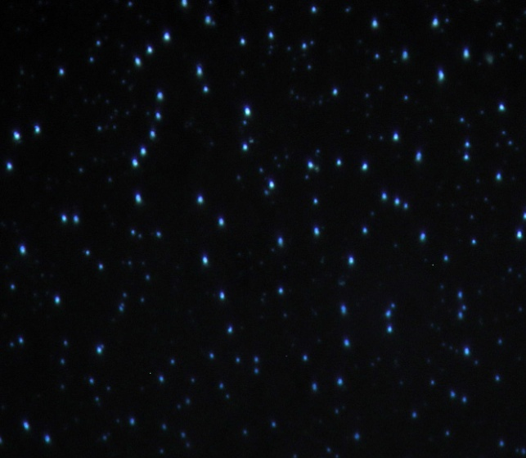
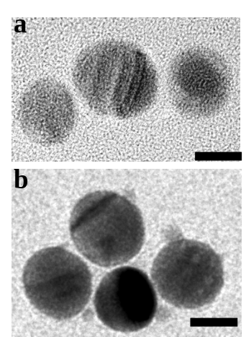

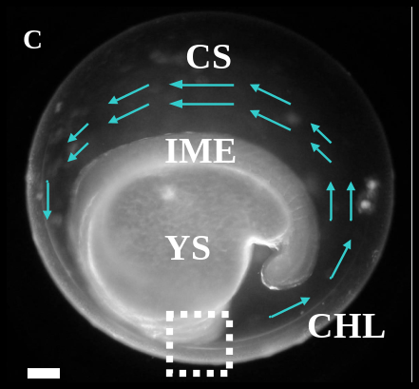
B
A

We have developed a simple washing approach to reduce the ionic strength of the solution, which increases thickness of electric double layer on the surface of silver and gold NPs, and thereby enhances their surface zeta potential. This approach allows us to prepare optically uniform (75-99%) (A) and purified Ag NPs (11.3 ± 2.3 nm) that are stable (non aggregating) in solution for months (B), permitting them to become robust and widely-used single nanoprobes for in vivo optical imaging (C). One can use our methods to prepare other purified and stable (non-aggregated) NPs for a wide variety of applications.

Unlike other particle tracking experiments, we utilized size-dependent localized surface plasmon resonance spectra (LSPRS) (colors) of single Ag NPs to determine given colored (sized) NPs in situ and used the monodisperse color (size) of NPs to simultaneously measure viscosities and flow patterns of multiple proximal nano-environments in segmentation-stage zebrafish embryos in real-time (C). This study demonstrates the possibility of using individual monodisperse NPs as nanophotonic probe to study the roles of embryonic fluid dynamics in embryonic development.

References
- P. Nallathamby, K. Lee, X. Xu*, “Design of stable and uniform single nanoparticle photonics for in vivo dynamics imaging of nanoenvironments of zebrafish embryonic fluids”, ACS Nano, 2, 1371 (2008).
- L. Browning, K. J. Lee, T. Huang, P. D. Nallathamby, J. Lowman, X. Xu*, “Random walk of single gold nanoparticles in zebrafish embryos leading to stochastic toxic effects on embryonic developments”, Nanoscale 1, 138 (2009).
3. For further information email: xhxu@odu.edu; visit website: http://www.odu.edu/sci/xu/nirt/nirt.html

