Exploiting Protein Cage Dynamics for Engineering Active Nanostructures
NSF NIRT CBET-0709358
PIs: Trevor Douglas (PI), Brian Bothner, Yves Idzerda, Mark Young
Montana State University

The focus of this Montana State University (MSU) NIRT builds upon a strong multidisciplinary team in the development of protein cage architectures as size and shape constrained templates for nanomaterials synthesis [1]. A deepening understanding of these systems has led to an appreciation that protein cage dynamics plays an important role in the overall properties of the nanomaterials. The central focus of this NIRT is to examine how particle confinement and protein cage dynamics at active interfaces controls nanomaterials synthesis and material functionality. The long-term goal is to use this knowledge to guide the development of a new generation of active and responsive nanomaterials.

The project is divided into three integrated components: Active Interfaces, Cage Dynamics, and Confinement.
Protein cage architectures, such as viruses and ferritins have three active interfaces can be manipulated, both chemically and genetically. These include the exterior surface, the interior surface, and the interface between the subunits that comprise the protein cage architecture.

Active Interfaces is focused on directing interactions for defined chemical synthesis using hard-soft interfaces, particle-surface interactions and controlled hierarchical assembly [2-4].
We have shown that we can use mass spectrometry to monitor metal ion binding and nanoparticle growth within a protein cage architecture. We have demonstrated that interactions between protein macromolecules and metal ions or nanoclusters can be preserved and metal deposition can be monitored by following mass increases of the protein-metal composite. Our state-of-art mass spectrometry has a sufficient mass accuracy and resolution to discriminate 2-3 metal ions depending on atomic masses of metal ions. Therefore, it is possible to concurrently detect multiple populations distributed within an ensemble and monitor their changes individually instead of averaging all signals. Using a combination of electrospray ionization (ESI) and time-of-flight (TOF) mass analyzer, the mass measurement of giant non-covalent macromolecular complexes has been possible and preservation of non-covalent interactions and solution structures in the gas phase inside mass spectrometer has been well demonstrated.
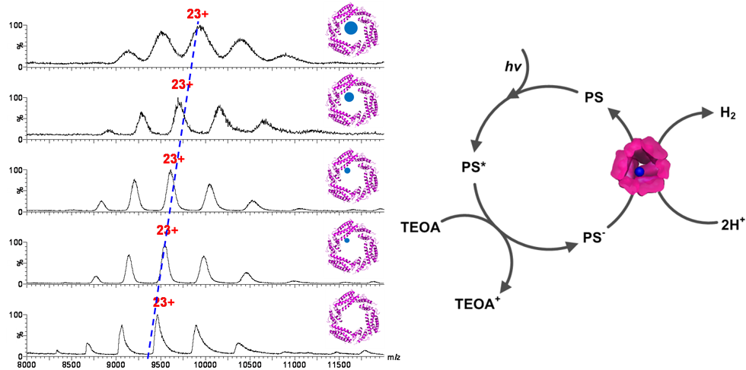
Fig 1. ESI Mass spectrometry was used to monitor Pt(II) ion binding and reduction to form Pt clusters. The clusters were active for H₂ formation when coupled to an Ir photosensitizer [2].

Cage Dynamics is centered around understanding and directing inherent and engineered cage dynamics to control material confinement, directed self-assembly, and particle-particle interactions [5-6].
Protein cages are assembled from identical individual subunits to form the overall architecture. The dynamics of the cages can arise either from the collective motions of these individual subunits or from individual components of the structure. We have investigated the change in modulus that occurs when a virus capsid undergoes a structural transition between a closed and an open conformation resulting in a roughly 10% increase in diameter. Shown in Fig 2 is the structural transition and the modulus, measured by quartz crystal microbalance (QCM).

Using our ability to control the disassembly and reassembly of the cages from individual subunits we have made chimeric cages of multiple modified subunits. We analyzed the ensemble distribution of the cages by native mass spectrometry and found homogeneous populations that fit to a bimodal distribution of subunits (Fig 3). This approach now allows us to selectively modify subunits and assemble ‘designer’ cages in which the distribution of modified subunits is controlled by the input ratio in the re-assembly reaction [5].
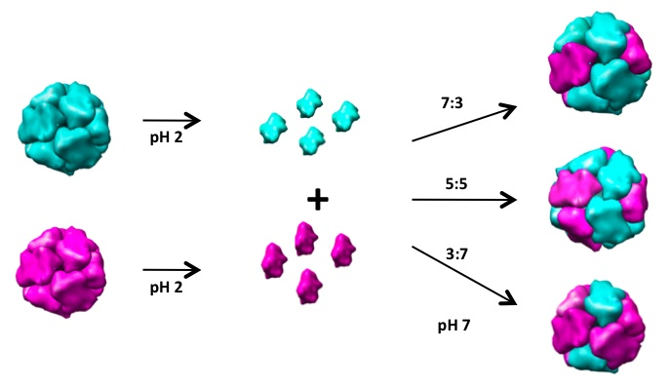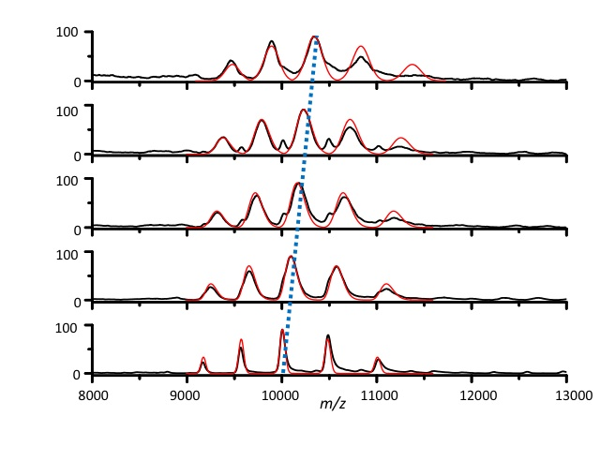
Fig 3. Using the Dps protein cage we have shown that we can differentially modify two subunits and reassemble into a chimeric cage, which follows a binomial distribution of subunits [5].
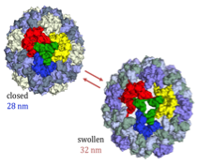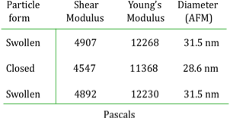
Fig 2. The CCMV virus undergoes a swelling transition, which has been probed by QCM to determine the elastic modulus of these two conformations. Environmental triggers (pH and [Metal ion] switch between these two conformations.
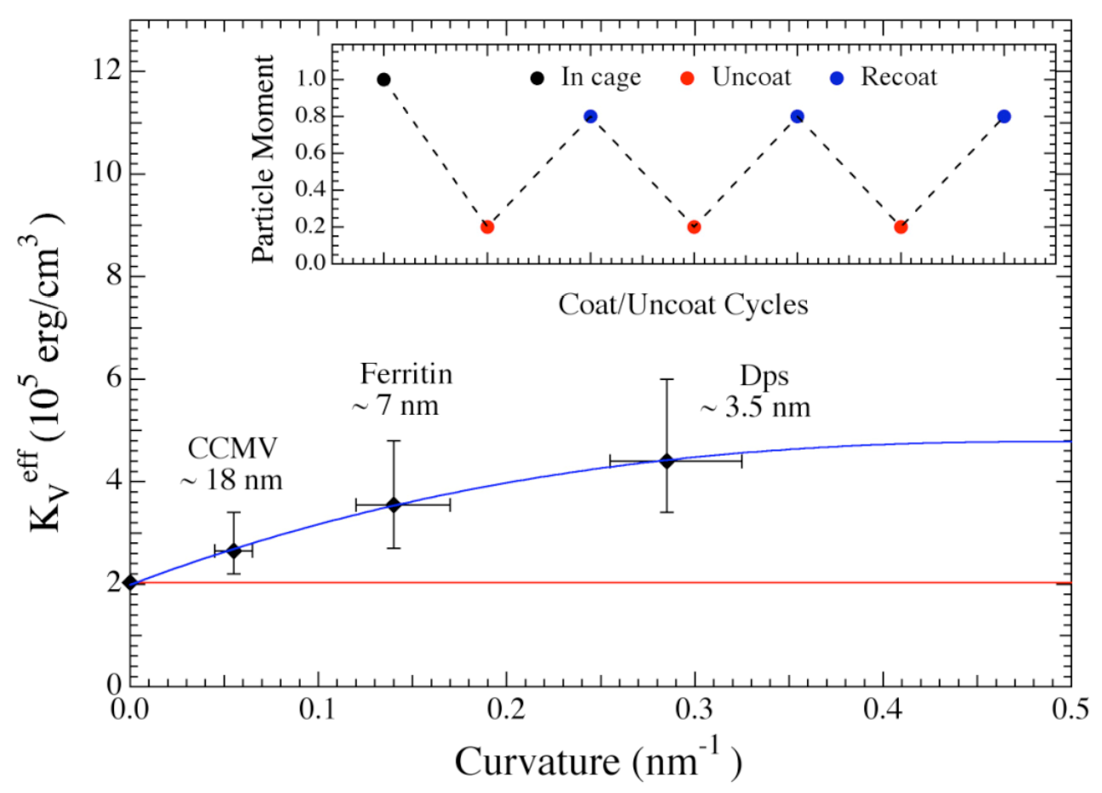
Fig 4. Confinement of magnetic nanoparticles within protein cages of different sizes. Removal of the protein results in loss of overall moment but recoating the particles restores most of the moment. This uncoating/coating can be cycled to reduce and restore the overall moment.
The Confinement thrust integrates the Active Interfaces and Cage Dynamics to explore their consequences on the physical properties of individual and collections of particles [7-12]. Confinement of mineralized particles in protein cages modifies the behavior of the surface spins by reducing the surface anisotropy. This directly affects the surface spin configuration, greatly enhancing the overall moment of the nanoparticle. Control would allow us to turn on and off catalytic activity, substantially reduce particle magnetic moment for new sensor applications, and modify optical properties. As an example, magnetic nanoparticle sensor applications typically rely on the attachment or detachment of the particle. By using active control of the surface anisotropy, the particle can remain attached, but the particle moment can be reduced by 80%, which would essentially remove the magnetic signal.

References
- For further information about this project link to < http://www.cbin.montana.edu/research/NIRT.html >
- Sebyung Kang, Janice Lucon, Zachary B. Varpness, Lars Liepold, Masaki Uchida, Debbie Willits, Mark J. Young, and Trevor Douglas “Monitoring Biomimetic Platinum Nanocluster Formation using Non-covalent Mass Spectrometry and Cluster Dependent H₂ Production” Angewandte Chemie (2008) 47, 7845 – 7848.
- M. Klem, M. Young, T. Douglas “Biomimetic Synthesis of β-TiO₂ Inside a Viral Capsid” J. Materials Chem (2008) 18, 3821-3823.
- M. Klem, P. Suci, D. Britt, M. Young, T. Douglas “In plane ordering of CCMV” Journal of Adhesion (2008) accepted.
- Sebyung Kang, Luke M. Oltrogge, Chris C. Broomell, Lars O. Liepold, Peter E. Prevelige, Mark Young, and Trevor Douglas “Chimeric Cages” J. Amer. Chem. Soc. (2008) accepted.
- P. Suci, M. Klem, M. Young, T. Douglas “Signal amplification using nanoplatform cluster formation “ Soft Matter (2008) DOI: 10.1039/b808178f.
- M. Parker, B. Ramsay, M. Allen, M. Klem, M. Young, T. Douglas "Expanding the Temperature Range of Biomimetic Synthesis Using a Ferritin from the Hyperthermophile Pyrococcus furiosus" Chem. Mater. (2008) 20, 1541-1547.
- M. Klem, J. Mosolf, M. Young, T. Douglas “Synthesis of Protein Encapsulated Nanomaterials by Photoreduction” Inorg Chem (2008) 47, 2237-2239.
- H. Li, Y. U. Idzerda, M. T. Klem, K. B. Sebby, T. Douglas, D. J. Singel, and M. Young, "Determination of Anisotropy Energy Constants of Protein Encapsulated Iron Oxide Nanoparticles be Electron Magnetic Resonance." J. Mag. Mag. Mater. (2008) (accepted).
- K. Gilmore, Y. U. Idzerda and M. D. Stiles "Spin-orbit Precession Damping in Transition Metal Ferromagnets", J. Appl. Phys. 103, 07D303 (2008).
- M. T. Klem, D. A. Resnick, K. Gilmore, M. Young, Y. U. Idzerda and T. Douglas, "Synthetic Control over Magnetic Moment and Exchange Bias in All-Oxide Materials Encapsulated within a Spherical Protein Cage", J. Am. Chem. Soc. 129, 197 (2007).
- V. Pool, M. Klem, J. Holroyd, T. Harris, T. Douglas, M. Young, Y. Idzerda, "Site Determination of Zn Doping in Protein Encapsulated ZnxFe3-xO4 Nanoparticles" J. Appl. Phys. (2008) (accepted).

