NSF- NIRT: "Surface State Engineering"
Charge Storage and Conduction in Organo-Silicon Heterostructures as a Basis for Nanoscale Devices
John C. Bean (PI)¹, Avik Ghosh¹, Lloyd R. Harriott¹, Lin Pu², Keith Williams³
¹Dept. of Electrical and Computer Engineering, ²Dept. of Chemistry, ³Dept. of Physics
University of Virginia, Charlottesville Virginia

Introduction: Combining the lessons of molecular electronics with the needs of microelectronics, in this project we proposed the development of “Surface State Engineering.” That is, we would attach organic molecules to silicon surfaces so strongly and intimately, that confined molecular electrons and free silicon electrons would be able to interact quantum mechanically. This could address the known statistical shortcomings of impurity doping processes in nanoscale FETs by offering the ability to fine tune electron transfer between molecule and Si. And, in the longer term, it would open the door to new devices based on quantum effects such as Fano and Kondo scattering, and on random telegraph signal phenomena. To achieve these goals, we proposed three enabling tools: 1) Modeling techniques that could realistically combine the very different physics of quantum dots and silicon layers; 2) Novel molecular self-assembly techniques that would allow for both molecular passivation and electrical activation of Si surfaces; 3) A quasi 1D Si on insulator FET structure that would serve both as a tool for molecular surface-state “fingerprinting” and as a device development platform.

Strategy in the Project’s First Year: We anticipated that our complete e-beam lithography based device platform would take at least one year to fully develop. We therefore adopted a “concurrent engineering” strategy where one sub-team focused on fundamental modeling and characterization, while a second sub-team developed molecular self-assembly techniques on Si, while the third sub-team developed the complete nano Si FET device test bed.

a) Fundamental Modeling and Characterization: This sub-team was driven by professors Ghosh and Williams. Ghosh’s modeling strategy was to combine Density Functional Theory (for continuum Si electronic states) with Extended Hückel Theory (for confined molecular states) to model FET conduction within the framework of Non-Equilibrium Greens Functions. To provide up-front validation of this methodology, he analyzed prior data from Tour et al. [1] on “SURFET” devices. For a variety of molecules, he was indeed able to accurately model induced FET threshold voltage shifts in terms of molecular polarization and charge transfer.[2, 3]

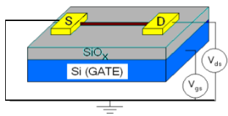 | 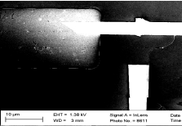 | 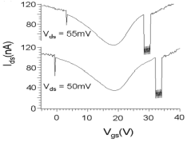 | 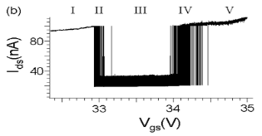
CNT FET Structure | CNT FET | I-V | Enlarged overlapping RTS I-V

Williams and Ghosh then identified the shortest route to a testable quasi-1D FET as being one based on a single carbon nanotube (CNT). They developed such structures (as shown above left) and began testing these for Random Telegraph Signals (RTS). These signals occur when an available electronic level (“trap”) occurs in close proximity to a quasi-1D FET device channel. In its charged state, that trap can act as a FET gate, pinching off channel conduction. As charge moves in and out of that level, FET conduction flickers, with the on-off duty cycle of that flickering depending on the local Fermi level position, which is in turn controlled by device gate, source and drain voltages. Analysis is straight-forward when only one charge-center/trap is active. But with molecules distributed along its channel, our proposed hybrid molecular-Si FET could easily have multiple active charge-centers/traps. This raised the question of whether molecular fingerprinting would still be possible in the presence of overlapping RTS signals. To answer this question, Williams and Ghosh were able to identify an anomalous overlap occurring in the signals of certain CNT FET devices (as shown above right). As shown below (left and center) they were able to model this as overlapping charge centers, producing excellent agreement between observed and modeled device I-V characteristics, reinforcing our plan to use interpreted RTS data our fundamental molecular “fingerprinting” tool.[4]
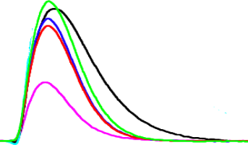
Acetylene / Si
Thermal Oxide / Si
Native Oxide / Si
}
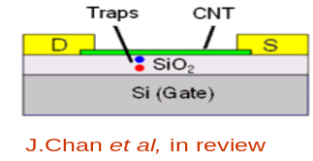 | 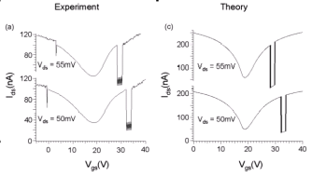
Quasi 1D CNT FET with adjacent charge centers | Successful comparison of experimental and modeled overlapping RTS signals | Pulsed photoconductance of Acetylene passivated Si

b) Molecular Self-Assembly on Si: In parallel, the sub-team led by professors Pu and Bean developed means of attaching highly pure, highly ordered molecular layers to Si. The approach was to use vacuum-based “hydrosilylation.” In this approach, arriving molecules are terminated with a double or triple carbon-carbon bond which, under UV illumination will reduce in bond order, one carbon removing a hydrogen atom from the adjacent Si surface, freeing that Si atom for bonding with the second carbon. This process was validated through a number of techniques including attenuated-total-reflection FTIR and pulsed photoconductance. Photoconductance tested the crucial question of whether, after removing conventional SiO₂ passivating layers from Si surfaces, we could then restore inactivity solely based on molecular attachment. If this were achieved, surface recombination would be eliminated as a path for photo-induced minority carrier recombination, thereby extending photoconduction. As the data above right show, for hydrosilylated acetylene on Si we were indeed able to achieve pulsed photoconduction fully comparable to that of control Si samples passivated by state-of-the-art thermal oxidation. This sets the stage for the gradual substitution of the electrically active molecules as proposed in our 1D organo-silicon FETs.

c) Development of Nanoscale Quasi 1D Organo-Silicon FET: For the development of the full quasi 1D silicon on insulator nano FET, professors Harriott, Bean and their students acquired and set up a new electron beam lithography system, and developed a device process based on double metal lift-off. The proposed structure (below left) incorporates not only a SOI backgate but also metal side gates on each side of the channel that can be used to further narrow the channel conduction path. Fabricated side gates with 92 nm separation are shown below at center left. Etched Si-on-insulator channels of both 50 nm and 29 nm width are then shown on the right. These components are now ready to be combined within the nano FET device test structure, which will then be available for full organo-Si device development.

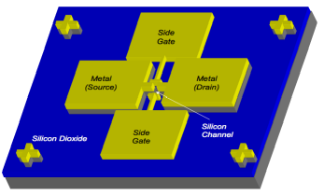 | 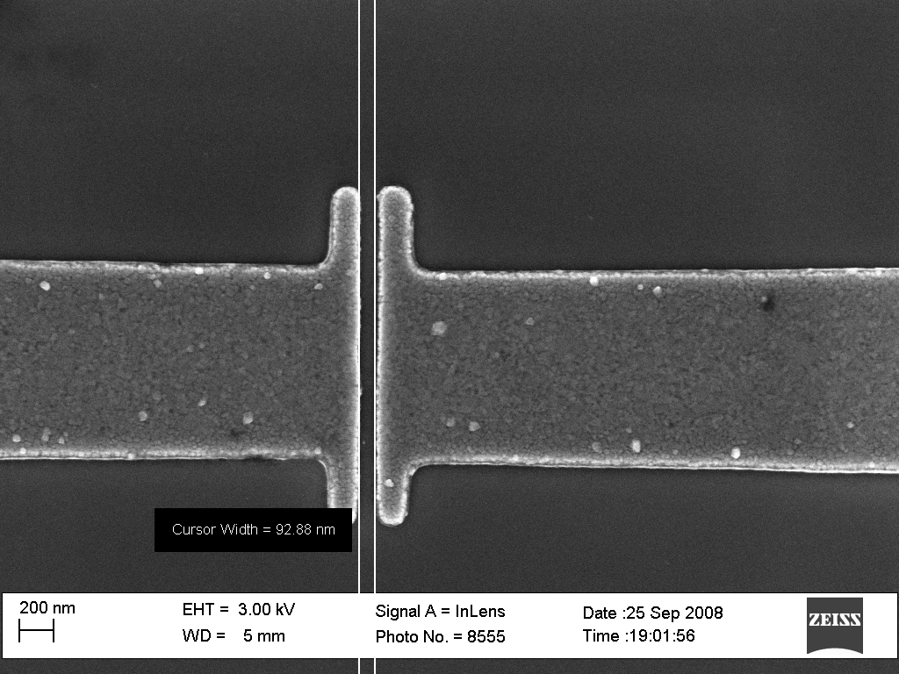 | 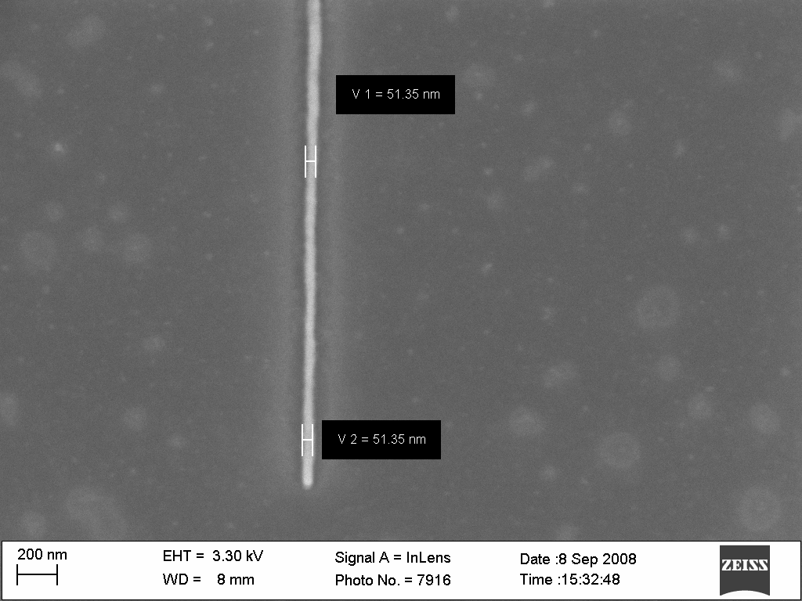 | 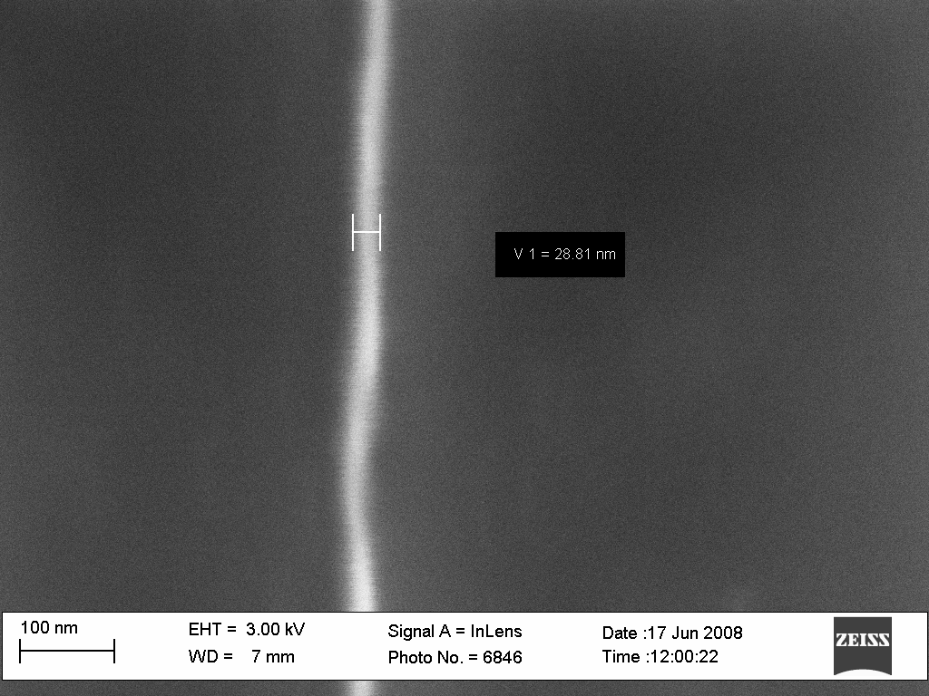
Quasi 1D SOI-FET | Side Gates w/ 92 nm separation | 50 nm Si channel | 29 nm Si Channel

Education and Outreach built upon earlier our NSF CCLI funded the “UVA Virtual Lab” science education website (www.virginia.edu) and our NSF NUE funded “Hands on Introduction to Nanoscience” class (www.virlab.virginia.edu/Nanoscience_class/Nanoscience_class.htm). That website has now accumulated over 4 ¼ million hits, and the combined projects led to PI Bean being named as the 2009 recipient of the IEEE Undergraduate Teaching Medal. In this NIRT project, those resources were combined with the expertise of the multi-site Science Museum of Virginia to develop nanoscience curricula for Virginia K-12 public schools. The highlight of this year’s effort was a full class on “Teaching Nanoscience” taught for “southside” Virginia K-12 science teachers by Bean last August (for university credit), with ongoing activities continuing throughout this fall. Those activities included a successful partnership with Danville Community College to gain not one but two grants to fund their acquisition of STMs and AFMs as the foundation for building their own nanoscience AA degree program (to be modeled on the UVA NUE curriculum).

For further information about this project, contact John C. Bean: john-bean@virginia.edu

References

[1] Controlled Modulation of Conductance in Silicon Devices by Molecular Monolayers, He, T.; He, J.; Lu, M.; Chen, B.; Pang, H.; Reus, W. F.; Nolte, W. M.; Nackashi, D. P.;Franzon, P.D.; Tour, J. M.; J. Am. Chem. Soc., 128, 14537-14541, (2006)

[2] Modeling electrostatic and quantum detection of molecules, S. Vasudevan, K. Walcak,K. and A.W. Ghosh, IEEE Sensors Journal, 8, 857-862 (2008)

[3] Controlling transistor threshold voltages using molecular dipoles, Smitha Vasudevan, Neeti Kapur, Tao He, Matthew Neurock, James M. Tour and Avik W. Ghosh
arXiv:0807.3378v1

[4] Reversal of current blockade through multiple trap correlations, Jack Chan, Brian Burke, Kenneth Evans, Smitha Vasudevan, Kamil Walczak, Mingguo Liu, Joe Campbell, Keith A. Williams and Avik W. Ghosh, submitted to Nature Nanotechnology

