NIRT: Engineered Therapeutic nanoparticles as catalytic antioxidants
NSF NIRT Grant 0708172
PIs: S. Seal,¹ W. Self,¹ A. Masunov¹ and J. McGinnis²
¹University of Central Florida, Orlando, and ²University of Oklahoma

Rare earth nanoparticles have shown great potential for biological applications. Based on the ability undergo reversible redox reactions, these nanoparticles can effectively quench free radicals. We are developing engineered rare earth nanoparticles (cerium oxide nanoparticles and its hybrids) to mimic antioxidant enzymes in order to reduce accumulation of biological damage due to free radicals. This investigation will uncover and elucidate the molecular mechanism of the antioxidant nature of nanoceria as well as develop these materials into radical scavenging therapeutics. The NIRT team is studying the entire product cycle from synthesis, surface modification and characterization of the nanoparticles using advanced analytical tools, testing of their radical scavenging properties and their subsequent application in biological systems. In order to understand the details of the mechanism of functional activity, quantum chemical calculations are being performed on the ceria NPs. Although these NPs have shown excellent antioxidant and regenerative behavior in neurons, the details of cellular interaction mechanism are yet to be understood. In this program, we are developing engineered rare earth NPs to study their protective behavior in retinal cells. Furthermore, the computational data on the therapeutic characteristics of NPs are correlated with the experimental data. This will provide a solid foundation for further optimization and development of ceria and other rare earth nanostructures to enhance their biological activity. Based on the evaluation of experimental and theoretical data, ceria NPs will be tested in vivo in the albino rat light – damage model system.
Currently the team has produced engineered ceria nanoparticles, ranging between 2 and 10 nm in size, were introduced into organotypic rat brain cell cultures which consisted of neurons, glia and microglia. Cultures treated with nanoparticles not only maintained the normal physiology properties of the neurons, but the survival rate of such cultures exceeded that of control cultures by a factor of three. Nanoceria particles have shown to be preventing the increases in the intracellular concentrations of ROS in primary cell cultures of rat retina and the loss of vision in vivo due to light-induced degeneration of photoreceptor cells. We hypothesized that the nanoparticles increased longevity by reducing the free radical damage to the biological system. Furhter, we are working on simulations of lattice parameters and electronic structure of nanoceria: The team had shown that formation of subsurface vacancies is sufficient to explain the expansion of lattice parameter with decreasing size of the ceria nanoparticles. The biofocus team has discovered that nanoceria can catalyze SOD activity in vitro, and have been working to understand the molecular mechanism of this radical scavenging property of the material. Catalytic activity of nanoceria with higher level of Ce³⁺ was shown to be superior in our preliminary work (Patent Pending). Finally the team in collaboration with U of Oklahoma has made significant contributions in preventing retinal degeneration. In one of the recent studies using albino rat in vivo light damage model, it has shown intravitreal administration of nanoceria in rat retina can prevent the damage of photoreceptors (1 patent issued, 1 Patent Pending).The team have shown that nanomolar concentrations of CeO₂ NPs in serum-free cell culture media is effective in scavenging free radicals to reduce damage to neurons in the model system. We have also found that the co-existence of both Ce³⁺ and Ce⁴⁺ oxidation states in CeO₂ NPs plays a critical role in its antioxidant behavior. Experimental data have shown that the reversal of oxidation state also continues over time in cell culture and therefore CeO₂ NP acts as a catalyst.

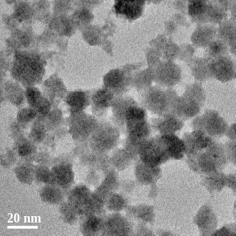
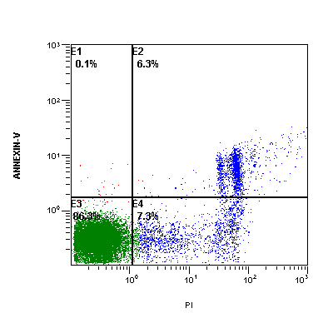
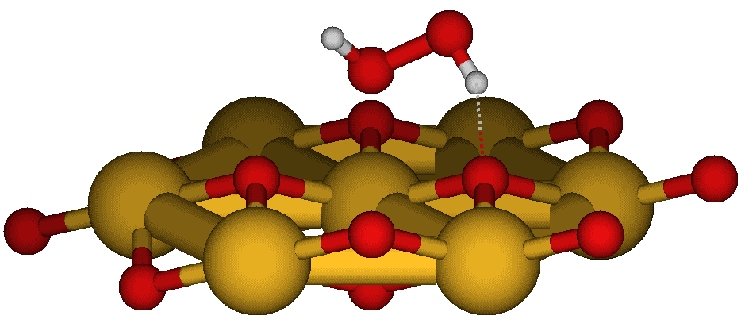
These can be a new version of regenerative nanomedicine and open an entirely new field of rare-earth based nanomedicines. Millions of people suffer from neurodegenerative disease including macular degeneration. Our current multidisciplinary combined with engineers and scientists have created novel nano-rare earths with regenerative capability in scavenging radicals and protecting mammalian cells. The research will train students from engineering, simulation and biomolecular engineering and has created unique partnership between University of Central Florida and University of Oklahoma/
600 µM H₂O₂
10 nM NP
(a)
(b)
(c)
This research successfully bridges nano and biotechnology, engineering, and molecular medicine to address the potential cure for glaucoma. The broader impact of this research is in the discovery of the novel regenerative rare earth nanomedicine using bioactive nanostructures. The highly multidisciplinary environment involves engineering, biomedical science, nanoscience and college of medicine researchers and provides a valuable research environment for undergraduate, graduate students, and postdocs. Furthermore, the research is integrated into undergraduate courses in nanoscience and technology. All the PIs will use material generated in this project as case studies to illustrate key concepts in materials engineering, chemistry, and nanotechnology and molecular medicine.
Fig Highlight: (a) Engineered multivalent states in 5 nm ceria particles. (b) Ce – brown, O – red, H – white. First-Principle geometry optimizations of atomic clusters Ce7O14+H2O2 simulating hydrogen peroxide chemisorbed on the NP (111) oxygen-terminated surface used Density Functional Theory (BMK exchange-correlation functional) with Gaussian basis set and Effective Core potentials – showing the potential for SOD mimetic activity, (c ) Cerium oxide nanoparticles significantly decrease RPE cell death induced by hydrogen peroxide (600 micromolar concentration.

Almost 3 Million people from USA suffer from Glaucoma, and this research has potential solutions to understand and development of disease prevention, which can help to reduce medical cost and improve lives. Thus the science has enormous potential impact in creating regenerative nanomedicine using active nanostructures.
The research is tranformatory because of the following key reasons:
1. Potential treatment to prevent blindness using nanoparticles, prevention of neurodegeneration, hereditary blindness and macular degeneration – extending to Biomedical applications
2. Stability of nanoparticles as a function of aging contributing to the Colloidal science
3. SOD mimetic activity found in inorganics – e.g., nanoceria for the first time.
4. Atomic-level details of SOD mimetic activity as a function of nanoparticle aging and chemistry.
5. Development of regenerative nanomedicine
6. Providing valuable multidisciplinary training male and female students including minorities.

