ANN NIRT: GOALI : Nano-Engineering Efficient Optoelectronic Devices
NSF NIRT Grant 0609416
PIs: S. A. Nikishin, J. Berg, A. Bernussi, M. Holtz, H. Temkin
Texas Tech University
Deep ultraviolet (UV) light sources are needed for numerous purposes, including lighting, homeland security, defense, and environmental applications. Our Year 1 efforts were focused on nanoengineering of deep UV light emitting diodes (LEDs). We have successfully laid the groundwork for the growth of novel optoelectronic nanostructures based on AlGaN/AlGaN and InGaN/GaN superlattices. We identify three area of major technical achievement. These are as follows: 1) Gas source molecular beam epitaxy (GSMBE) of a nanoengineered AlGaN/AlGaN active region, containing quantum dots of AlGaN, and yielding significant enhancement of internal quantum efficiency; 2) Development of selective area metal organic chemical vapor deposition (MOCVD) of GaN micro- and nano-islands, using templates of AlN/sapphire and GaN/sapphire obtained from our industry collaborators; 3) Fabrication and characterization of nanophotonic surfaces on Si and GaN test structures.
AlGaN Quantum Structures with Enhanced Luminescence: AlGaN is the best material for material for deep UV emitters, but the efficiency of light emission is extremely low. As a first step towards addressing this problem, we investigated AlGaN-based active region structures with enhanced luminescence. We fabricated Al_{x}Ga_{1-x}N/Al_{y}Ga_{1-y}N quantum well structures using GSMBE, and studied their structural and optical properties using transmission electron microscopy (TEM) and room temperature cathodoluminescence (CL) measurements.
The quantum well structures consist of five pairs of Al_{y}Ga_{1-y}N, 0.3 < y < 0.45, wells (2 to 4 nm thick) and Al_{x}Ga_{1-x}N, 0.55 < x < 1, barriers (5 nm thick). In order to understand the formation of these quantum structures, the growth has been monitored in real time during growth, using reflection high-energy electron diffraction (RHEED). The RHEED patterns allow us to understand the crystal formation mechanisms, which can be controlled to obtain two- and three-dimensional quantum structures.
We find a definite correlation between growth mode and observed luminescence intensity. Figure 1 shows the observed intensity for a series of samples grown with varying ammonia flux. Quantum structures are formed in the wells of Al_{0.4}Ga_{0.6}N/Al_{0.55}Ga_{0.45}N superlattices under controlled growth conditions, as confirmed by TEM (inset). Optical properties were investigated using room temperature cathodoluminescence and time-resolved photoluminescence. We obtained well growth conditions to produce ~ 60 fold intensity enhancement over purely two-dimensional structures. During the next year we will enhance the efficiency of deep UV LEDs operating in the 260 nm to 290 nm range.
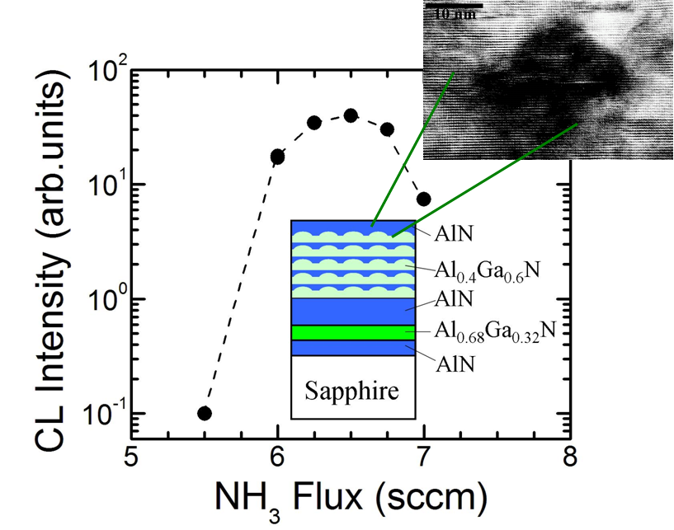
Fig. 1. The room temperature CL intensity of QWs versus NH₃ flux. Insets are depiction of quantum structure formation and TEM cross-section of a domain.
MOCVD Selective Area Growth of GaN Nano Islands: Dislocation imperfections reduce optical efficiency by providing sites for electron/hole recombination. One approach to reducing dislocations in crystals is to grow them on a small scale, so that defects prefer to form on the surface. We studied the properties of GaN islands selectively grown by MOCVD on (0001) GaN/sapphire templates and on bare (0001) sapphire substrates. The GaN/sapphire templates were delivered by our industrial partner, Technologies and Devices International, Inc. The approach allows us to grow GaN crystals with control over size and density through optical (micro-scale) and scanning electron microscope (SEM) e-beam (nano-scale) lithography. We have obtained complete pyramidal and prismatic hexagonal GaN islands as shown in Fig. 2.
The growth characteristics are found to be very different from what we obtain for epitaxial layers, an effect which is attributed to loading and surface diffusion of source materials on the hard mask. From the dependence of growth rate of the pyramids with pitch we evaluate Ga surface diffusion length of ~ 10 µm over the SiO₂ mask.
Micro-Raman measurements of the GaN islands were carried out using a 2 µm excitation spot size. Narrow E₂² phonon line width of 3.9 cm^{–1} and 4.9 cm^{–1} were obtained for GaN islands grown on GaN and sapphire templates respectively, compared to a line width of 3.8 cm⁻¹ obtained for our reference sample (a 60 µm thick GaN layer). This indicates a very good crystalline quality of these islands. Stress in these islands was evaluated based on the Raman shift and found to be 50±17 MPa and 84±20 MPa in pyramidal and prismatic islands, respectively. This implies that the GaN islands are nearly relaxed. The GaN islands, of varying shapes, were overgrown with InGaN multiple quantum wells. The MQW intensity was much stronger, indicating superior optical properties to the underlying GaN.
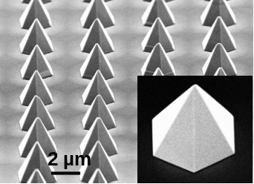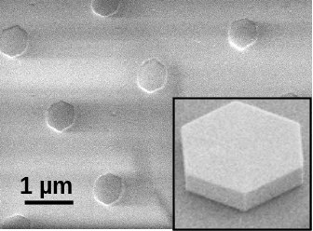
Fig. 2. SEM images of pyramidal (left) and hexagonal (right) islands. Insets show individual islands grown on GaN template (left) and nitridated sapphire (right).
Nanophotonic Surfaces: Our previous work has shown that insertion and extraction efficiencies can be altered by nanoscale surface patterning. Recent developments in nanoscale patterning have resulted in the possibility to design surface textures, altering the way light interacts with structures. One well-known example is the photonic crystal, which is receiving intense study. We have fabricated nanophotonic textures in metal and semiconductor surfaces. Both approaches rely on nanolithography, and combinations of high-aspect ratio plasma etching and lift-off.
In a recent experiment, see Fig. 3, nanohole arrays were produced in metallic coatings on cleaved optical fibers and also on glass substrates. Nanoholes range in size from 100 to 700 nm, the pitch is varied from 300 to 3000 nm. Transmission properties are examined using visible (632.8 nm) and infrared (1550 nm) laser light. The observed interference patterns are determined by array symmetry, nanohole diameter, and pitch. Results from the optical fibers are compared with larger array areas fabricated on bulk glass substrates. In all cases the results are simulated using near- and intermediate-field diffraction theory with good agreement. This experiment demonstrates that nanoscale texturing can be used to shape the optical transmission field. In addition, theory is developed to understand the observed behavior.
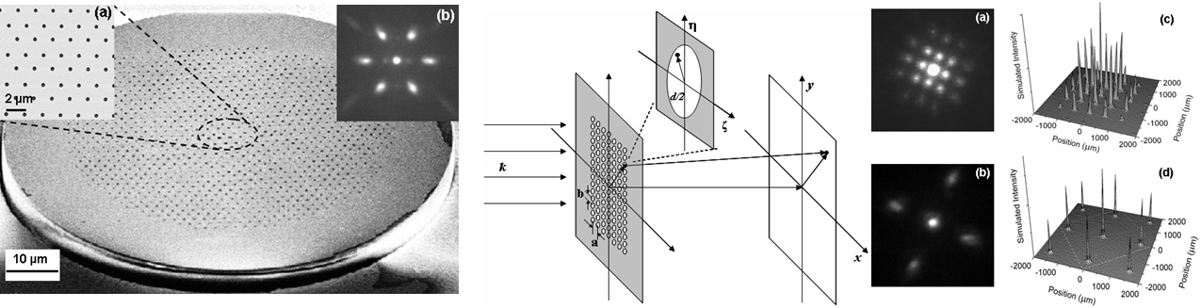
Fig. 3. Nanohole arrays produced in metallic coatings on cleaved optical fibers. Nanoholes range in size from 100 to 700 nm, the pitch is varied from 300 to 3000 nm. Transmission properties are examined using visible (632.8 nm) and infrared (1550 nm) laser light. In all cases the results are simulated using near- and intermediate-field diffraction theory with good agreement.
We have initiated studies to understand the effects of nanoscale texturing on the optical properties of GaN for enhancing UV light emission. The texture consists of circular holes etched in a hexagonal array with 1 μm spacing. Hole diameters range from 125 to 700 nm and depths range up to 1 μm. We study the optical properties using cathodoluminescence measurements in a scanning electron microscope. Intensity is found to increase with pore diameter, an effect we attribute to changes in the optical extraction efficiencies. A red shift observed in the emission peak is attributed to local relaxation of the compressive stress present in the starting GaN epilayer. Future work will focus on applying these approaches to deep UV light emitting diodes for improved efficiencies.
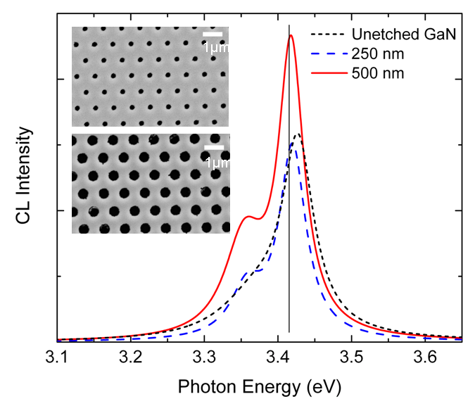
Fig. 4. Effect of nanotexture on GaN emission.
This project has provided nine students at the BS, MS, and PhD levels with a fully integrated multidisciplinary setting for research and training. Of the students involved in this work, five are female, and one of those was African-American.

Publications to date under this grant
- “Transmission properties of nanoscale aperture arrays in metallic masks on optical fibers,” J. Appl. Phys. 101, 014303 (2007).
- “Phase effects in broad-area heterolasers with curved grooves of distributed feedback grating”, Tech. Phys. Lett., 33, 292 (2007).
- “Selective area growth of GaN nano islands by metal organic chemical vapor deposition: experiments and computer simulations,” Proc. Mat. Res. Soc. Symp., 955, 0955-I07-14 (2007).
- “Enhanced luminescence from Al_{x}Ga_{1-x}N/ Al_{y}Ga_{1-y}N quantum wells grown by gas source molecular beam epitaxy with ammonia,” Proc. SPIE Photonics Conf., 6473, 647306 (2007).
- “X-ray diffraction study of AlN/AlGaN short period superlattices”, J. Appl. Phys., JR07-3866R (2007).
- “Deep UV light emitting diodes and solar blind photodetectors grown by gas source molecular beam epitaxy”, J. Mater. Sci: Mater Electron, on line DOI: 10.1007/s10854-007-9405-3 (2007).
- “Luminescence properties of Al_{x}Ga_{1-x}N (0.4<x<0.5)/Al_{y}Ga_{1-y}N (0.6<y≤1) quantum structures grown by gas source molecular beam epitaxy”, physica status solidi c (2007).
- “Influence of photonic nanotexture on the optical properties of GaN” Appl. Phys. Lett. 91, 103115 (2007).

