NIRT: Nanometer Stoichiometric Particle Compound Solutions and Control of their Self-Assembly into the Condensed Phase
NSF NIRT Grant 0609318
C M Sorensen, B M Law, K J Klabunde, A Chakrabarti and C Aakeroy
Departments of Physics and Chemistry, Kansas State University, Manhattan, KS 66506

Our goal is to create a new family of nanometer “stoichiometric particle compounds,” or what could also be called nanoparticles (NP) of all the same size, and understand their solution phase behavior, interfacial phenomena, transitions to other phases, and controlled assembly and into condensed phases. These NP systems lie between molecular solutions and classical polydisperse colloids.
Thus our research seeks to:
1. Develop synthetic methods to produce a wide variety of uniformly sized NPs with different surface ligands,
2. Understand and control of solution phase and interfacial properties of NP solutions, and self-assembly of NPs to yield two and three dimensional superlattices, films and gels.
3. Understand surface and interfacial properties of NP solutions.

- Synthesis of Nanoparticles
1.1 Gold, Silver, Cadmium Selenide and Indium Nanoparticles. The Solvated Metal Atom Dispersion (SMAD) technique [1] was used to prepare nanoparticles (NP) in much of our work. This involves evaporating bulk powder and then co-condensation of the vapor with a solvent vapor at LN2 temperatures. This frozen matrix is then warmed and accretion occurs to form NPs. These particles are stabilized by using various ligands like alkyl thiols and amines trioctylyphosphine (TOP) and trioctylphosphineoxide (TOPO). As prepared SMAD colloidal products are then digestively ripened [2-4] via reflux in different solvents like toluene, t-butyltoluene, trioctylphosphine (TOP) and oleylamine. The resulting particles are reasonably monodisperse
1.2 Ligand Exchange Reactions. We are also working on ligand exchange reactions to study the transfer of these nanoparticles from organic solvents into solvents of varying polarity including water. We find that starting with a rather weakly bound ligand such as dodecylamine facilitates the exchange. We have placed the following ligands on gold NPs: mercaptoundecanoic acid and mercaptoundecanol, 1-mercapto-2, 3-propanediol, and bis(8-imidazol-1-yloctyl)disulfide.

2. Phase behavior and Nucleation in Nanoparticle Solutions
We have studied gold NP’s ligated with dodecane thiol in solutions of mixtures of tert butyl toluene and 2-butanone which are good and poor solvents for the NP’s, respectively. We found this system to have a reversible solubility phase diagram. Extensive studies of nucleation of the individual nanoparticles, the soluble phase, to 3d superlattice crystals, the insoluble phase, have been made. We find that quenching from the one phase regime at 65C into the two phase regime yields clusters of NP with size dependent upon the quench temperature, Fig. 1. These clusters occur quickly and do not grow within our experimental time scale. We also find that the concentration of the cluster phase decreases rapidly with increasing quench temperature, Fig. 2. We have a preliminary explanation of these results based on nucleation theory. However the single sized and non-growing clusters in the quenched phase are a mystery. Very recently we found that Au/dodecanethiol NP’s prepared by a radically different procedure but of approximately the same size display a different phase diagram but the same nucleation behavior.
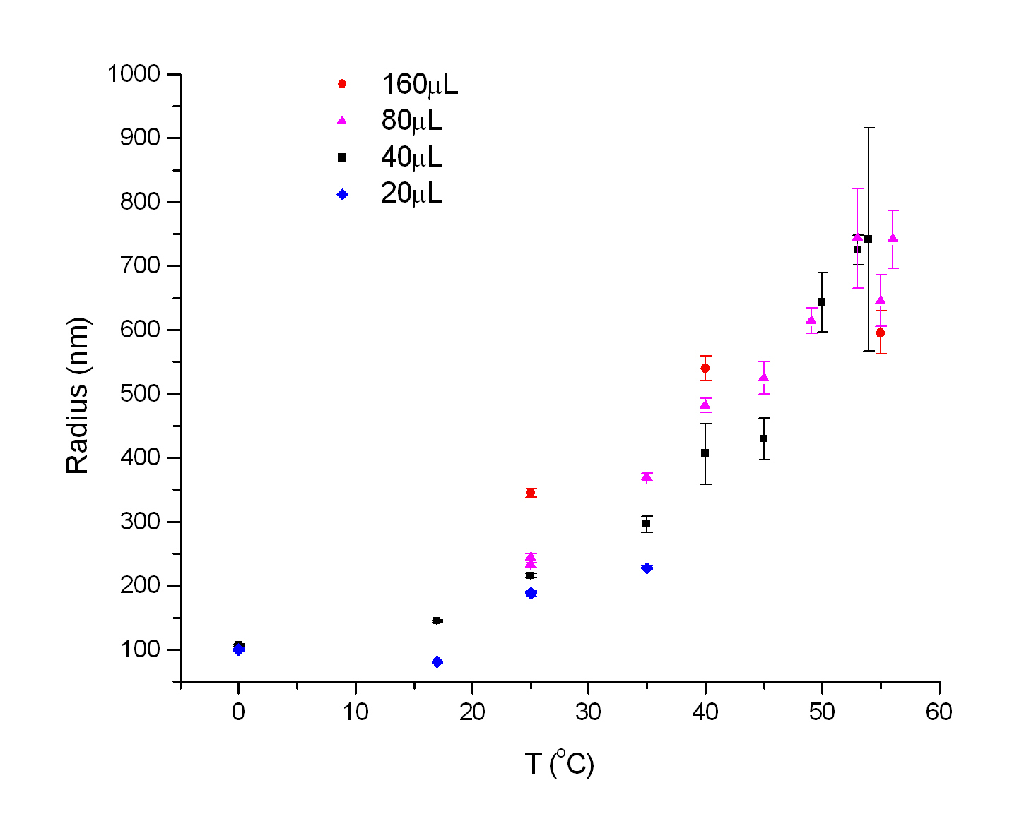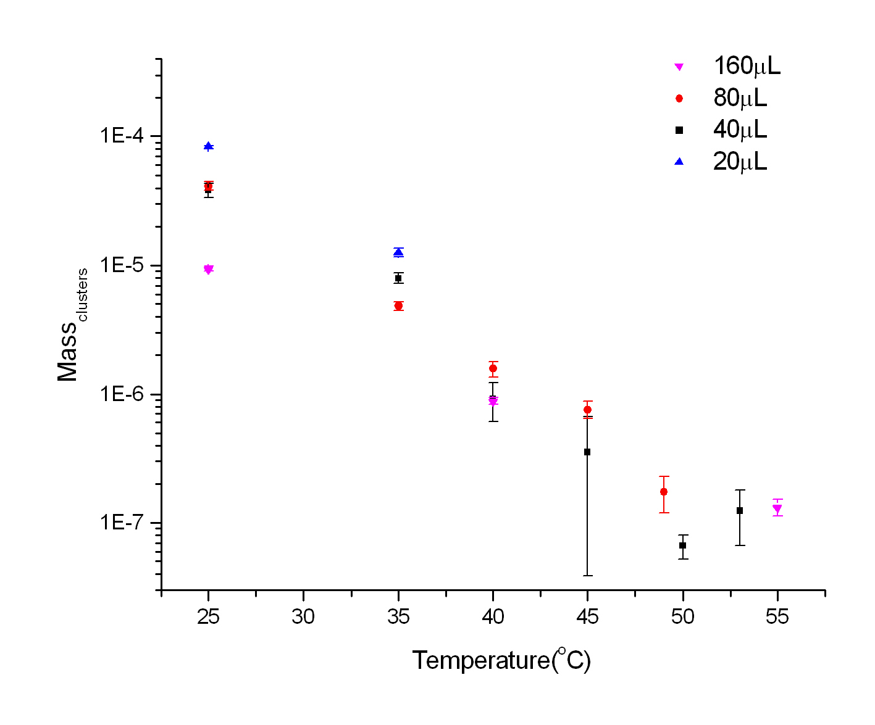
Fig. 1 Nucleated cluster size vs. nucleation temperature.
Fig. 2 Total cluster mass vs. nucleation temperature.

3. Controlling Nanoparticle Assembly through Supramolecular Synthesis
Controlling the metrics of a nanocrystal superlattice is inherently challenging since nanoparticles tend to display a high-degree of structural isotropy; rather than chemical or structural asymmetry necessary to impart directional or anisotropic lattice growth. Furthermore, the relative softness and flexibility of the intermolecular forces between adjacent aliphatic chains tend to produce superlattices that are mechanically and thermally weak. However, by replacing some of the surfactant molecules with linking molecules (terminated with a suitable self-complementary hydrogen-bond moiety), the intermolecular interactions between nanoparticles will be dominated by hydrogen bonds.
To this end, we have placed mercaptoundecanoic, mercaptoundecanol and bis(8-imidazol-1-yloctyl)disulfide ligands on gold NPs. Early results show solubilities in polar solvents like methanol and DMSO and both homo and hetero cluster formation.

4. Surface Effects of Nanoparticle Solutions
We plan to quantify surface effects of NP solutions and how NP concentrations within the solution influence NP adsorption, wetting and droplet contact angles
In the last year we developed an ellipsometer whereby adsorption at the solid-liquid interface could be monitored at the same time that contact angle time dynamics of droplets could also be examined. Contact angle time dynamics provide information about the dissipation mechanisms (i.e. frictional forces) that act to slow down and stop the spreading of droplets at surfaces. In the past, dissipation has mainly been studied in simple pure non-volatile droplets and there has been very little work on more complex solution droplet dissipation mechanisms, or how adsorption may play a role in influencing the dissipation.
We have studied Au NPs coated with a dodecanethiol ligand in t-butyl toluene. We have observed preliminary NP adsorption effects, measured via ellipsometry, at the liquid-vapor interface. At a glass-NP solution interface, no analogous adsorption effects were observed. Dynamic contact angle measurements for this solution on various types of solid surfaces (Teflon, octadecylsilane coated Si wafer, fluorosilane coated Si wafer, cyano-silane coated Si wafer) have also been collected and we are in the process of analyzing this data to see if the dissipation in NP t-butyl toluene differs from pure t-butyl toluene. We have also seen NP concentration effects for the contact angle of solutions of gold NPs ligated with 1-mercapto-2,3-propanediol in water.

5. Theoretical Interactions between Nanoparticles in Solution
We have modeled the interaction potential between two ligated gold nanoparticles in terms of (1) the van der Waals interaction and (2) the steric interaction between the tethered alkyl chains. Contributions to the van der Waals interaction arise from core-core, core-ligand, and ligand-ligand interactions mediated by the chosen solvent. Steric interactions are considered for two different cases where: (i) the chains undergo interpenetration and (ii) they undergo both compression and interpenetration.
Each gold nanoparticle in our model has a core diameter of d₀ = 5.5 nm and the length of the alkyl ligands are L₀ ~ 1.77 nm. In terms of center to center distance 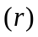 rescaled by the diameter of the gold nanoparticles (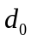), we estimate that complete interdigitation of the ligands takes place around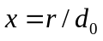= 1.3. The total interaction potential obtained in our calculations shows a minimum at about 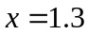 (see figure) with the depth of the potential well being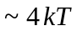. Brownian Dynamics simulation with this interaction potential shows formation of superlattices. The ‘superlattice constant’ of agrees quite well with TEM measurements of gold nanoparticle superlattices

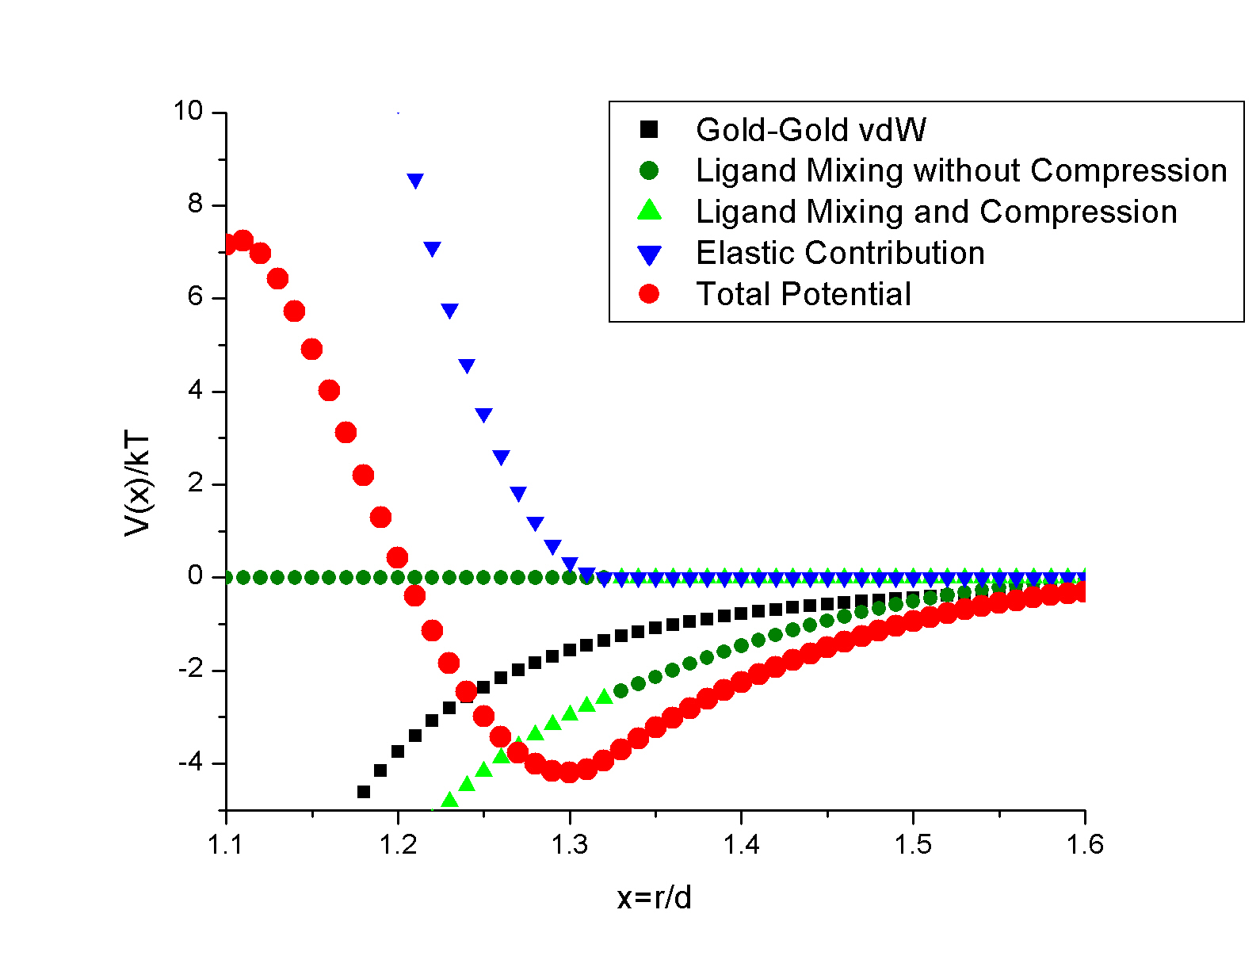
Fig. 3 Interaction potential vs. scaled NP-NP separation.

Contact: sor@phys.ksu.edu.

References
[1] S. Stoeva, K. J. Klabunde, C. M. Sorensen, and I. Dragieva, J. Am. Chem. Soc. 124, 2305 (2002).
[2] X. M. Lin, C. M. Sorensen, and K. J. Klabunde, J. Nanopart. Res. 2, 157 (2000).
[3] S. Stoeva, B. L. V. Prasad, S. Uma, P. K. Stoimenov, V. Zaikovski, C. M. Sorensen, and K. J. Klabunde, J. Phys. Chem. B 107, 7441 (2003).
[4] D. Heroux, A. Ponce, S. Cingarapu, and K. J. Klabunde. Adv. Funct. Mater., in press.

