Semiconductor Nanowire Electronics
NSF NIRT 0609282
PIs: Joan Redwing¹, Elizabeth Dickey¹, Mark Lundstrom², Theresa Mayer¹ and Suzanne Mohney¹
¹Pennsylvania State University, ²Purdue University

Introduction
The NIRT program involves a four-year collaborative effort focused on fundamental issues in the fabrication and device physics of group IV (Si, Ge, Si_{x}Ge_{1-x}) semiconductor nanowire-based electronics. The studies focus on two specific device types: field-effect transistors (NW FETs) and axial p-n homojunction diodes which are used as diagnostic structures to study scaling effects on device performance. The research on nanowire FETs tightly couples device modeling and simulation with detailed experimental studies to extract information on carrier mobility and scattering mechanisms in the low-field regime and to probe the transition from bulk to one-dimensional (1D) or quasi-1D behavior as the wire diameter is scaled down. Similar studies will investigate changes in diode properties with decreasing wire diameter in axial p-n homojunctions. The semiconductor nanowires are synthesized using a metal catalyzed vapor-liquid-solid (VLS) growth method and the synthesis experiments are combined with nanoscale characterization tools to examine size-related effects on nanowire growth and processing. The research results are anticipated to be broadly applicable both to scaled Si CMOS technology and the rapidly emerging field of nanowire-based devices. Potential areas of impact include future generation logic devices, high speed transistors, resonant tunneling devices, chemical and biological sensors and devices for solar and thermal energy conversion.

Research Accomplishments
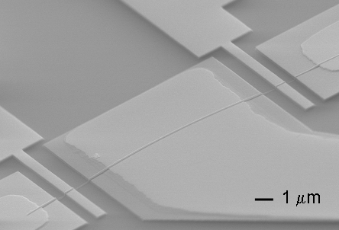
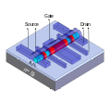
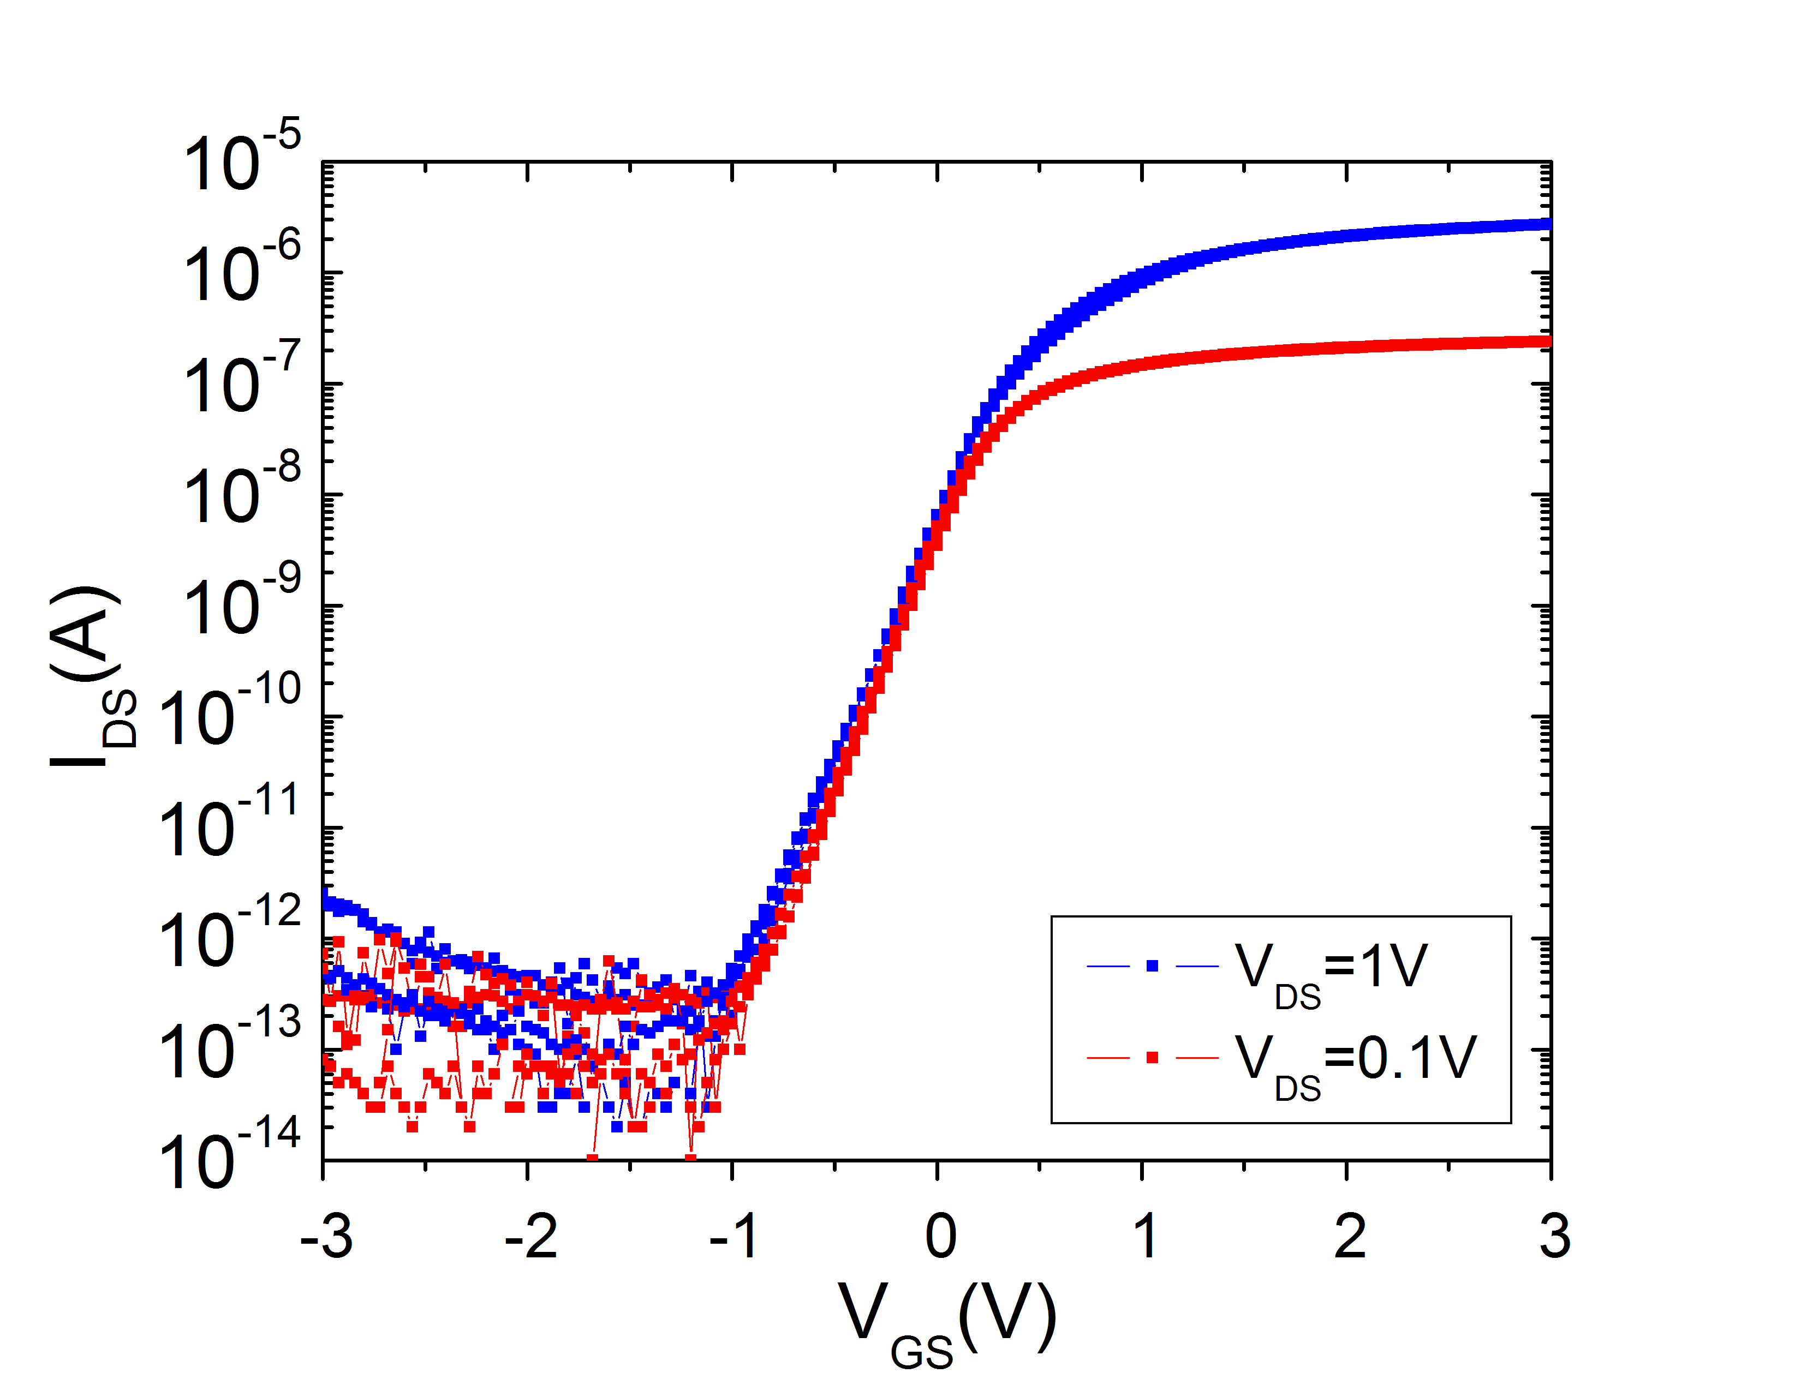
Over the past year, we successfully demonstrated that ~ 50 nm diameter thermally-oxidized, axially-doped n⁺-p⁻-n⁺ silicon nanowires (SiNWs) can be used to fabricate stable and reproducible gate-all-around NW-FETs that operate in the inversion-mode with high on-state current, on-off ratio and transconductance (Fig. 1). Measurements using back-gated test structures that probe separately the n+ and p⁻ NW regions confirm that radial deposition of n-type Si onto the p-channel region is prevented during growth of the second n⁺-SiNW segment, which is necessary for achieving large channel modulation with low source/drain resistance. We have also developed an electroless plating method to clearly delineate the n+ segments in the axial-doped NWs. The demonstration of carrier inversion in the NW channel represents a significant advance over prior depletion-mode SiNW FET devices, providing statistical data for device modeling that can be used to elucidate electrical transport properties (i.e. carrier mobility) and compare device performance across various platforms.
Fig. 1. (a) FE-SEM image of top-gated axial modulation doped n+-p-n+ SiNW FET and (inset) schematic drawing of device showing location of gate and source/drain contacts. (b) Subthreshold characteristics showing high on-state current and good on/off ratio for the n-channel (inversion mode) device.
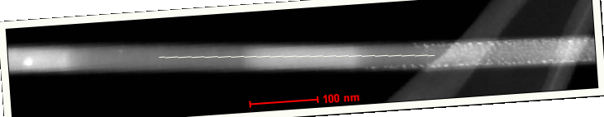

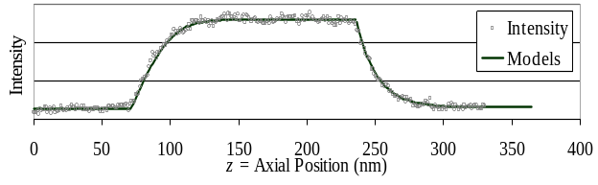
50 nm
Fitted
Si
Si_{1-x}Ge_{x}
GeH₄ on
GeH₄ off
Fig. 2 (top) Annular dark-field STEM image of a Si/Si_{1-x}Ge_{x} hNW comprised of Si_{1-x}Ge_{x} segments separated by Si segments grown for the same duration. (middle) Higher magnification ADF-STEM image of last SiGe segment and (bottom) corresponding intensity profile revealing asymmetric turn-on and turn-off transients for Ge.

Building on these promising device results, we have focused our attention on the synthesis, in-situ doping, processing and integration of small diameter SiNWs (<10 nm) which are needed in order to reach the 1D transport regime. The fabrication of semiconductor structures at this length scale is complicated due to size-dependent growth and processing phenomena which we are studying as part of our overall research effort. Our recent studies of the vapor-liquid-solid (VLS) growth of Si/Si_{1-x}Ge_{x} axial nanowire heterostructures reveal that both the Si and Si_{1-x}Ge_{x} segment lengths (and therefore the growth rates) decrease significantly with decreasing nanowire diameter. This behavior can likely be attributed to surface curvature-related phenomena (i.e. Gibbs-Thomson effect), which alters the chemical potential of species in the VLS growth process. We have observed that this effect gives rise to diameter-dependent alloy composition in the VLS growth of Si_{1-x}Ge_{x} NWs. In the growth of Si/Si_{1-x}Ge_{x} axial nanowire heterostructures, our studies reveal distinct “turn-on” and “turn-off” transients in the Ge composition at the heterointerfaces (Fig. 2) which are believed to arise as a result of the time that it takes to accumulate/deplete Ge from the liquid alloy catalyst.Error: Reference source not found The interfacial width in these structures was found to increase in proportion to the wire diameter due to the additional time required to change the composition of larger catalyst particles. We have also investigated processing and size-related effects in the thermal oxidation of SiNWs and observed a reduction in the rate of oxidation with decreasing wire diameter which arises from compressive stress normal to the Si-SiO₂ interface that slows the interfacial reaction between the oxidant and Si at the interface. Our research on nanowire synthesis, processing and integration allows us to simultaneously achieve two goals. First, we are able to provide insight into how size influences the processing of materials, which is important to the broader nanomaterials community. In addition, our work enables the fabrication of test structures that provide the opportunity to experimentally study the effect of decreasing wire diameter on transport in nanowire FETs.

In the area of device modeling, our efforts have focused on a comparison of 1D and two-dimensional (2D) Si MOSFETs in order to elucidate characteristic features of 1D transport. The device simulation work provides us with general guidance on the type of behavior that we may anticipate observing experimentally in small diameter (<10 nm) SiNW FETs. This work utilized a simple ballistic model for 1D and 2D MOSFETs based on the top-of-the-barrier approach. The results for model devices show that 1D and 2D transistors behave quite similarly if we assume perfect electrostatics. Distinctive features of 1D transport are difficult to observe at room temperature. The effects of bandstructure on the I-V and C-V characteristics of Si and InAs nanowire transistors were also examined using the sp³d⁵s tight-binding model. We find that bandstructure effects in 1D transistors are most distinctively reflected in the drain current vs. gate bias or transconductance vs. gate bias for low drain bias at low temperatures. Similar 1D effects may also be observed in nanowire C-V characteristics. These results provide some general guidance for observing 1D transport in ballistic NW transistors, but the role of scattering requires further study because scattering is also affected by dimensionality.

Education and Outreach
A mentoring program for middle school/high school girls was initiated at Penn State in January 2007. The middle school years have been identified as the time period over which girls “drop out” of math and science due to declining confidence in their abilities, which precedes a drop in achievements. A small group (~10) of seventh and eight grade girls from area middle schools were identified to participate in the program. During 2007, we held three outreach activities with the girls and the NIRT faculty members at Penn State – two hands-on workshops on smart sensors (February 2007) and nanofabrication (May 2007) and a field-trip to the Franklin Institute in Philadelphia (October 2007). Reizelie Barretto, a graduate student in science education, is assisting us with the development of workshop activities, coordination of events and communication with the girls and their parents. During the remaining three years of the NIRT program, a combination of science-oriented and social activities with the girls and the female faculty will be organized with the goal of establishing mentoring relationships. The type of activities will change as the girls move into high school and begin to focus on college and future careers. At the end of the program, the effect of sustained mentoring on girls’ attitudes and interests in science and technology will be assessed through surveys and their enrollment in advanced math and science courses in high school and plans for college.

References [?] T.T. Ho, Y.F. Wang, S.M. Eichfeld, B.Z. Liu, S.E. Mohney, J.M. Redwing and T.S. Mayer, manuscript in preparation.
[?] C.M. Eichfeld, C. Wood, B.Z. Liu, S.M. Eichfeld, J.M. Redwing and S.E. Mohney, Nano Lett. 7 (2007) p. 2642.
[?] T.E. Clark, P. Nimmatoori, K.K. Lew, L. Pan, J.M. Redwing and E.C. Dickey, submitted to Nano Letters.
[?] X. Zhang, K.K. Lew, P. Nimmatoori, J.M. Redwing and E.C. Dickey, Nano Lett. 7 (2007) p. 3241.
[?] B.Z. Liu, Y.F. Wang, T.T. Ho, K.K. Lew, S.M. Eichfeld, J.M. Redwing, T.S. Mayer and S.E. Mohney, submitted to Small.
[?] R.S. Kim, N. Neophytou, A. Paul, G. Klimeck and M.S. Lundstrom, submitted to J. Vac. Sci. Technol. B.
[?] A. Rahman, J. Guo, S. Datta and M.S. Lundstrom, IEEE Trans. Electron Devices 50 (2003) p. 1853.
[?] S. O. Koswatta, S. Hasan, M.S. Lundstrom, M.P. Anantram and D.E. Nikonov, IEEE Trans. Electron Devices 54 (2007) p. 2339.
[?] N. Reid, Int. J. Sci. Educ. 25 (2003) p. 509.

