NIRT: Active Nanostructure Enabled On-Chip Spectroscopy System for Cancer Detection
NSF NIRT Grant BES0608934
PIs: Won Park¹, J.-B. Lee², Lynne Bemis³ and Bill Robinson³
¹Department of Electrical & Computer Engineering, University of Colorado at Boulder
²Department of Electrical Engineering, University of Texas at Dallas
³School of Medicine, University of Colorado at Denver and Health Sciences Center

The ultimate goal of this project is to develop an on-chip spectroscopy system for cancer detection. The on-chip spectrometer consists of a tunable negative index lens, light source, photodetector and a microfluidic channel through which blood sample containing nanoprobes will be passed. The research activities are thus comprised of three different phases: development of tunable negative index lens, system integration and nanoprobes for gene detection.

Negative Index Photonic Crystal: Negative refraction is the key phenomenon to be used for both light collection and frequency selection in the proposed on-chip spectroscopy system. We propose to develop negative index lens based on photonic crystal (PC) structure. There are two distinct mechanisms through which PCs may exhibit negative refraction. One is through the second photonic band which exhibits negative slope in its dispersion diagram and the other is when the photonic crystal has giant anisotropy. We have experimentally demonstrated the lensing effect in the near-infrared region in both cases [1,2]. The PC structures were fabricated on a silicon-on-insulator (SOI) substrate by etching periodic array of holes along with input and output waveguides. Fig. 1(a) shows the PC structure for negative index imaging through the second photonic band. Fig 1(b) shows the far-field infrared image in which the bright spot after the PC indicates focusing. Furthermore, the inset shows the light output from the output waveguide array in which only the central waveguide is strongly illuminated. Fig 1(c) is another Si PC structure designed to exhibit negative refraction due to large anisotropy. The color pattern is the near-field image overlaid on top of scanning electron micrograph. The intense spot just inside the PC region shows the internal focus due to negative refraction. We have also investigated the phase front propagation in the PC and directly demonstrated the reversal of phase front curvature due to the large anisotropy. It was the first direct observation of phase front propagation in a PC structure.
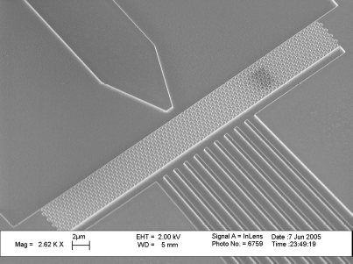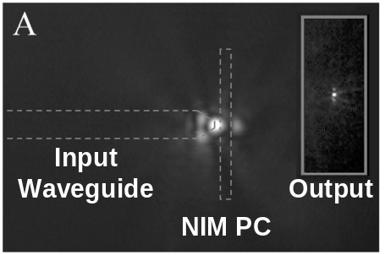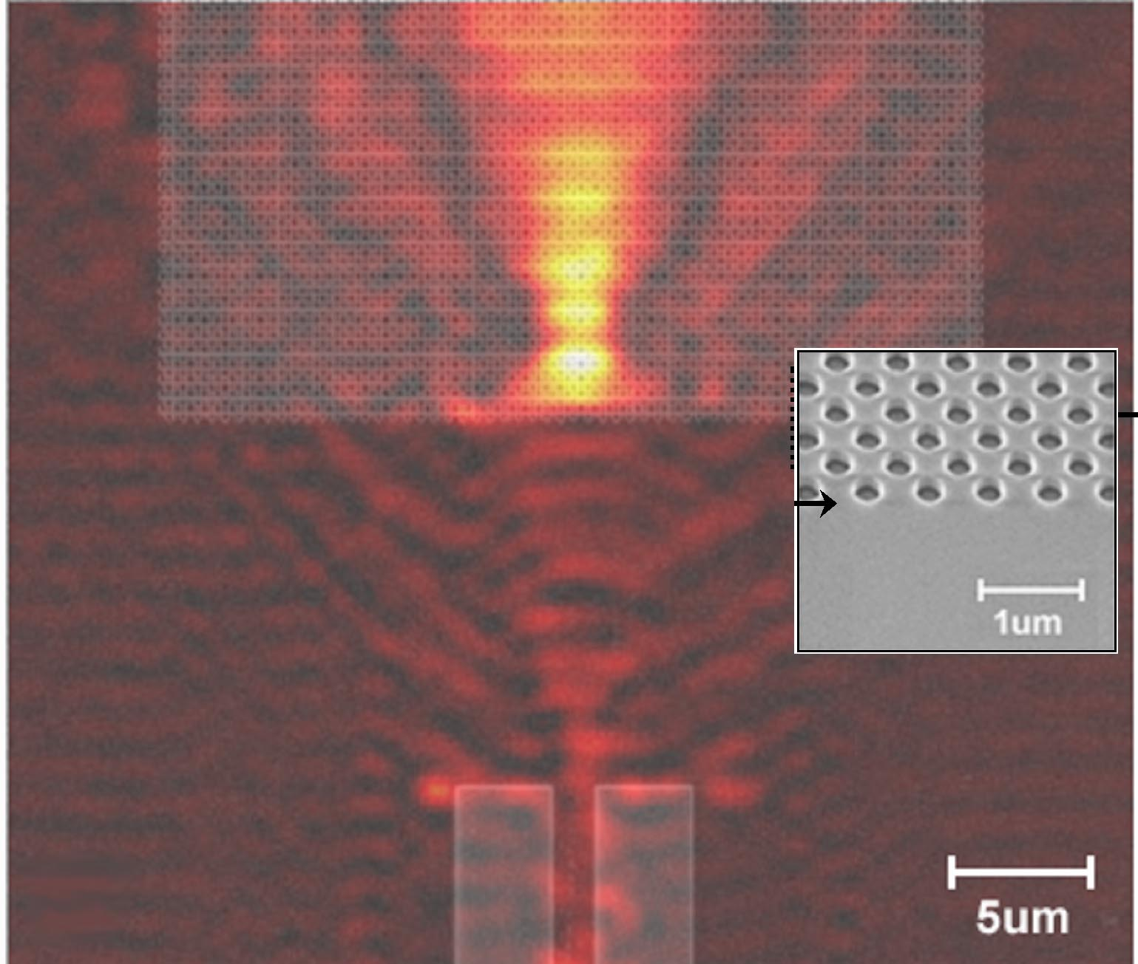
(a)
(b)
(c)
Fig. 1 (a) Scanning electron micrograph (SEM) of a negative index PC lens co-fabricated with input and output waveguides. (b) Far-field infrared image showing focusing due to negative index PC (Inset: Infrared image of output waveguide array in which only one waveguide is strongly illuminated.) (c) Near-field scanning optical micrograph image overlaid on top of an SEM micrograph of a Si PC exhibiting negative refraction due to large anisotropy.
Tuning the negative index imaging will be accomplished by adopting the mechanically tunable PC concept [3]. It takes advantage of the fact that the optical properties of a PC is strongly dependent on the structural design and symmetry and thus achieves wide tunability by exerting mechanical force to modify structural parameters.

Microfluidic Channel and System Integration: Heterogeneous integration of light source, photodetector and microfluidic channel with the negative index lens is critical for compact, integrated on-chip spectroscopy system. We designed and fabricated microfluidic channels for droplet manipulation technology. We have demonstrated the droplet manipulation test structure as shown in Fig. 2. Initial structures suffered electrolysis damage after a few cycles of operations. This problem was solved by using both high quality and thinner insulating layer along with a combination of optimal surface coatings. With these improvements, operational voltage has been substantially lowered (by a factor of 2) and the electrolysis is no longer a problem. Up to this point, the droplet manipulation was demonstrated with water. The next logical step would be testing of the droplet manipulation for blood samples or blood-like liquids to be ready for the monitoring of the cancer specific DNA-hybridized blood samples.
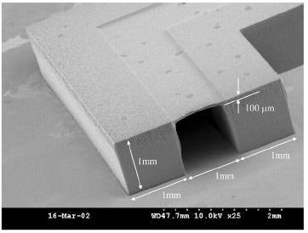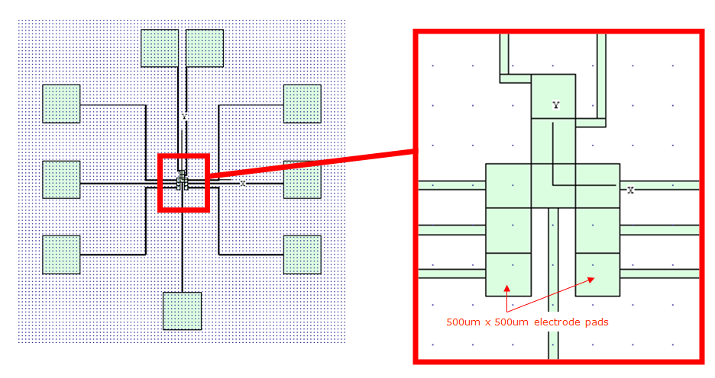
(a)
(b)
Fig. 2 (a) SEM image of lithographically fabricated SU-8 microfluidic channel (b) Schematic diagrams for the droplet manipulation test structures.

In the area of system integration, a tunable photonic crystal structure was fabricated and integrated with micro-heater, as shown in Fig. 3. The Si-based PC was designed to select transverse-magnetic (TM) polarization, acting as a polarizer. The PC fabrication was done by focused ion beam (FIB) and reactive ion etch (RIE) while the micro heater was fabricated using UV lithography technique. Alignment between the nano-patterned structures with the UV lithography, which is a critical task in the proposed system integration has been successfully achieved. Also, vertical cavity surface emitting laser has been successfully integrated by the heterogeneous integration process. A similar process will be used for photodetector too.
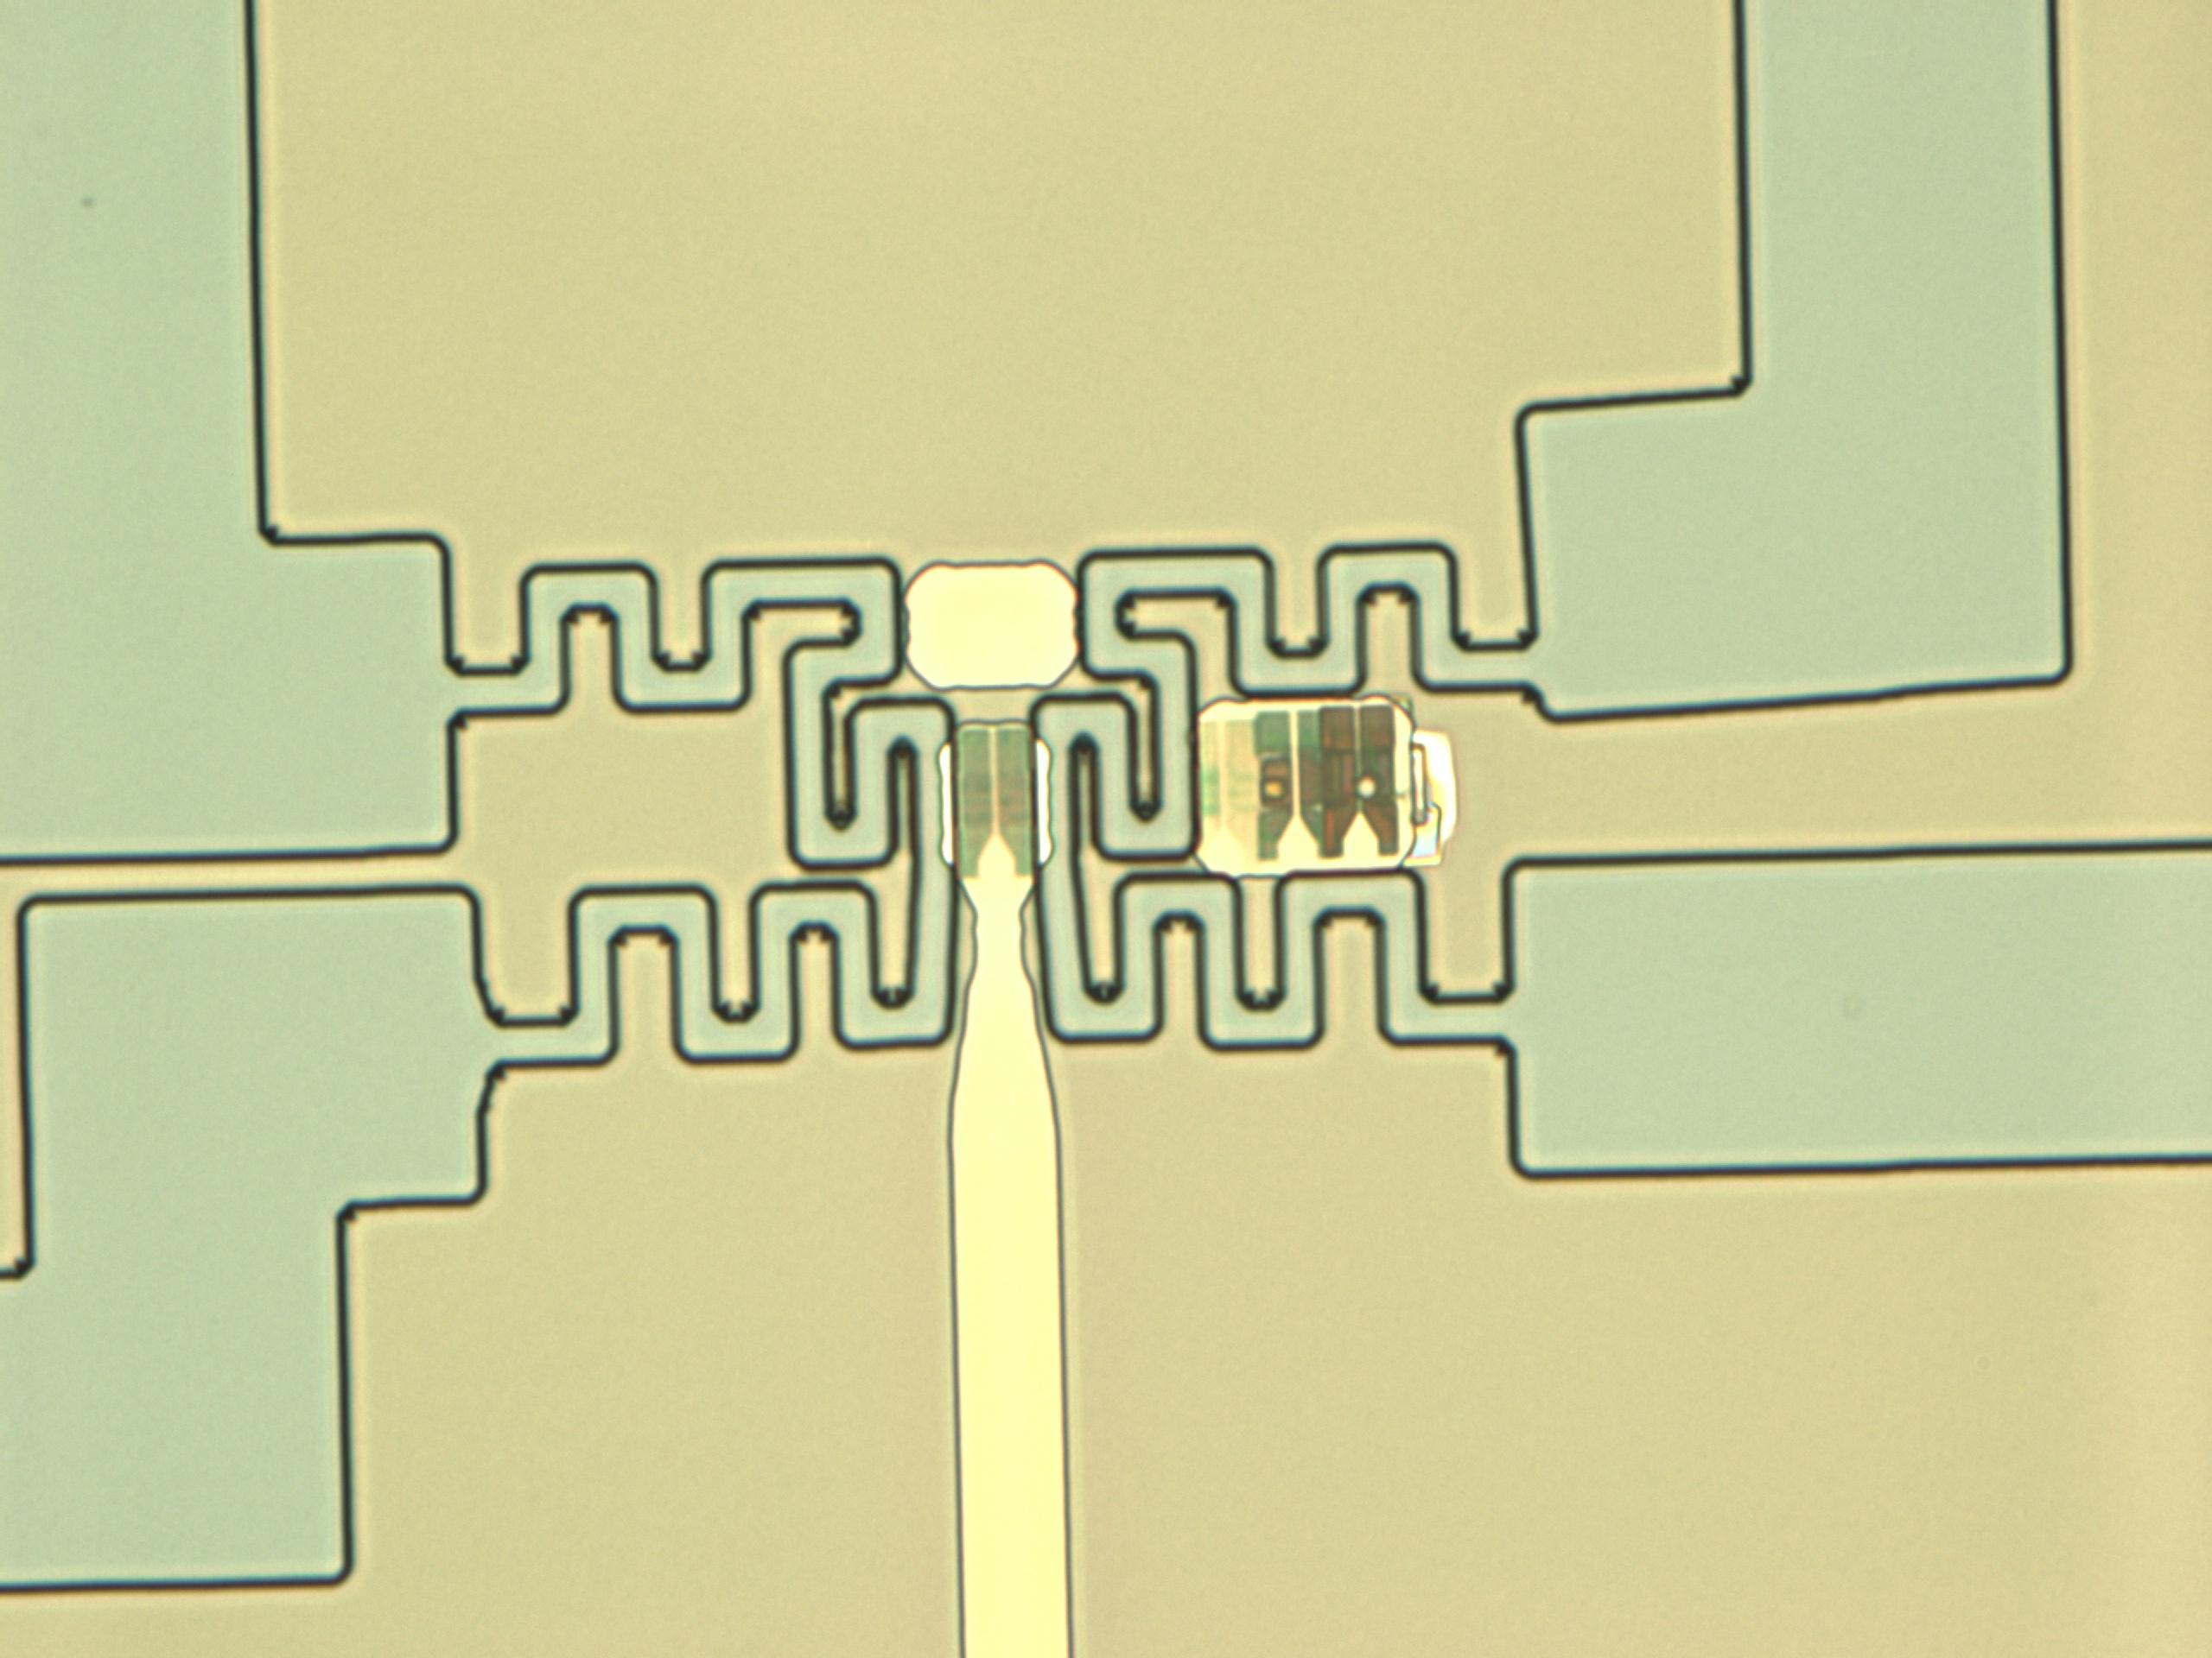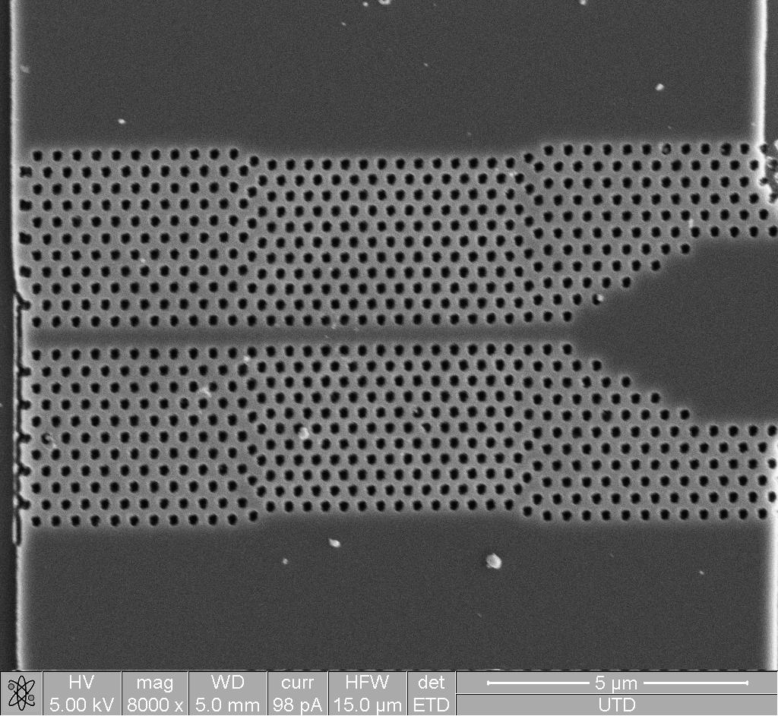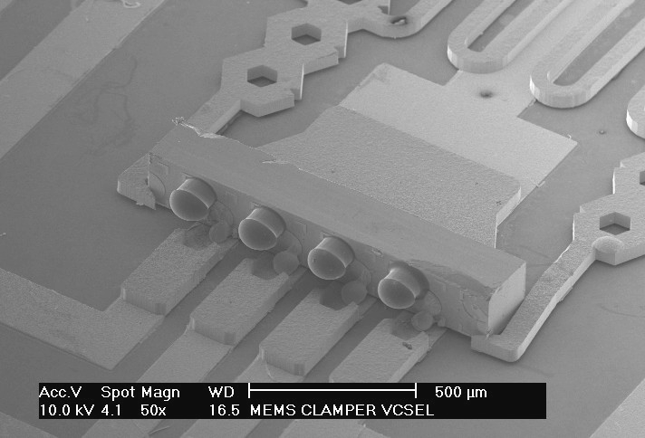
Input waveguide
Output waveguide
TM polarizer
4.9 μm
(a)
(b)
Fig. 3 (a) Micro heater integrated photonic crystal light modulator. (b) Heterogeneously integrated vertical cavity surface emitting laser.
Nanoprobes for DNA detection: Malignant melanoma is the most rapidly increasing cancer throughout the world. Current methods for detection of metastatic malignant melanoma are not adequate. At least 20% of patients develop advanced disease, which is rarely curable. In this proposal we are applying the use of nanoparticles for cancer detection. We specifically target BRAF, one of the most commonly mutated genes in melanoma. BRAF is mutated in as many as 70% of melanoma cases. Detection of BRAF mutations is thus necessary for determining which patients will respond to therapeutics targeting melanoma cells that harbor BRAF mutations.

We synthesized gold nanoparticles, nanoshells and nanorods by the solution-based techniques. The synthesized nanomaterials exhibited well-defined sizes and their optical extinction spectra were in excellent agreement with the Mie theory. They are then conjugated with oligonucleotides targeting mutated BRAF. The conjugated nanoparticles maintained the strong plasmon resonance, which is optically detected and monitored in the subsequent hybridization process. We then conducted hybridization experiments with 49 base-long single stranded primers which are exactly complementary to the primers attached to the gold nanoprobes. As the primers hybridize with one another, the gold particles begin to agglomerate, resulting in a peak shift in the optical spectrum, as shown in Fig. 4(a). This work is currently being extended to longer, double-stranded targets, which resemble more closely the actual genes in patient samples.
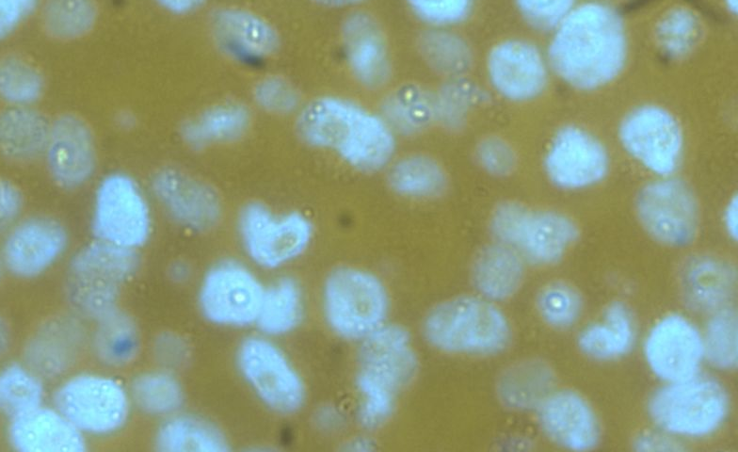
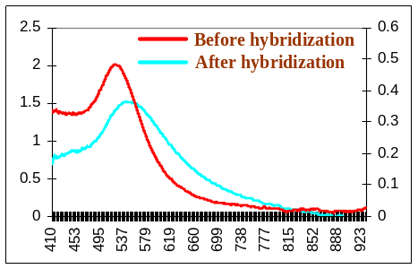
(a)
(b)
Fig. 4 (a) Optical extinction spectra taken before and after the hybridization experiments with the 49-bases long target strands. (b) Optical micrograph of melanoma cells treated with BRAF mutant specific nanoprobes, which are seen as bright spots inside the cells.

It would be helpful in the clinic if we could use the nanoparticle approach to identify which cells in a given tumor sample actually harbor the BRAF point mutation. For this, we initially used cells known to harbor specific alterations in BRAF and queried with nanoprobes. At the single particle direct labeling we could not identify those cells with a mutation. However, when we added a second round of nanoparticles that would bind in multiple places to the first probe we were able to clearly see hybridization in the mutant cells with the mutant specific nanoprobe and not with the normal BRAF nanoprobes as shown in Fig. 4(b). The detection of BRAF genes in both blood samples and cells will be further optimized and eventually used in the on-chip spectroscopy system.

References
[] E. Schonbrun, T. Yamashita, W. Park and C. J. Summers, “Negative Index Imaging by an Index-Matched Photonic Crystal Slab”, Phys. Rev. B 73, 195117 (2006)
[2] E. Schonbrun, Q. Wu, W. Park, M. Abashin, Y. Fainman, T. Yamashita and C. J. Summers, “Wavefront Evolution of Negatively Refracted Waves in Photonic Crystals”, Appl. Phys. Lett. 90, 041113 (2007)
[3] W. Park and J.-B. Lee, “Mechanically tunable photonic crystal structures”, Appl. Phys. Lett., 85, 4845 (2004)

