NANO HIGHLIGHT
Nanostructured Catalysts for Fuel Cells
NSF NIRT Grant CBET-0709113
PIs: Chuan-Jian Zhong (PI)¹⁾, Susan Lu²⁾, Bahgat Sammakia³⁾, Lichang Wang⁴⁾
Department of ¹Chemistry, ²Systems Science and Industrial Engineering, ³Mechanical Engineering, State University of New York at Binghamton, NY 13902; ⁴Department of Chemistry & Biochemistry, Southern Illinois University at Carbondale

The goal of this research program is to establish the fundamental correlation between the nanostructural parameters (size, shape, composition, phase, surface, etc.) and the electrocatalytic properties (activity and stability) that enables the ultimate application of fuel cell technology^{[1]}. For example, the nanoscale alloying and phase segregation of gold-platinum nanoparticles have been shown to depend on a combination of particle size, bimetallic composition, preparation condition, and support materials (Fig. 1A) ^{[2]}. The change from alloying at a lower temperature of thermal calcination to partial phase segregation at a higher temperature has been shown to exhibit a significant effect on the electrocatalytic activity and stability for oxygen reduction reaction (ORR) (Fig. 1B) ^{[2a]}, and the fuel cell performance ^{[2b]}.
(A) 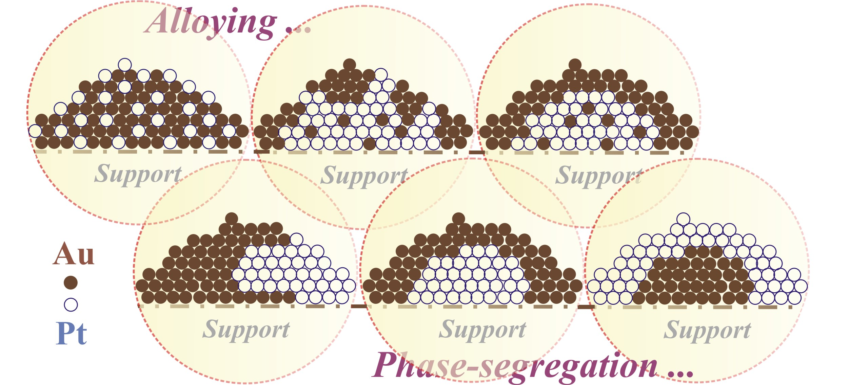 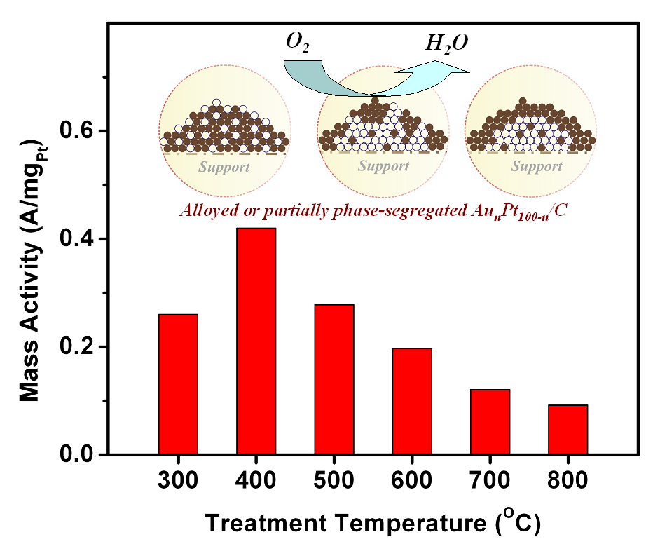 (B)
Figure 1. (A) Nanoscale alloying and phase segregation; (B) Mass activity vs. the calcination temperature.

In another example from the investigation of nanoscale shape effect on the catalytic activity, chromium-assisted synthesis of platinum nanocubes was developed as a novel strategy for shape-engineering of electrocatalysts (Fig. 2A). The presence of significant (100) faces in the platinum nanocubes was demonstrated to be partially responsible for the increase in the specific activity for ORR (Fig. 2B) ^{[3]}.
(A) 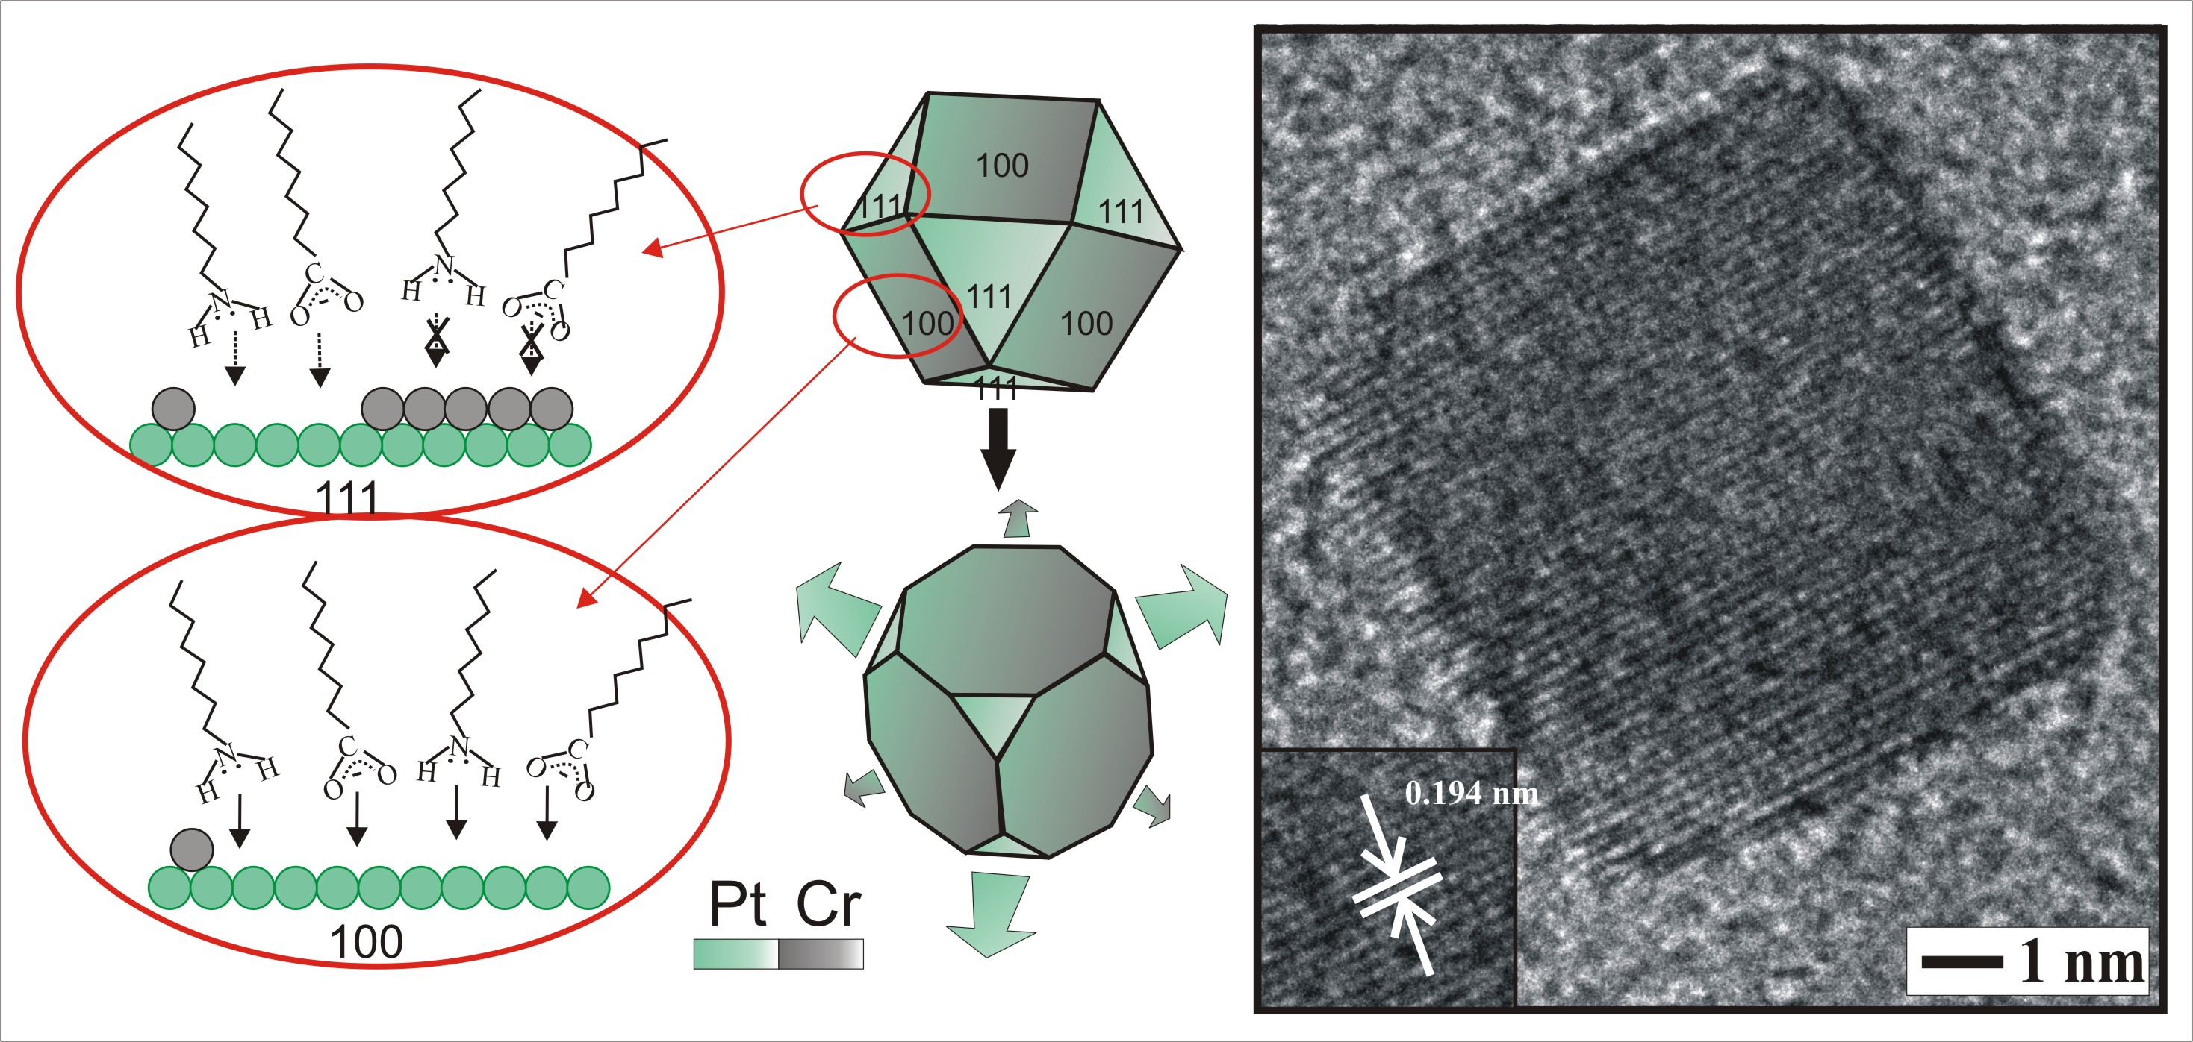 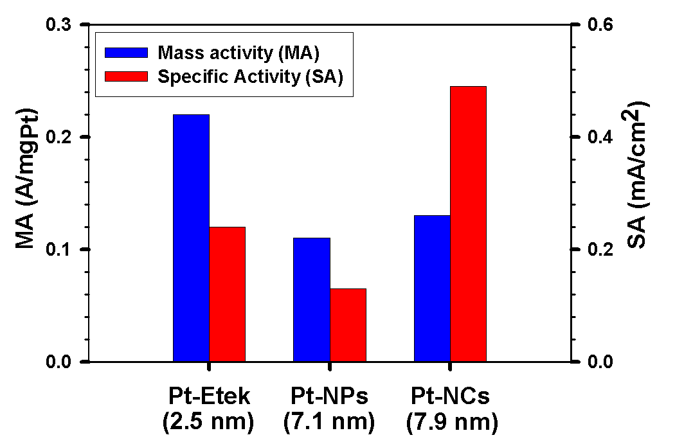 (B)
Figure 2. (A) Cr-assisted synthesis of Pt nanocubes. (B) Comparison of electrocatalytic activities for .ORR.

In addition, the nanoscale strain in the multimetallic nanoparticle catalysts ^{[4]} has also been shown to display a significant effect on the electrocatalytic activity. The detailed understanding of the results constitutes the basis for advancing fuel cell technology, an important area for the global drive to energy independence from fossil fuels and green energy.

References
- C. J. Zhong, et al, Nanotechnology, 2010, 21, 062001.
- (a) B. N. Wanjala, et al, Chem. Mater., 2010, 22, 4282. (b) B. Fang, et al, J. Power Sources, 2011, 196, 659.
- R. Loukrakpam, et al, Chem. Comm., 2010, 46, 7184-7186.
- B. Wanjala, et al, J. Phys. Chem., C. 2010, 114, 17580.

