NANO HIGHLIGHT

Large-area Nanocontact Printing Using Metallic Nanostencils
NSF NSEC Grant 0647560
PI: Teri W. Odom
Northwestern University

Advances in nanocontact printing methods can increase the effectiveness of biological assays and electronic circuits as well as generate model substrates to study cell adhesion and cell proliferation mechanisms. The development of molecular printing techniques that can achieve dense arrays of sub-100 nm patterns has been driven by scientific interest in new physical and chemical properties at the nanometer scale. Significant effort has been devoted to improving high resolution, self-assembled monolayer patterning methods such as microcontact printing and dip pen nanolithography. Printing large-area arrays of molecules where both the feature size and pitch are on the nanometer scale is still a challenge, however, due to lateral diffusion of the molecular inks.

This group of NU-NSEC researchers have focused on developing nanoscale contact printing methods that can achieve large-area arrays of molecular patterns with both high-density (400-nm spacing or less) and high-resolution (down to 50-nm features). Nanostencil masks—gold films of nanohole arrays attached to a flat slab—were used to improve the resolution of printed molecular patterns. The solid portion of the gold hole array film acted as a vapor transport barrier and the nanohole areas determined the size and shape of the patterned molecules. Using nanohole films of different thicknesses, the group controlled whether the nanostencil masks printed edge patterns or 1:1 patterns. Nanostencil masks are reusable and mechanically robust and offer a new platform for the inexpensive, scalable production of functional nanostructures.
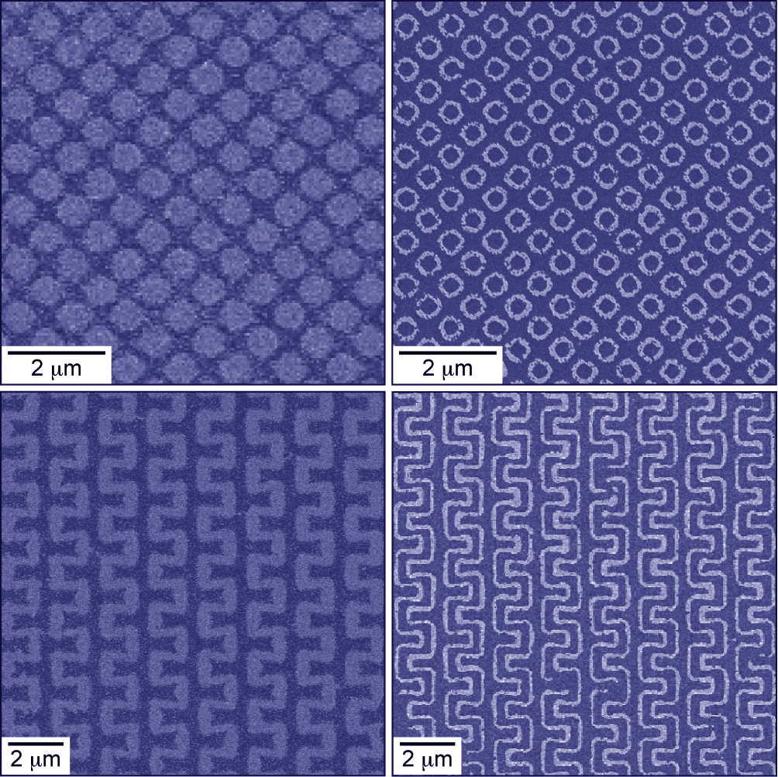
Gold nanopatterns after molecular printing and etching using nanostencil masks.
Credit: Teri Odom, Northwestern University

Reference
[1] For further information about this project link to www.nsec.northwestern.edu or email nanotechnology@northwestern.edu
[2] M.H. Lee, J.Y. Lin, and T.W. Odom. Angew. Chem. Int. Ed., 2010, 49, 3057-3060.

