Center for Nanoscale Chemical-Electrical-Mechanical-Manufacturing Systems (Nano-CEMMS)
NSF NSEC Grant 0749028
Placid M. Ferreira, Director
Dept. of Mechanical Science and Engineering
University of Illinois Urbana-Champaign
Urbana, IL 61801

Abstract: The Center for Nanoscale Chemical-Electrical and Mechanical Systems is a NSF-sponsored Nanoscale Science and Engineering Center (NSEC) that is focused on developing the science and engineering of processes, tools and systems for manufacturing at the nanoscale along with the human resources to enable it. Established in September of 2003 and renewed in 2008, Nano-CEMMS is a partnership between North Carolina A&T, Northwestern University, Notre Dame University, Stanford, University of California at Irvine and the University of Illinois at Urbana Champaign.
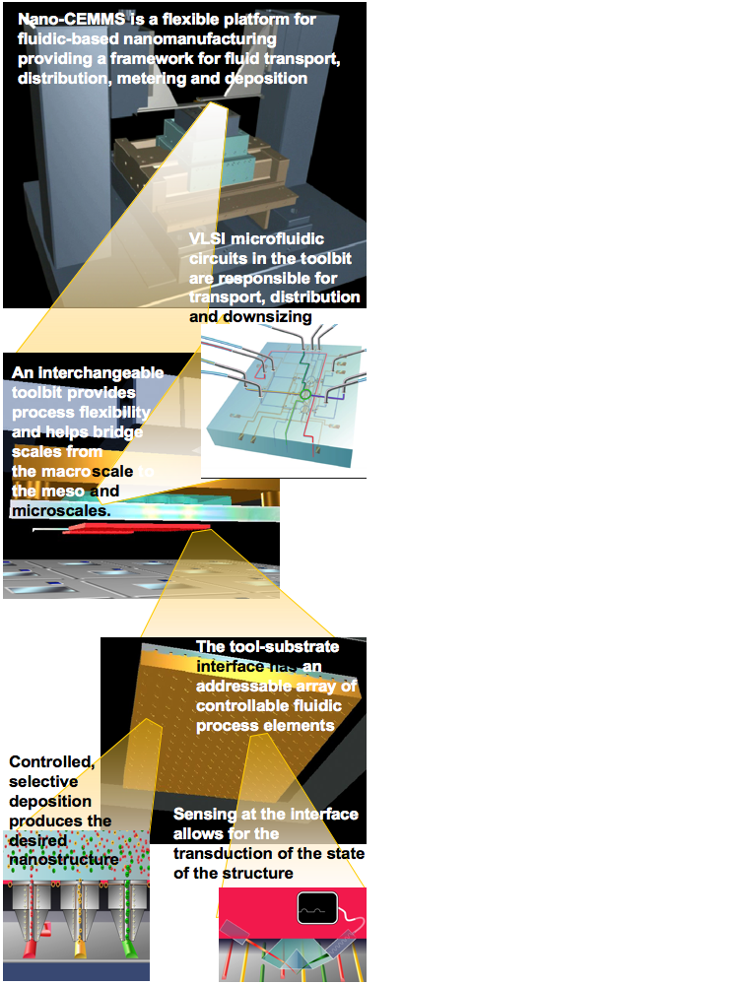
Figure 1: Schematic of the different scales & subsystems in the Nano-CEMMS Platform.

1. Introduction
The vision of the Nano-Chemical-Electrical-Mechanical Manufacturing Systems (Nano-CEMMS) Center ^{[1]} is to make the most basic elements of manufacturing, transcription of matter and the transduction of its state, a practical reality at the nanoscale. Therefore, its mission is to: (a) Explore and develop new methodologies and tools that exploit chemical, mechanical and electronic phenomena and processes for 3-D manufacturing at the nanoscale; (b) Create viable technologies that integrate nanoscale manufacturing methodologies into scalable, robust and cost-effective operational systems for manufacturing devices and structures at larger length scales; and (c) Develop diverse human resources to enhance the scientific research, education, and industrial nanotechnology workforce the country.
The programs within the Center concentrate on two main areas (a) Research and (b) Education and Outreach. The Center integrates the work of roughly 21 faculty (from 7 disciplines), 4 post-doctoral researchers, 25 graduate students, 17 undergraduate students and 6 staff members into a number of cross-disciplinary research projects with strong components of education and outreach.
2. Research
Nano-CEMMS’ strategic research vision is to explore and exploit fluidic and ionic transport phenomena at the nanoscale to create a fundamentally new manufacturing paradigm to enable nanoscale heterogeneous integration. If a fundamentally new manufacturing paradigm is possible, then nanoscale fluidics, rich in efficient and tunable transport, is an obvious domain in which to begin. Therefore, the Nano-CEMMS primary strategic goals are to:
Goal 1 – Explore and characterize nanoscale fluidic or ionic transport and phenomena to increase the knowledge of fluid-material-structure-field interactions, for the purpose of creating new approaches to manufacturing at the nanoscale. This goal is addressed by Thrust 1 – Micro-Nano Fluidics.
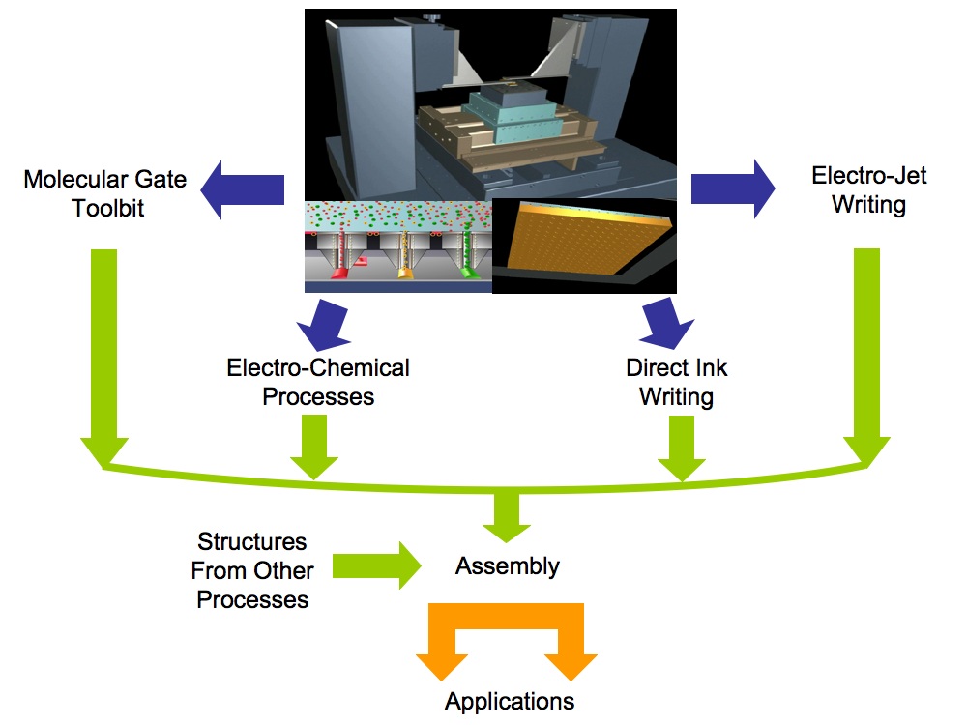
Figure 2 The Nano-CEMMS manufacturing strategy integrates fluidics-based processes with an assembly process to create a manufacturing pathway to heterogeneously integrated products.
Goal 2 – Develop and extend the basic technology infrastructure required in a manufacturing process (such as sensing, positioning, microfabrication tooling, and micro-nanofluidics) beyond the current state-of-the-art to support fluid and ionics-based manufacturing at the nanoscale. This goal is addressed by Thrust 2 – Nanoscale Sensing and Positioning and Fabrication.
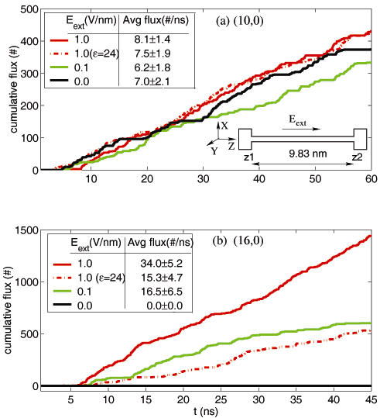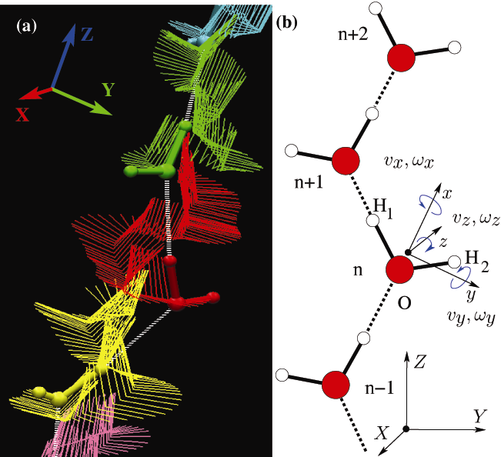

Figure 3: Cumulative flux of water molecules crossing the tube as a function of time for (a) (10, 0) and (b) (16,0) CNTs for various values of E_{ext}. (right) (a) Trajectory of water molecules in a (10,0) (E = 0 V/nm) CNT. Each color represents a water molecule’s trajectory for 1.9 ps. The ball-stick models (various colors) denote the position of water at t=0. (b) Schematic of a single file water with body centered principal axes frame xyz and the fixed box reference frame XYZ.
Goal 3 – Combine the results of basic exploration of nanoscale fluidic transport and phenomena in a new nanomanufacturing modality and merge these capabilities into an integrated set of processes for nanomanufacturing, addressed by Thrust 3 – Manufacturing Processes and Systems.
Goal 4 – Demonstrate how the new manufacturing processes being developed (i) produce new routes to heterogeneous integration in electronics, optoelectronics and microfluidics, with capabilities at the nanoscale; and (ii) create new capacity to support specific testbed applications. This goal is addressed by Thrust 4 – Applications and Testbeds.
To integrate these goals, Nano-CEMMS uses a manufacturing platform depicted in Figure 1. Figure 2 shows how the basic scheme underlies a set of processes and assembly mechanisms for heterogeneous integration, enabling broad material coverage, nanoscale resolution capabilities and flexibility in the geometries, from flat to full three-dimensional layouts. The vision of a fluidic and ionic-based nanomanufacturing platform includes developing physical realizations of the manufacturing processes in configurations that enable high throughput, high resolution, flexibility, robustness and high yield, via positioning platforms, embedded sensing, and localized control arrays of process elements and interchangeable toolbits. Research teams within Nano-CEMMS have made significant progress with respect to each of the goals. Since inception the Center has made 32 patent disclosures of which 23 have been filed. Last year alone, researchers in the Center published 103 journal papers and 95 conference papers. For example,
- In the past year, Aluru has explained the extraordinarily fast transport of water in carbon nanotubes (CNTs) observed in recent experiments and generally attributed to the smoothness of the CNT surface ^{[2]} (See Figure 3). Using molecular dynamics simulations, Aluru has investigated water flow in (16,16) CNTs and showed that the enhanced flow rates over Hagen-Poiseuille flow arise from a velocity “jump” in a depletion region at the water nanotube interface and that the water orientations and hydrogen bonding at the interface significantly affect the flow rates.
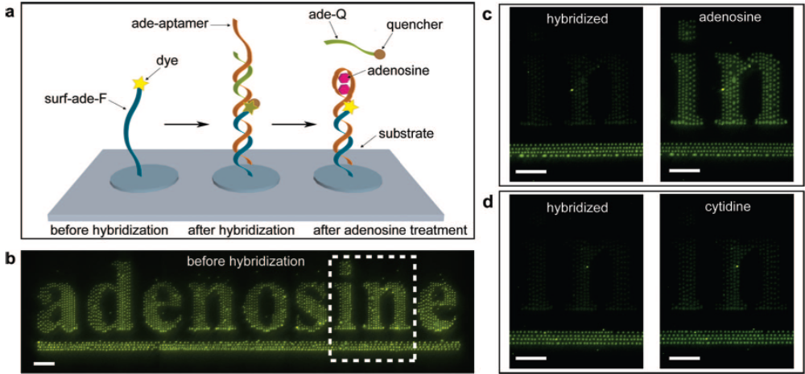
Figure 4: A biosensor to detect adenosine (Scale bars indicate 50 μm). (a) Schematic depiction of the working of the sensor, (b) E-jet printed ss-DNA with a fluorophore, (c) when hybridized by its complementary strand with a quencher and the aptamer. The aptamer reacts with an adenosine molecule when the adenosine is present, causing the quencher-strand to be separated from the e-jet printed strand producing bright fluorescence again. (d) The specificity of the sensor is evident by the lack of fluorescence in the presence of cytidine.
.

- Electro hydrodynamic printing is a center developed manufacturing processes and has been used to demonstrate the fabrication of a DNA aptamer-based biosensor. DNA aptamers are oligonucleic acid molecules that bind only a specific target molecule. Since they are more stable against biodegradation and relatively easy to obtain, compared with antibodies, the aptamers have become prime candidates as sensors in a number of applications, especially for medical diagnostics. The Rogers and Lu team ^{[3]} fabricated a biosensor to detect adenosine using the DNA aptamer. (It has been known that adenosine causes transient heart block in the atrioventricular node, lightheadedness, diaphoresis, or nausea.) Figure 4(a) shows a schematic of the working of the sensor. After e-jet printing the ss-DNA labeled with a fluorophore (Figure 4(a)), its complementary strand with quencher and the aptamer were hybridized together (dark fluorescence in Figure 4(c)). The aptamer reacts with an adenosine molecule when the adenosine is present, which causes the quencher-strand to be separated from the e-jet printed strand (bright fluorescence), as shown in Figure 4(c). Since the aptamer does not react with other molecules, for example cytidine, the fluorescence intensity does not brighten significantly (Figure 4(d)). The center will continue developing such sensors and integrating them further with the other sensing modes. By printing different DNA probes in different patterns, such biosensors can check for the presence of multiple proteins with built in read-out capabilities.
3. Education and Outreach
The broader mission of the Center involves advancing education in nanoscience and technology, and developing diverse human resources in science and engineering in general and nanomanufacturing in particular. A solid HRD program infrastructure supports programs for pre-college, undergraduate, and graduate students, as well as teaching professionals. Components aimed at increasing diversity are embedded in all facets of the Center.
Since the Center’s inception, 11 new courses based on Center research have been taught at UIUC and NCA&T. 10 other courses (6 at UIUC and 4 at NCA&T) have also been modified to incorporate findings from the Center’s research. Last year 8 Ph.D. and 15 M.S students graduated, and 8 REU students participated in the Center. Additionally, 1260 and 3,928 middle and high school teachers and students respectively attended Center institutes, workshops, and programs. Nationwide, 1,260 students used classroom learning modules developed by the Center.
The Center collaborates with several collegiate, state, and national organizations concerning the evaluation and funding of its educational outreach programs. Evaluations of all education and outreach activities are conducted by faculty and staff from the Departments of Education at UIUC and NCA&T. The budget of the Center’s education program has been leveraged through collaborations with the Illinois State Board of Education for the development and delivery of teacher education programs, funds from private foundations, and monetary support from Project Lead the Way.
4. Summary
In the six years since its inception, Nano-CEMMS has developed into a vibrant, interdisciplinary research and education environment. Tangible results of this integrated environment are evident from its ability to leverage funds from other agencies and industry. The productivity of the environment is visible in the number of publications (338) with more than half published with two or more Center researchers, and the number of patents (23 applications). The Center has graduated 19 PhD and 33 MS students and this number is expected to increase steadily.
5. References
[1] http://www.nano-cemms.uiuc.edu/
[2] S. Joseph and N. R. Aluru, “Pumping of confined water in carbon nanotubes by rotation-translation coupling”, Physical Review Letters, Vol. 101, No. 6, Art. No. 064502, 2008.
[3] Jang-Ung Park, Jung Heon Lee, Ungyu Paik, Yi Lu, and John A. Rogers, “Nanoscale Patterns of Oligonucleotides Formed by Electrohydrodynamic Jet Printing with Applications in Biosensing and Nanomaterials Assembly,” Nano Lett. 8, 4210–4216 (2008)

