The Nano/Bio Interface Center

The University of Pennsylvania
Director: Dawn Bonnell, Associate Director: Yale Goldman

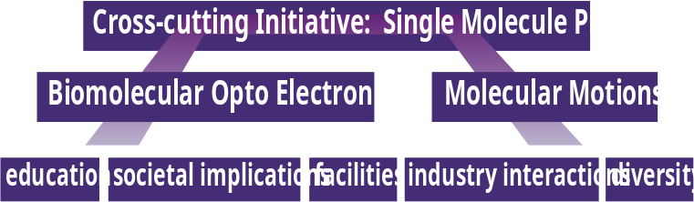
The Nano/Bio Interface Center unites investigators from ten disciplines to elucidate fundamental interactions of molecules at physical interfaces that enable technologies in biomedicine and energy. The research informs the development of new Probe Facility, as well as a portfolio of educational and outreach activities aimed at K-12 education in the Philadelphia School System.

Research Teams focus on biomolecule-nanostructure hybrids and mechanical motion of proteins at the molecular level. A Cross Cutting Initiative develops the single molecule probes by combining near field optical probes with mechanical and electronic probes. Each theme has a strong fundamental component and obvious technological impact that ranges from nanoelectronics to medical diagnostic devices.

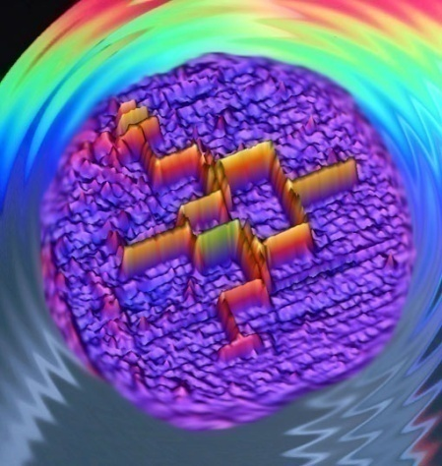
Several recent exciting research advances characterize the activity of the NBIC Research. The Bio optoelectronics team has designed new prophyrin and peptide based molecules that are optically active. Ferroelectric Nanolithography is used to pattern hybrid structures of these new molecules with nano particles, tubes, and dots. An emergent phenomenon in which surface plasmons are transduced to molecular electrical conduction was discovered. This result suggests a new family of efficient photo voltaic devices.

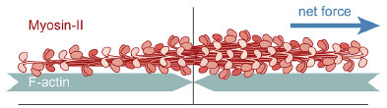
The Molecular Motion team used microfluidic devices and directed assembly to construct environments in which motor proteins encounter increasing complexity and constraint. They directly measured the manner in which proteins overcome (move past) obstacles. This leads to a better understanding of how protein motors operate in realistic cellular systems.

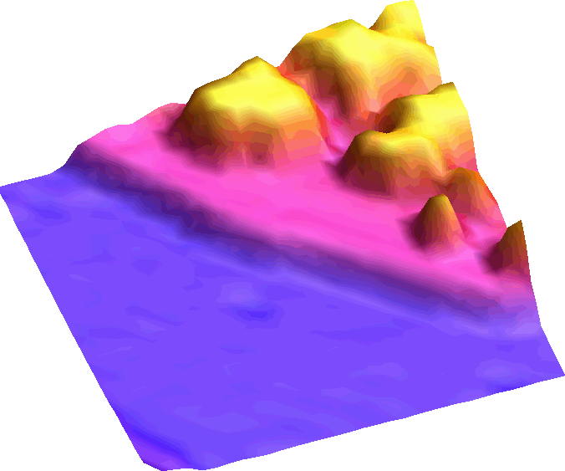

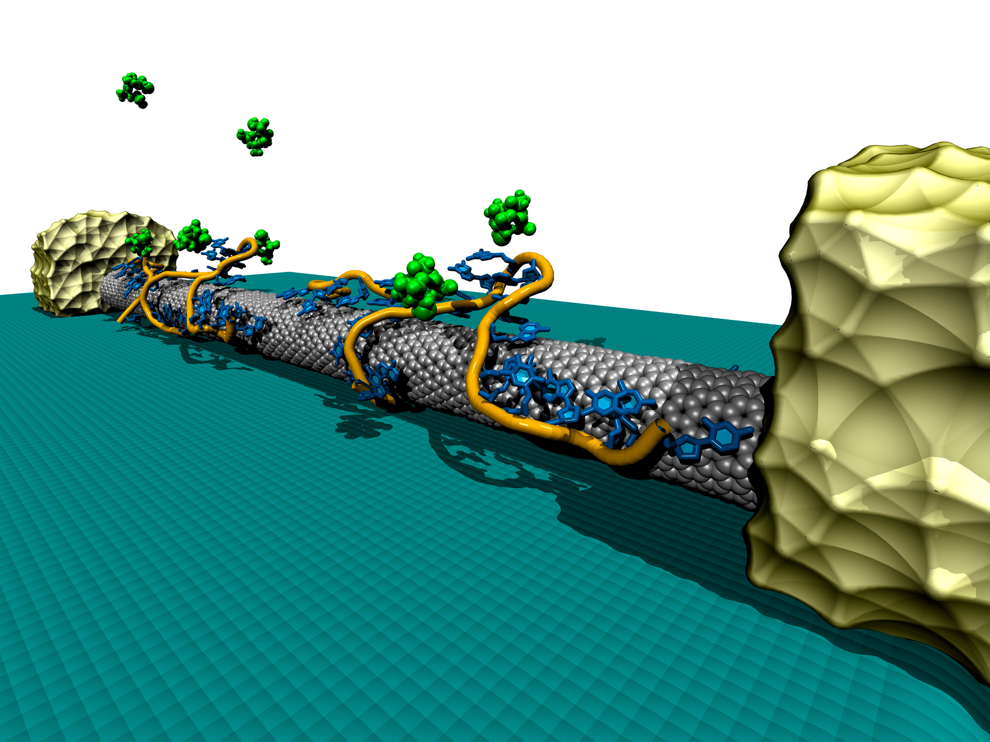
The Cross-Cutting Initiative recently demonstrated that the dielectric properties of a single molecular layer can be determined with scattering near field microscopy and that the specific orientation of the molecules has a large influence on the electrical potential of such an interface. A new experimental approach to 3-D optical tomography was suggested by inverse scattering theory. These physical measurement advances are part of the NBIC probeportfolio in metrology, which is a prerequisite not only to advancing new frontiers in science but in reliable manufacturing at the nanoscale.

Education, Outreach, and Internationalization

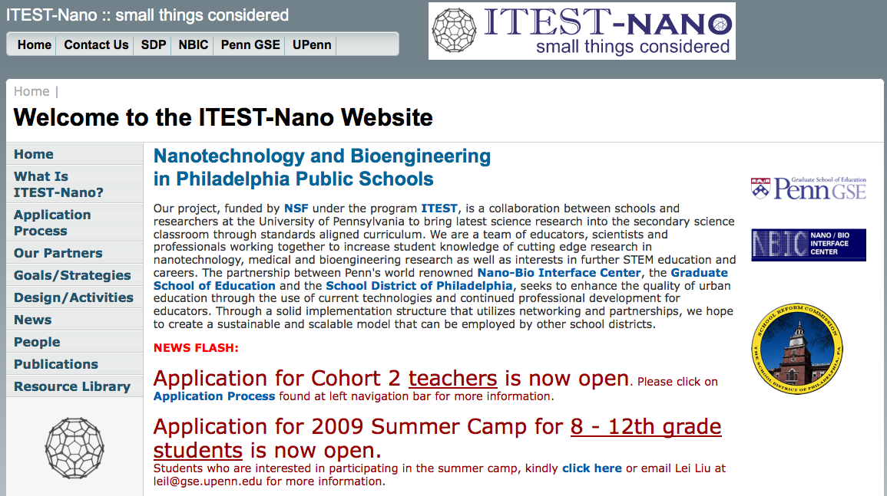
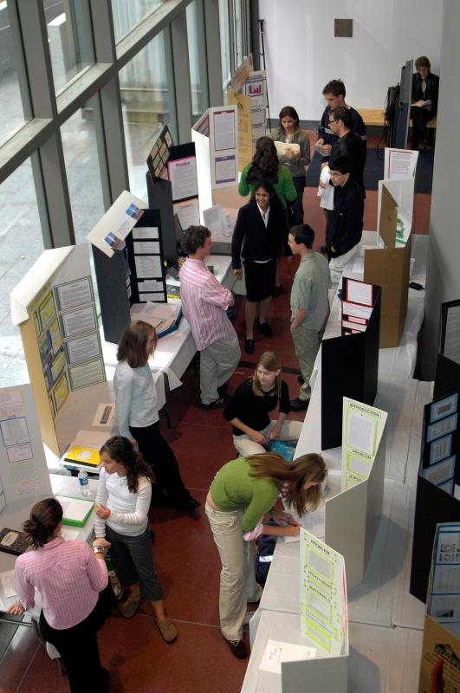
The NIBC engages the local community in several forums. Professional development activities for teachers are held at high schools that serve under represented populations, 87 RET teachers impact over 9000 students in the Philadelphia school system, 10 classroom kits were developed. NanoDay@Penn has engaged over 550 student visitors, 130 science fair projects, 45 exhibits designed by grad students, with multimedia nanotechnology presentations and a new Nanotechnology Film Festival. A summer academy course on Nanotechnology for high school students has graduated over 120 students. A new partnership with the graduate school of education and School District of Philadelphia , ITEST-Nano, brings the latest scientific and technologic tools to the classroom in standards aligned curriculum.

An undergraduate minor, graduate certificate and, new in 2009, a masters degree in nanotechnology have been established. May 2009 saw the first graduates of undergraduate minor program. The NBIC faculty continue to lead in curriculum development.
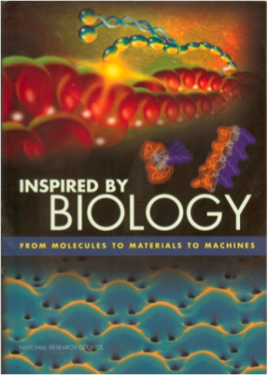
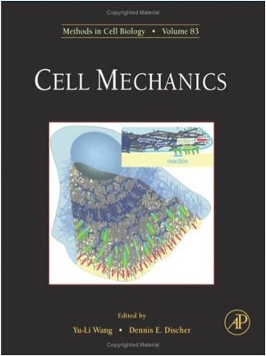
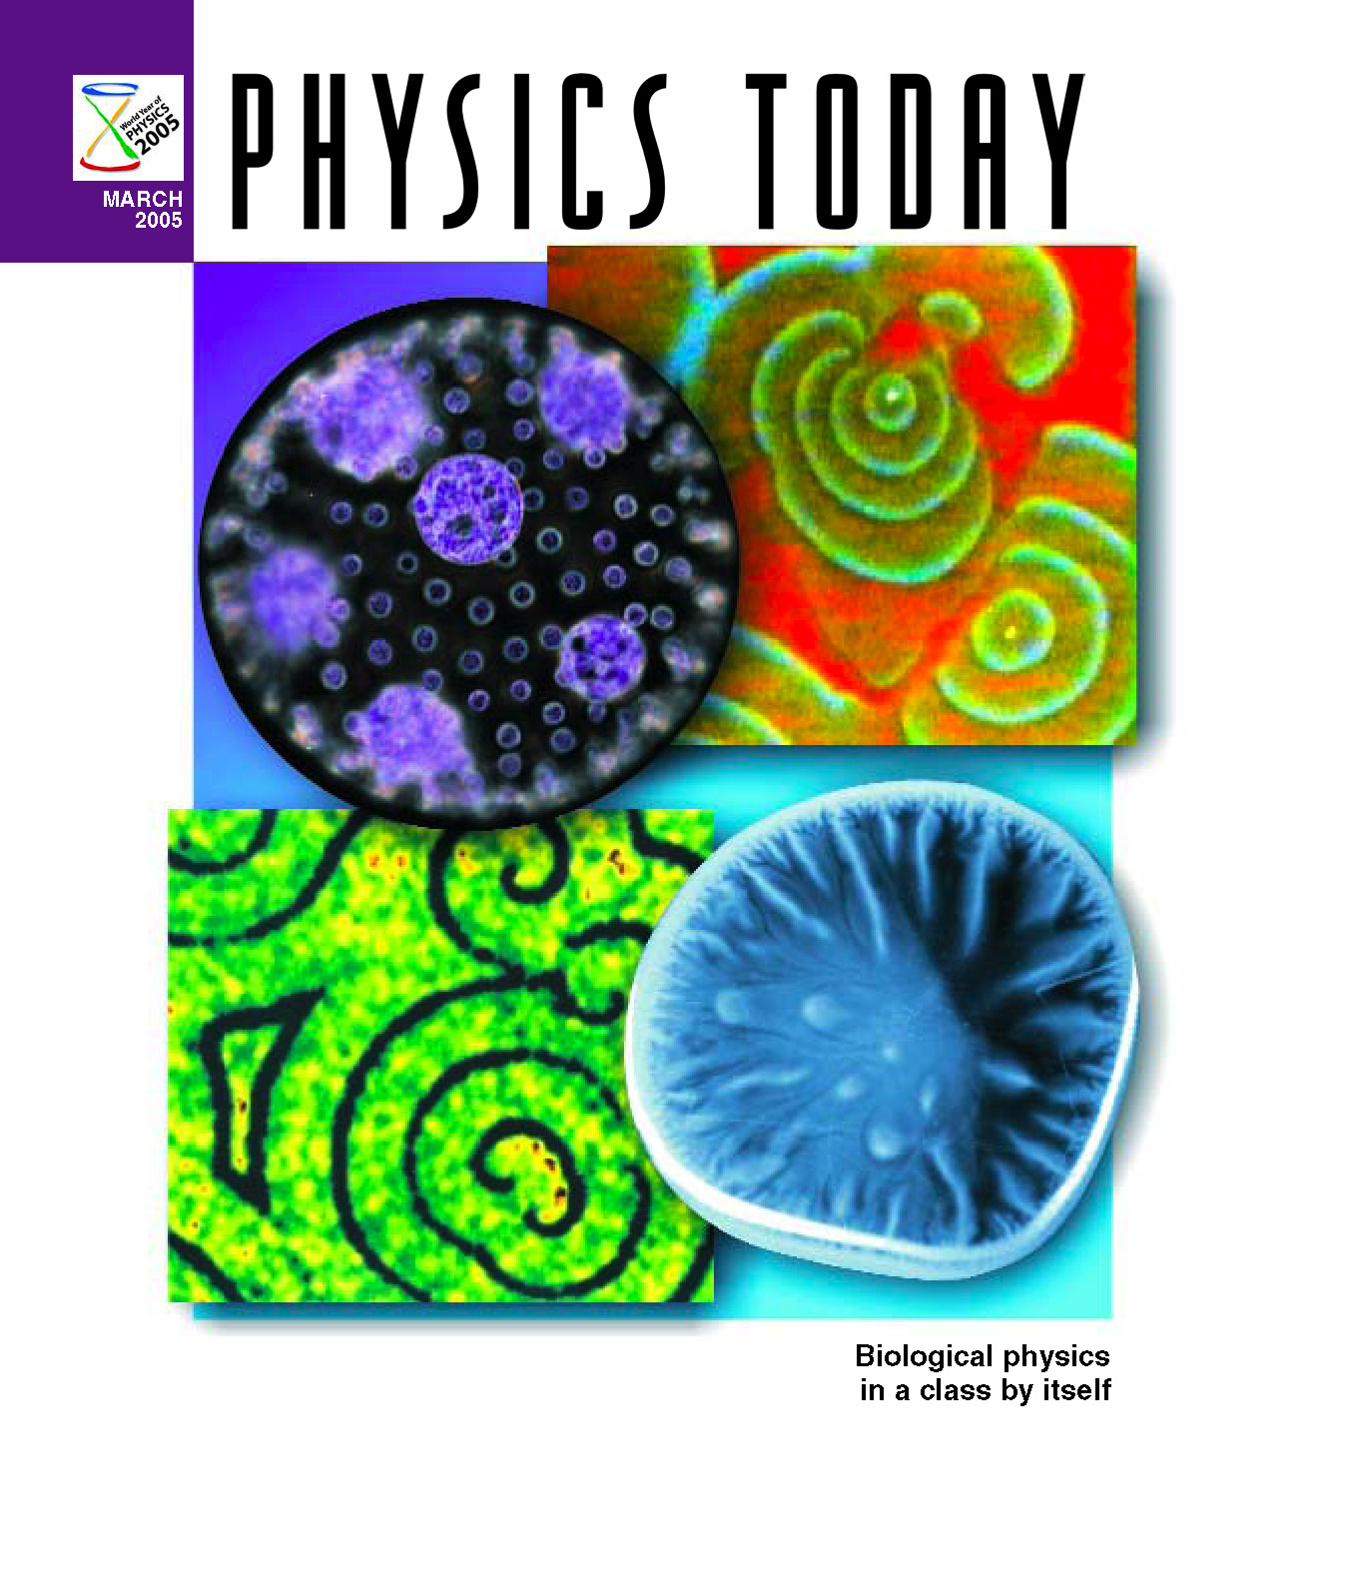



The NBIC established an International Nano/Bio Network which is an electronic venue with forums, monthly live e-discussions, blogs by experts in the field, collaboration and project management tools. Members reside in 72 countries and the site has facilitated EU/NSF joint commission and DoE strategic planning workshops.

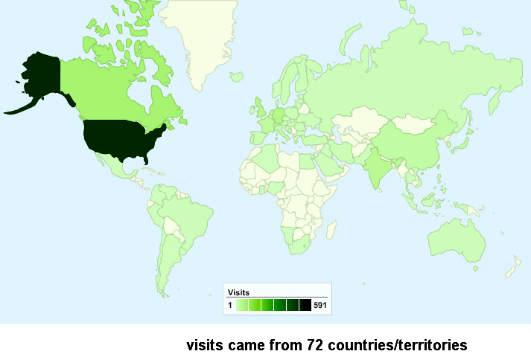

Infrastructure Development
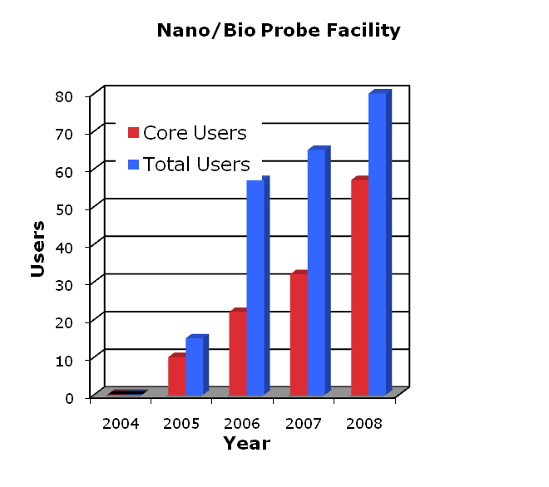
The Nano/Bio Probe Innovation Facility develops next generation probes of local phenomena, making these available to the research community long before they become commercialized and works with industry to transition discoveries to products to allow wider dissemination. The facility is developed within the framework of a 3-phase plan. Phase one developed first generation probes and prototypes, provided immediate access to the community and installed the necessary management infrastructure. The second phase developed additional resources and expanded these capabilities. The third phase involves consolidating this facility to one location in the new Krishna P. Singh Nanotechnology Building. The continued increase in the number of users attests to the value of the facility to the research community.

www.nanotech.upenn.edu
www.nanoprobenetwork.upenn.edu

