Optics on a Nanoscale Using Polaritonic and Plasmonic Materials
NSF NIRT Grant 0709323
PIs: Andrey Chabanov¹, Federico Capasso², Vinothan Manoharan², Michael Spencer³, Gennady Shvets⁴, Christian Zorman⁵
¹University of Texas-San Antonio, ²Harvard University, ³Cornell University,
⁴University of Texas-Austin, ⁵Case Western Reserve University

The goal of this project is to develop a novel approach to coupling optical energy to the nanoscale. Light diffraction prevents confinement of light in the regions smaller than half a laser wavelength, impeding the development of future nanophotonic devices and limiting future nanoimaging applications. Surface polaritons (phonons or plasmons), on the other hand, can have wavelengths that are orders of magnitude shorter than in vacuum. Thus plasmonic/ polaritonic components (waveguides, membranes, ultra-sharp tips) enable us to achieve unprecedented focusing of optical energy that can address the needs of nanophotonics, nanomanufacturing, NEMS, nanoscale thermal source development, and nanofluidics. Exotic optical devices such a “superlenses” capable of resolving sub-wavelength features are also enabled by plasmonic/polaritonic materials. Our project brings several unique approaches to bear on this subject.
First, we employ phonon-polaritonic materials, such as SiC and TiO_{2,} for mid-infrared (mid-IR) super-resolution imaging, which could potentially revolutionize label-free detection of biological and chemical substances. Building upon our recent demonstration [1] of mid-IR superlens-enabled subsurface imaging through SiO2 substrate (Fig.1), our goal is to demonstrate mid-IR imaging through water, paving the way to in vivo imaging of nanoscale biological objects transported through nanofluidics channels.
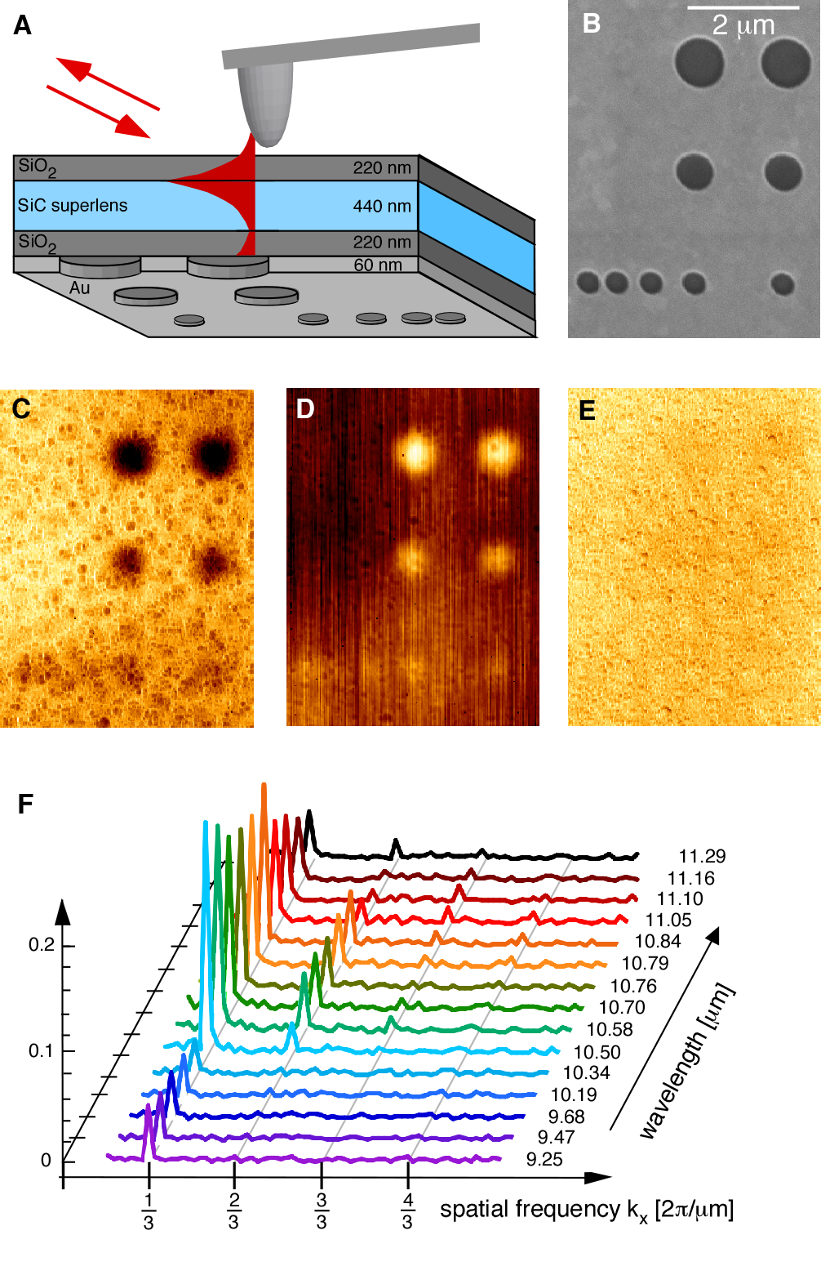
Figure 1. Near-field microscopy through a 880-nm thick superlens structure:
A. Sketch of the experimental setup.
B. Scanning Electron Micrograph of the object plane showing holes in a 60 nm thick Au film (1200/860/540 nm diameter).
C. IR amplitude map in the image plane at λ=10.85 μm, where superlensing is expected.
D. IR phase contrast map at λ=11.03 μm.
E. Control image of IR amplitude at λ=9.25 μm.
F. Fourier transforms of amplitude images of a grating. High spatial frequencies seen (up to the fourth diffracted order) are transmitted by the superlens at λ=10.84 μm.

Second, we take a significant step towards engineering liquid metamaterials, or metafluids, whose optical properties can be controlled by an external signal. Active control of optical and near-IR properties of water is demonstrated [2] by using a concept of Artificial Plasmonic Molecules (APMs) that are synthesized in emulsions and appropriately shaped to enable strong resonance response (Fig.2). Colloidal solutions of APMs can act as an optical medium with very large, small, or even negative effective permittivity and substantial effective magnetic permeability in the visible and near-IR spectral bands. This new metamaterials will be used as an actively controlled component in applications such as IR imaging and liquid-liquid waveguides that guide light owing to the change in both electric permittivity and magnetic permeability.
Figure 2. Artificial Plasmonic Molecules-based metafluid:
A. Silica cores are synthesized and functionalized with a silane linker. Gold nanoparticles are self-assembled onto the surface and gold shells with controllable shell thickness are created by electroless deposition
B. Gold 180-nm diameter nanoshells are assembled into trimers using capillary-force clustering or DNA-mediated adhesion
C. Single nanoshell absorption spectra of particles (130 and 170 nm core) are measured in air on a glass substrate
A
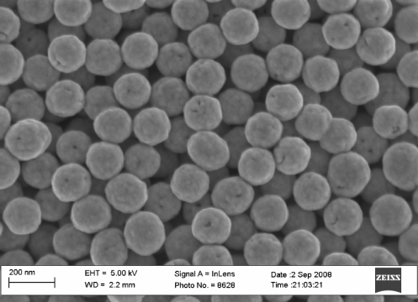
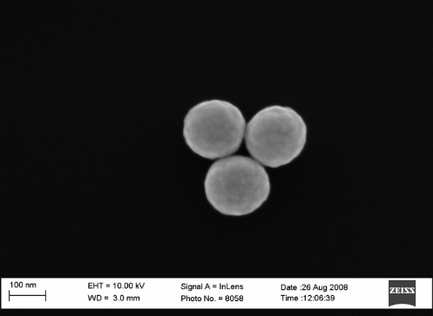
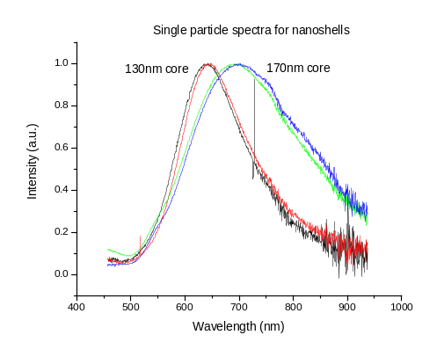
B
Third, we take advantage of the fact that SiC relies on the properties of its phonons to ensure its polaritonic properties. Therefore, there are no fundamental physical phenomena on a nanoscale that should prevent us from making SiC waveguides and tips as sharp as 10nm or less. This will result in incredible energy concentration at the tips and possibility of making active nanophotonic devices.
C

This research project brings together collaborators from several areas of physics and engineering who have complimentary strengths in synthetic chemistry and chemical engineering, materials science and growth, device physics, optical characterization, and computational modeling. Graduate students are involved in all stages of the project. We work with local university outreach offices to establish Mentorship Networks among minority students in the San Antonio/Austin area aimed at enhancing their interest and awareness of nanoscale science. Last summer we have organized first annual Nanoscience Summer School at Harvard for graduate and undergraduate students involved in the project research.

References:
[1] Taubner, Korobkin, Urzhumov, Shvets, Hillenbrandt, Science 313, 1595, (2006).
[2] J Fan, D Aronzon, V Manoharan, and F Capasso, to be published.

