NIRT: Self-Assembled Nanohydrogels for
Differential Cell Adhesion and Infection Control
NSF NIRT Grant 0708379
Matthew Libera, Woo Lee, Svetlana Sukhishvili, Hongjun Wang, and Debra Brockway
Stevens Institute of Technology, Hoboken, New Jersey 07030

Among the possible complications associated with total joint replacement surgery, biomaterials-related infection is among the most common and most serious. Infection occurs in approximately 0.5 – 5% of the hip and knee replacements [1, 2] and is substantially higher in cases of trauma [3, 4]. Infection of an implanted device is a catastrophic problem, because there is currently no effective therapy to fully resolve an infected implant short of removing the implant altogether and pursuing a subsequent revision surgery.

At its core, the infection of an implant surface is a biomaterials problem. A number of materials modifications have been made to render such surfaces repulsive to bacteria – e.g. PEGylation [5-7] – but these bacteria-repulsive surfaces also repel eukaryotic cells. Instead, a surface is needed that is differentially adhesive such that it promotes osteoblast adhesion and proliferation while simultaneously inhibiting bacterial adhesion and proliferation (figure 1). This is a fundamental biomaterials problem that remains unsolved.
Fig. 1 – A differentially cell adhesive surface will enable osteoblast adhesion and proliferation for healthy healing while simultaneously minimizing bacterial adhesion and, hence, reducing the probability of infection.
Selective Surface
Bacteria

Nanoscale science and engineering offers a compelling possible solution to the differential cell adhesion problem. This solution uses nanoscale hetero-features organized on surfaces in two dimensions at submicron length scales. Modulations of cell adhesiveness at 1-100 μm length scales have been extensively studied for the purposes of eukaryotic cell patterning. However, the idea of modulating nanoscale adhesiveness to achieve differential cell adhesion to repel bacteria yet attract eukaryotic cells based on fundamental differences in the length-scale properties of these cells is new.

Our approach involves the synthesis and surface self assembly of nanosized hydrogels that will mediate the adhesion of osteoblasts and staphylococcal bacteria. Osteoblasts, like most eukaryotic cells, are typically on the order of 10 μm in diameter, they have flexible cell walls that can conform to a substrate, and they adhere to surfaces by nanoscale integrin-mediated focal contacts [8-11]. Staphylococcal bacteria, on the other hand, are spherically shaped, they do not easily conform to a substrate, and they are only about 0.6-0.9 μm in diameter. We are thus developing synthesis and self assembly methods over a range of hierarchical length scales in order to modulate cell adhesion based on these differences.

One focal point of our research effort uses inverse emulsion polymerization to synthesize copolymer hydrogel particles from PEG diacrylate (PEGDA 575) and acrylic acid (AA) precursors. The acid groups confer pH-dependent charge on the resulting gels and also provide sites for post-synthesis functionalization. After repeated cleaning and separation by centrifugation methods, gel particles with sizes ranging from about one micron down to tens of nanometers can be isolated (fig. 2). Zeta potential and dynamic-light-scattering measurements show that these gels undergo pH dependent charge and size changes as anticipated. Using established methods of electrostatic self assembly, we have successfully deposited sub-monolayer quantities of PEG-based nanohydrogels on poly(lysine)-primed silicon surfaces. As we move into our second year, our goals are to: (1) establish better control over the hydrogel particle size; (2) refine the electrostatic deposition parameters to control both the average inter-gel spacing and fractional coverage of surface; and (3) develop protocols to create cell-adhesive variants of the gel particles by the covalent grafting of adhesion-promoting protein moieties.
2 μm
Fig. 2 - SEM image of dry PEGDA-AA hydrogel particles.

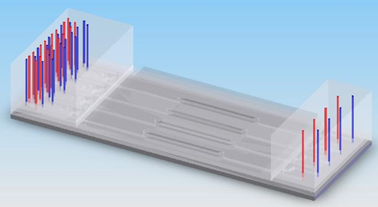
A second focal point of our research effort centers on the in vitro evaluation of the differential cell-adhesion properties of nanohydrogel-modified surfaces. Preliminary results using static cell culture indicate that the adhesion of Staphylococcus epidermidis is substantially reduced by sub-monolayer coverage of cell-repulsive gels on an otherwise cell-adhesive surface. To better assess differential cell adhesiveness, an important aim over the past year has been to establish a microfluidic platform and co-culture protocols as a novel means of evaluating the effects of nanohydrogel size and lateral organization on the differential adhesion of osteoblasts and S. epidermidis bacteria. We have designed and fabricated a microfluidic prototype (fig. 3) that can be used for in-situ imaging cell interactions with clinically relevant surfaces. Its key attributes are: (1) multiple cell culture chambers, (2) a clinically relevant Ti alloy substrate incorporated as the bottom surface of the device, (3) in situ confocal imaging of cell interactions with the biomaterial surface, and (4) embedded microvalves for time-controlled delivery of reagents and for preventing cross-contamination between the chambers. We have successfully developed cell co-culture protocols, and we are currently developing in situ imaging techniques to observe osteoblast response to a bacterial insult.
Fig. 3 - (A) Schematic co-culture microfluidic device (red and blue lines indicate punched holes for fluidic connections). (B) Prototype 2-chamber microfluidic devices fabricated with: (Top) Ti alloy surface roughened to
0.5 μm, (Middle) Ti alloy polished to 0.05 μm, and (Bottom) glass slide.

In situ imaging of cell-surface interaction
4 culture chambers
Flow control with 4 inlets & microvalves
B
A
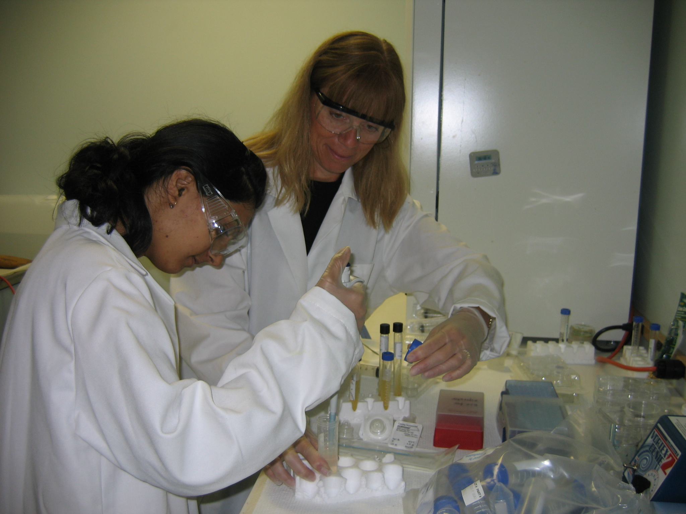
Fig. 4 - Stevens undergraduate Zareen Mobin working with Ms. Clare Kennedy from the Academies at Englewood / Dwight Morrow High School.

Our research activities are being integrated into a high-school outreach activity in collaboration with the Stevens Center for Innovation in Science and Engineering (CIESE). The objective is to develop, integrate, and pilot curriculum modules that will be taught in high school biology and chemistry classes and which incorporate themes related to the parent project. The curriculum modules were drafted during the summer of 2008 (fig. 4) and are now undergoing revision prior to being piloted in spring 2009. Teacher applications are being screened to select participants for this pilot. Additionally, broader dissemination began in October when a paper describing this aspect of the project was presented at the Fall 2008 Mid-Atlantic Section Conference of the American Society of Engineering Education (ASEE).

For additional in formation, email Dr. Matthew Libera at mlibera@stevens.edu

References

1. Campoccia, D., L. Montanaro, and C.R. Arciola, The Significance of Infection Related to Orthopedic Devices and the Issue of Antibiotic Resistance. Biomaterials, 2006. 27: p. 2331-2339.
2. Trampuz, A. and W. Zimmerli, New Strategies for the Treatment of Infections Associated with Prosthetic Joints. Current Opinion in Investigational Drugs, 2005. 6(2).
3. Calhoun, J., Antibiotics and War Wounds, in Extremity War Injuries: State of the Art and Future Directions. March, 2006, American Academy of Orthopaedic Surgeons: Chicago, Illinois. p. 14.
4. Darouiche, R.O., Treatment of Infections Associated with Surgical Implants. New England Journal of Medicine, 2004. 350(14): p. 1422-1429.
5. Ostuni, E., R.G. Chapman, M.N. Liang, G. Meluleni, G. Pier, D.E. Ingber, and G.M. Whitesides, Self-assembled monolayers that resist the adsorption of proteins and the adhesion of bacterial and mammalian cells. Langmuir, 2001. 17: p. 6336-6343.
6. Rowan, B., M.A. Wheeler, and R.M. Crooks, Patterning bacteria within hyperbranched polymer film templates. Langmuir, 2002. 18 : p. 9914-9917.
7. Wagner, V.E., J.T. Koberstein, and J.D. Bryers, Protein and bacterial fouling characteristics of peptide and antibody decorated surfaces of PEG-poly(acrylic acid) co-polymers. Biomaterials, 2004. 25: p. 2247.
8. Keselowsky, B.G., D.M. Collard, and A.J. Garcia, Surface chemistry modulates focal adhesion composition and signaling through changes in integrin binding. Biomaterials, 2004. 25: p. 5947-5954.
9. Massia, S.P. and J.A. Hubbell, An RGD spacing of 440 nm is sufficient for integrin-mediated fibroblast spreading and 140 nm for focal contact and stress fiber formation. The Journal of Cell Biology, 1991. 114(5): p. 1089-1100.
10. Mooney, D.J., R. Langer, and D.E. Inber, Cytoskeletal filament assembly and the control of cell spreading and function by extracellular matrix. Journal of Cell Science, 1995. 108(2311-2320).
11. Sastry, S.K. and K. Burridge, Focal Adhesions: A nexus for intracellular signaling and cytoskeletal dynamics. Experimental Cell Research, 2000. 261: p. 25-36.

