NIRT/GOALI: Development of a Multiscale Hierarchical Nanomanufacturing Tool
NSF NIRT Grant 070781
PIs: Xianfan Xu, Okan K. Ersoy, Arvind Raman, Minghao Qi
Purdue University
William A. Challener
Seagate Technology LLC

The objective of this project is to develop a low-cost, high throughput, hierarchical nanomanufacturing tool that allows mass production of components and devices with feature dimensions across several length scales, from nanometers to centimeters and above.

The key component of the manufacturing system is a nanoscale optical antenna aperture which concentrates light into a nanometer size domain with high transmissivity (or efficiency). The concentrated radiation from the antenna is used as a nanoscale light source for nanomanufacturing. To develop multiscale, hierarchical manufacturing tool, we incorporate micrometer resolution radiation sources, a volume zone plate, for fabricating micrometer size features. This will greatly speed up the manufacturing process. We also design and integrate optical and mechanical components, and develop computer-aided-manufacturing algorithms for multiscale, hierarchical manufacturing.

This is a collaborative project involving researchers in manufacturing, optics, dynamics and control, and semiconductor device fabrication. We also collaborate with Seagate Technology LLC to investigate the performance of the optical antenna apertures, who is interested in using these antennas for hybrid (optic-magnetic) data storage.

Notable results obtained so far include:
- Design and fabrication of volume zone plate.
- Design and fabrication of optical nano antenna.
- Construction of the nanolithography system.
(1) Volume zone plate design and fabrication. Volume zone plate produces a micrometer size light spot for fabricating micrometer size structures. It also allows integration with nano-optical antenna for fabricating nanometer size features. Figure 1a illustrates the schematic of a four layer zone plate. We use femtosecond laser to fabricate these volume zone plates (patent pending). Additionally, we have carried out optical computations to optimize the design of volume zone plates [1]. Based on computational design, we demonstrated that the efficiency of focusing can be as high as 80%, compared with a normal zone plate focusing element which has a maximum efficiency of about 40%.
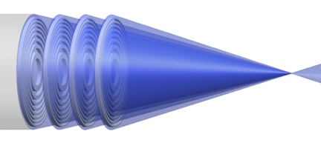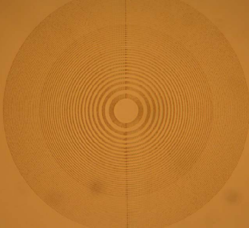
(a) (b)
Fig. 1: (a) Schematic of a four layer volume zone plate as a focusing element. (b) Femtosecond laser fabricated volume zone plate inside quartz. Outer ring diameter is 0.7 mm.
(2) Design and fabrication of optical nano antenna. The optical nano antenna aperture is the key element for producing a nanoscale light spot for nanomanufacturing. Figure 2 shows a schematic of the bowtie aperture. For antenna optimization, we carried out 3D FDTD (finite difference time domain) and FEFD (finite element frequency domain) calculations of 3-dimensional bowtie structures.[2] The 3D bowtie structures are better approximation to the structure that can be fabricated using focus ion beam milling. The performance of focusing of nano antenna aperture is characterized using a home-built near field scanning optical microscopy (NSOM).
(3) Construction of the nanolithography system. A micro and nanomanufacturing system using micro and nano optical elements have been designed and built (Fig. 3). In addition to the optical components, it also has high precision motion control system for creating high precision patterns, optical metrology system for measuring the relative positions of the optical elements with respect to the substrate, computer interface, and clean air handling system. Current it is being tested for fabricating various micro and nano-structures.

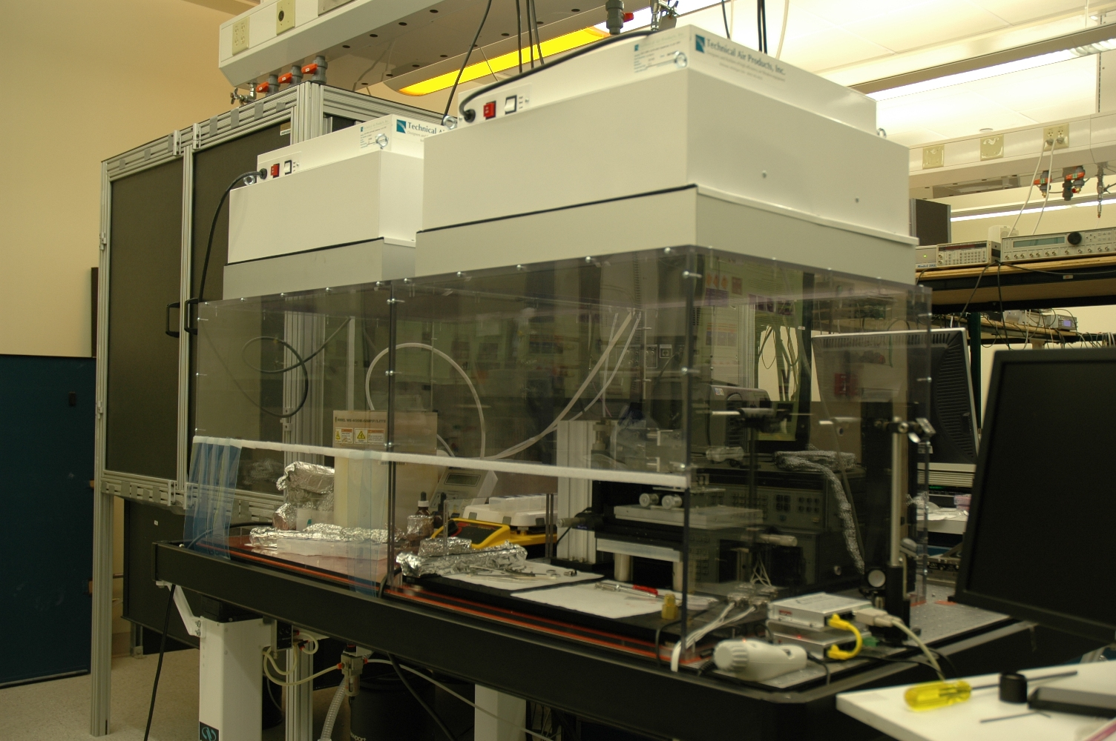

Fig. 3: The nanomanufacturing system.
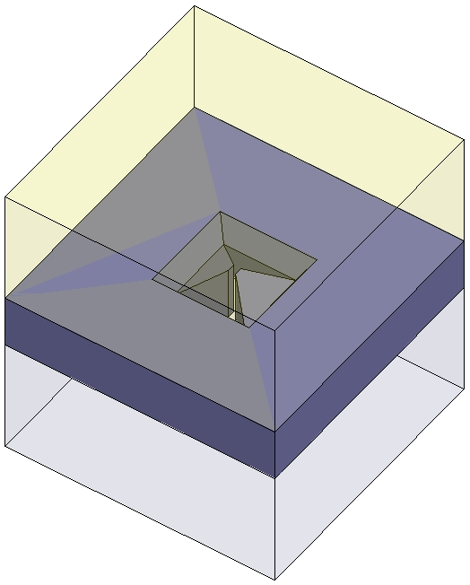
Fig. 2: 3D view of the simulation setup.

References:
[1] P. Srisungsitthisunti, O.K. Ersoy, X. Xu, “Simulation of Modified Volume Fresnel Zone Plates Fabricated by Femtosecond Laser Direct Writing”, J. Opt. Soc. Am. A., in review.
[2] E.C. Kinzel and X. Xu, 2008, “Numerical analysis of the spectral response of an NSOM measurement,” Appl. Phys. B., in print.

