Stanford University Center for Probing the Nanoscale
NSF NSEC Grant 0425897
PI: Kathryn A. Moler, Co-PI: David Goldhaber-Gordon, Stanford University

The joint Stanford University/IBM Center for Probing the Nanoscale (CPN) at Stanford University is a research and education center with goals to develop and apply novel nanoprobes. These novel instruments dramatically improve our capability to observe, understand, manipulate and control nanoscale objects and phenomena. The CPN disseminates its knowledge among the scientific community and works closely with industrial partners to transfer technology for adaption into commercial products. The CPN has developed several science outreach and education programs that educate and inspire the community about nano science. Middle school students and their teachers are especially targeted. All outreach activities will promote and encourage a healthy growth of the next generation of scientists and engineers.
With the rapid and exciting progress in producing new and advanced nanomaterials, capabilities for probing and analyzing these materials have lagged behind. Motivated by fundamental questions in nanoscience and technology, CPN research and development focuses on making available novel probes that open windows into the nanoscale,. The past years of the CPN have enhanced and leveraged Stanford’s and IBM’s distinguished histories and strong programs in nanoprobes, resulting in substantive achievements in nanoprobe research and education with an emphasis on nanoelectronics and photonics, nanomagnetics, and molecular mechanics.
Future CPN work will concentrate research efforts in tightly knit, focused theme groups dedicated to collaboratively advance nanoprobe technologies. The five theme groups are described in the following paragraphs:
1) Plasmonic Scanning Tunneling Microscopy
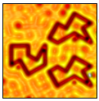
The study of light-sensitive, dynamic processes in molecular-scale objects is at the core of understanding phenomena governing the electronic structure of materials such as photochromic molecules and semiconductor quantum dots. The plasmonic scanning tunneling microscope will perform local electronic and optical imaging and spectroscopy. The pivotal goal is to combine the exquisite spatial resolution inherent in high-resolution scanning tunneling microscopy and spectroscopy with the detailed information on high-frequency excitations of materials yielded by optical channels. Theory will provide input on combined electronic and excitation spectra in materials. At spatial resolutions of 0.1 – 10 nm and frequency ranges of 10¹² – 10¹⁵ Hz, we will map local density of states, while also directly and coherently probing infrared to optical band phenomena in nanostructured materials and devices.
Figure 1
Carbon monoxide atoms assembled into structures that confine electrons, to study quantum phase of single electron wavefunctions.
2) Individual Nanomagnet Characterization
Magnetic nanoparticles have a number of present and proposed applications spanning various areas in information technology, biology and medicine. For example, magnetic nanoparticles are crucial in increasing the density of information storage, have been clinically approved for use as MRI contrast agents and have the potential to be successfully used for treatment and removal of cancer cells. The properties of magnetic nanoparticles are inherently sensitive to small variations in volume, shape, and structure, and therefore it is vital to characterize them individually. Our theme group will develop and advance a variety of nanoprobes with the spatial resolution and magnetic sensitivity to detect and characterize individual nanomagnets for nano-biotechnology applications. We will demonstrate the feasibility of characterizing the magnetic moment and dynamics of individual nanomagnets and apply these techniques in collaboration with chemists and biologists working to realize the potential of nanomagnets for nanobiotechnology.
3) Nanoscale Electrical Imaging
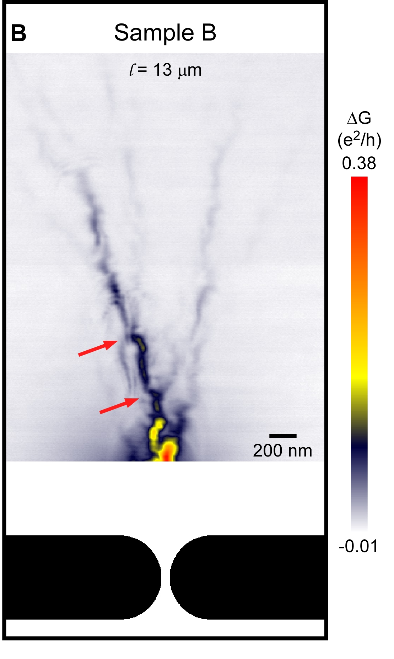
With the rapid advancement in electronic devices, lithographically-patterned structures such as transistors now commonly have electronic properties that vary on scales of a few to tens of nanometers. Novel materials also exhibit local electronic variations, due to patterns in the underlying atomic structure, inhomogeneity in structure or doping, or spontaneous organization of electrons. These local variations have important implications for the behavior of the materials or structures and ultimately determine the properties and performance of advanced electronic devices. We propose to develop and apply a suite of techniques to measure electronic properties such as dielectric constant, conductivity, and carrier density of materials at the 10 nm scale, with sensitivity to variations deep beneath a sample surface.
Figure 2
Electron Flow in a GaAs/AlGaAs-based two-dimensional electron gas. Electron flow originates from a narrow orifice (quantum point contact) formed between the two depletion regions, schematically indicated in black below the image.

4) Nanoscale Magnetic Resonance Imaging
Extending the sensitivity of magnetic resonance imaging to the level of individual nuclear spins would enable the development of a “molecular structure microscope” capable of imaging the atomic structure of molecules in three dimensions. Such a capability would have revolutionary impact on structural molecular biology since it would allow atomic structures to be obtained for proteins that cannot be crystallized for x-ray diffraction analysis. Recent work sponsored by CPN has proven that magnetic resonance force microscopy (MRFM) can achieve three-dimensional imaging with spatial resolution below 10 nm. We will focus now on extending MRFM resolution to below 1 nm – or roughly an order of magnitude improvement over today’s capability. If sub-nanometer can be achieved, then MRFM’s true 3D imaging capability, lack of radiation damage and elementally specific contrast could make it a powerful tool for structural biologists.
5) BioProbes: Nanoscale Cantilevers
Understanding the principle and processes that govern the functions of cell membranes will help us tailor drugs to effectively penetrate the membrane for efficient treatment. The novel nanoprobes will directly study the membrane and measure the forces, mechanical stiffness, electrostatics, and sequence of biological processes to replace and complement more traditional remote sensing techniques. Our theme will adapt unique cantilever designs for aqueous solution, based on recently invented torsional and dual-cantilever AFM cantilevers that have extremely high force sensitivity together with kHz sampling frequencies, ideal for biological samples. We will apply these cantilevers for solution phase biological imaging and time-resolved measurements. Functionalized probe tips on the cantilevers will provide specific biomolecular functionality, enabling us to attack the biologically important processes of viral peptide penetration and ion channel activity. Ultimately, we plan to simultaneously measure nanoscale electrical potential and membrane stiffness of active ion channel clusters using cone-shaped coaxial core-shell electrochemical probes. These metrologies will unlock the real time mechanical and electronic processes at and within biological membranes that are currently inaccessible by any other technique.
The CPN includes thirteen core faculty-level Investigators (including three IBM Investigators who also serve as Consulting Professors at Stanford), twenty-eight affiliated faculty members and dozens of students and postdocs in eight academic departments. We maintain active collaborations and information exchange with other non-formally-affiliated groups.
Seed grant opportunities are widely advertised and seed grants are competitively awarded. CPN Graduate Prize Fellowships are competitively awarded on the basis of advisor recommendations and student-written proposals, and provide graduate students with a full stipend to initiate a novel nanoprobe research project.
Nanotechnology is being increasingly adopted by industry, and future generations will encounter a significant amount of nanotechnology in day-to-day products. Educating the public about nanotechnology is therefore at the core of CPN’s outreach activities. It is known that middle school students lose interest in science and therefore CPN’s outreach program is targeting this particular age group to retain and foster students’ interest and excitement about nanotechnology and nanoscience.
A successful approach for reaching middle school students has been the Summer Institute for Middle School Teachers (SIMST). Middle school teachers participate in an intensive week-long program of content lectures, hands-on activities and curriculum development exercises. The CPN helps the teachers to apply their new knowledge by having them create nanoscience lessons that are shared among participants for use during the school year. Furthermore, these activities and lessons will be compiled for broader dissemination through future workshops and made available as online education resources. To provide continuing support for teachers and to assess the effectiveness of SIMST, CPN members keep in close contact with program alumni, including conducting classroom visits. The CPN has also held teacher development workshops to help pre-service teachers enrolled in the Stanford Teacher Education Program (STEP) incorporate nanoscience into their curriculum from the beginning of their teaching careers.
The Annual Nanoprobe Workshop, which features 8-10 world-class nanoscience researchers as speakers, provides an excellent opportunity for academic and industrial scientists to exchange knowledge and ideas and to broaden the horizons of our students. The workshop grows in popularity each year and attracted about 200 participants in 2008.
Future outreach activities of the center will build on the established structure and will increasingly target populations historically underrepresented in the physical sciences to encourage their participation in nanoscience. These activities will be performed in close collaboration with Stanford’s Office of Science Outreach and will focus on local schools that serve large numbers of the targeted populations.
References
[1] For further information about this project visit www.stanford.edu/group/cpn/

