NANO HIGHLIGHT NSF NIRT Grant 0708172
NIRT: Engineered Therapeutic nanoparticles as catalytic antioxidants
PIs: S. Seal,¹ W. Self,¹ A. Masunov¹ and J. McGinnis²
¹University of Central Florida, Orlando, and ²University of Oklahoma

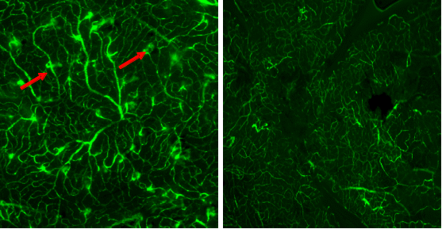
Almost 8 million people in the USA have Age Related Macular Degeneration, over 5 million have diabetic retinopathy and almost 3 Million people from USA suffer from Glaucoma. Therefore, this research project has the potential both to better understand these blinding diseases as well as to develop novel therapeutics for treatment or prevention, all of which can help to improve the quality of lives and reduce medical costs. Thus this NIRT program has enormous potential impact in creating regenerative nanomedicine using active nanostructures. Based on the ability to undergo reversible redox reactions, nanoceria nanoparticles (NP) can effectively scavenge reactive free radicals. We are developing engineered rare earth NPs to mimic antioxidant enzymes in order to reduce accumulation of biological damage due to free radicals. Although these NPs have shown excellent antioxidant and regenerative behavior in neurons, the details of cellular interaction mechanisms are yet to be understood. In the current program, we are studying the protective behavior in retinal cells. Furthermore, the computational data on the therapeutic characteristics of NPs are correlated with the experimental data.
Fig 1. Nanoceria prevent inherited leaky retinal vasculature in mutant mice.
Thesse NPs have found to prevent the increase in the intracellular concentrations of ROS in primary cell cultures of rat retina and the loss of vision in vivo due to light-induced degeneration of photoreceptor cells. Using a fluorescent assay that detects leaky blood vessels (red arrows) in mutant mouse retinas, our data showed that a single injection of nanoceria given 21 days prior to the assay, greatly reduced (estimate 85%) retinal edema in the mutant mouse retina (Fig 1). We hypothesized that the nanoparticles increased longevity by reducing the free radical damage to the biological system. We have further discovered that nanoceria can catalyze SOD activity in vitro, and have been working to understand the molecular mechanism of this radical scavenging property of the material. Catalytic activity of nanoceria with a higher level of Ce³⁺ was shown to be superior in our preliminary work. We have also found that the co-existence of both Ce³⁺ and Ce⁴⁺ oxidation states in CeO₂ NPs plays a critical role in its antioxidant behavior. Experimental data have shown that the reversal of oxidation state also continues over time in cell culture and therefore CeO₂ NP acts as a catalyst.

Our current multidisciplinary strategy combined with engineers and scientists have created novel nano-rare earths with regenerative capability in scavenging radicals and protecting mammalian cells. The research will train students from engineering, simulation and biomolecular engineering and has created unique partnership between University of Central Florida and University of Oklahoma.
Some news highlights: Sights set on nanoparticles” – Materials Today, 9(12), 2006, “Trouble with Photons”, New York Times, Oct 31, 2006, BBC News (http://news.bbc.co. uk/1/hi/health/ 6749707.stm), Key papers from the Team: McGinnis et al., Nature Nanotech, 1(2), 2006. Self, Seal, et al., Biomaterials, 29, 2008, Chem Comm, 10, 2007. Patent: 7,347,987, McGinnis, Seal et al. For more information: Contact sseal@mail.ucf.edu

