Laboratory for Integrated Science & Engineering
NSEC NSF/PHY 06-46094
Robert M. Westervelt
Harvard, MIT, USCB, MOS



New shared facilities operated by the Harvard's Center for Nanoscale Systems located in our new Laboratory for Integrated Sciences building new provide world-class, centralized facilities and technical support for research on nanoscale systems:
- Nanofabrication - e-beam, optical and soft lithography.
- Imaging - TEM, STEM, & SEM, as well as AFM and confocal microscopy.
Advanced Materials Synthesis

Nanoscale Informal Science Education NISE Network
NSEC NSF/PHY 06-46094
Carol Lynn Alpert, Larry Bell, Kathryn Hollar, Eric Mazur,
Robert M. Westervelt, George Whitesides
Harvard, MIT, USCB, MOS




Our NSEC is a strong partner in the Nanoscale Informal Science Education (NISE) Network that links science museums, educational organizations and research institutions. The Center's faculty and students, guided by our Education Director Kathryn Hollar, develop interactive demonstrations and help set up NanoFutures Forums at the Museum of Science, Boston, as well as particpate in the NISE Nanoscale Education Outreach (NEO) Workshops at the Exploratorium in San Francisco.

National Nanotechnology Infrastructure Network
NSEC NSF/PHY 06-46094
Robert M. Westervelt
Harvard, MIT, USCB, MOS

Harvard and UC Santa Barbara are two of an integrated partnership of thirteen user facilities led by Cornell and Stanford that provide opportunities for nanoscience and nanotechnology research. At Harvard, the NNIN provides expertise in computation and in soft lithography through the Center for Nanoscale Systems. At UCSB, the NNIN provides expertise in optics and electronic materials.

1-Chip CMOS NMR System
NSEC NSF/PHY 06-46094
Donhee Ham
Harvard, MIT, USCB, MOS

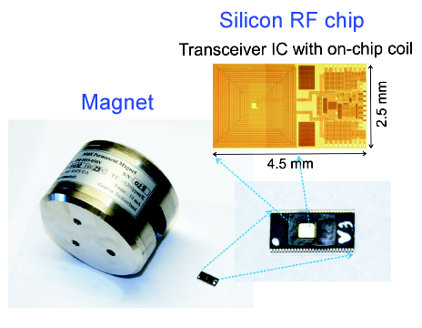
A 1-chip NMR relaxometry system that is 80x smaller, 60x lighter, yet 60x more mass sensitive than a commercial benchtop system. This is possible through CMOS integration of a highly sensitive RF transceiver, which controls and monitors nuclear spins in a sample. This system is a low-cost, portable diagnostic tool that can detect biomolecules (e.g., cancer marker proteins) by monitoring nuclear spin relaxation times, in conjunction with magnetic nanoparticles.

Microfabricated Fresnel Zone Plate Optical Tweezers
NSEC NSF/PHY 06-46094
Kenneth Crozier
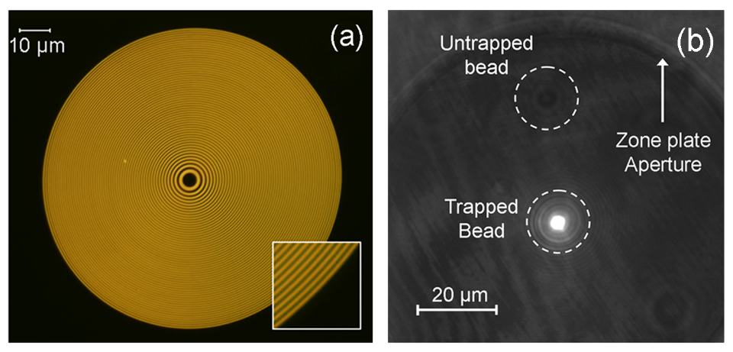Harvard, MIT, USCB, MOS

(a) Photograph of microfabricated Fresnel-Zone-Plate optical tweezer, consisting of concentric gold rings (50 nm thick) on a microscope slide. The Zone Plate outer diameter is 100 μm, and the focal length is 8 μm. (b) CCD camera image of a fluorescent bead (2μm diameter) trapped in Zone Plate focus.

Optical tweezers incorporated in microfluidic chips, could carry out many functions, including particle sorting and manipulation, and biophysical-force measurements. Crozier has demonstrated a Fresnel zone plate as an optical trap. The device, shown in (a), consists of concentric gold rings on a glass substrate. It focuses a collimated laser beam to a submicron spot. In (b), a photograph of a 2 μm bead trapped by the Zone Plate is shown.

Materials Deposition on a Nanowire Array:
Nanoscale Building Blocks
NSEC NSF/PHY 06-46094
Joanna Aizenberg
Harvard, MIT, USCB, MOS

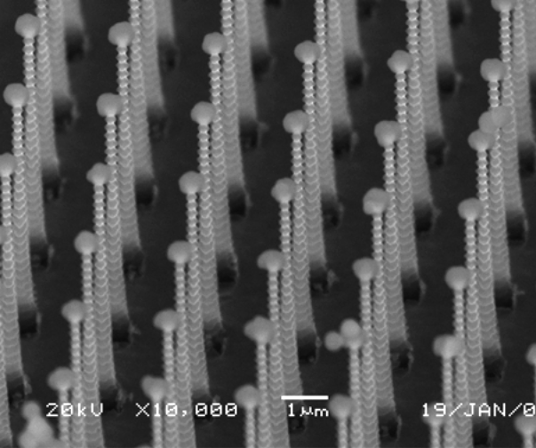

A new approach to fabricate nanowire arrays has been developed, in which a guest material is deposited at one end of each nanowire, due to the super-hydrophobic character of the surface. Highly uniform deposition of particles with controlled size, geometry and structure occurs, as shown for calcium carbonate particles. This method could be applied quite generally to produce novel functionalized nanowire arrays and 3-D nanostructures for applications in electronic and optical materials, actuators, biological sensors, functional “barcode” designs, and self-organization.

Phase-change Nanowires and Nanowire Heterostructures
NSEC NSF/PHY 06-46094
Hongkun Park
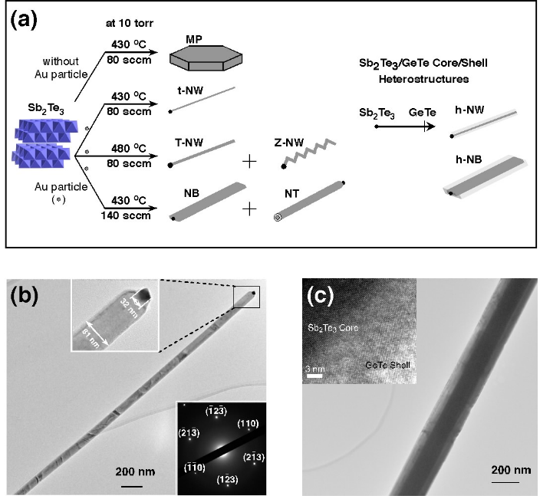Harvard, MIT, USCB, MOS

Chalcogenides exhibit a reversible crystalline-amorphous phase change induced by temperature or electric field, and form the material bases for data storage media such as CD/DVD and phase-change random access memory (PRAM). The intrinsic properties of chalcogenide materials and their size-dependent variations determine the speed, stability, and miniaturization of PRAM, highlighting the importance of studying these phase-change materials in a nanostructured form. Park has synthesized single-crystalline phase-change Sb₂Te₃ and GeTe nanowires and nanowire heterostructures.

Diamond Nanowires
NSEC NSF/PHY 06-46094
Marko Loncar
Harvard, MIT, USCB, MOS

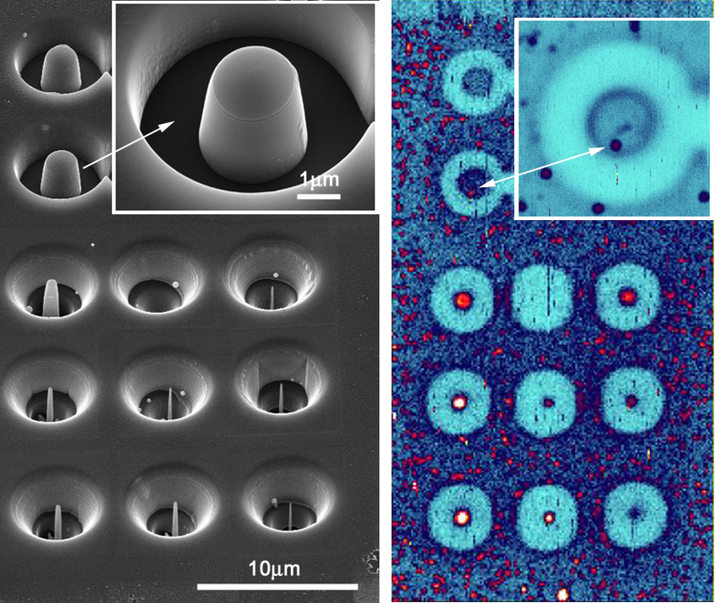

(left) SEM micrograph of an array of diamond nanowires and microposts fabricated in single crystal CVD-synthesized diamond. (right) Confocal photo-luminescence image shows presence of single NV color centers (small red dots) inside nanowires, as well as in the large posts (inset).
Spectroscopy of Quantum Hall Systems
NSEC NSF/PHY 06-46094
Raymond Ashoori
Harvard, MIT, USCB, MOS

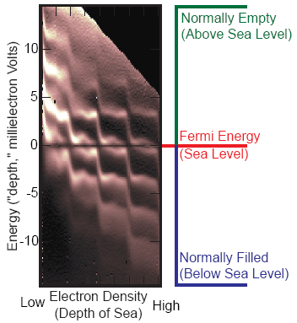

A new technique developed by Ashoori allows measurement of the energy spectrum of electrons in a two-dimensional electron gas with 1000 times better energy resolution than was previously possible. Electrons tunnel into an energy level in the 2D system much more quickly than they would otherwise, allowing the spectrum to be mapped by measuring the tunnel rate vs. electron energy. These spectra provide the first glimpse of these systems and show what a beautiful and interesting view that can be.

