NANO HIGHLIGHT

Nano-Pen
NSF NER, Grant #0609349
PI: Punit Kohli, Department of Chemistry and Biochemistry, Southern Illinois University, Carbondale IL 62901.
Students: Pradeep Ramiah Rajasekaran, Justin Wolff, Rashid Zakeri, Bojan Mitrovic, Charvi Patel and Kashyap Tadinisa. Collaborators: Sami Aouadi (Department of Physics) and Haibo Wang (Department of Electrical Engineering) Southern Illinois University. Horacio Espinosa (Department of Mechanical Engineering) Northwestern University. Christina Trautmann (GSI, Germany)
Patterning at submicron/nanometer resolution has a wide range of applications in a variety of fields. It is difficult to make these nanometer patterns with conventional photolithography. Making patterns in nanometer scale usually involves expensive and complex instrumentation. Some of the present techniques involve Atomic Force Microscopy (AFM), Dip Pen Lithography (DPN) etc. Here we propose a relatively simple and inexpensive technique for patterning at submicron- and nano-scale level. We use electric potential to force charged molecules through a “nanopen” that is made from glass. The electroosmotic/electrophoretic effects draw the charged molecule (DNA) on to the substrate for patterning purposes. This set up is attached to a set of XYZ piezoelectric motors which can be controlled with computer to make patterns on the surface.
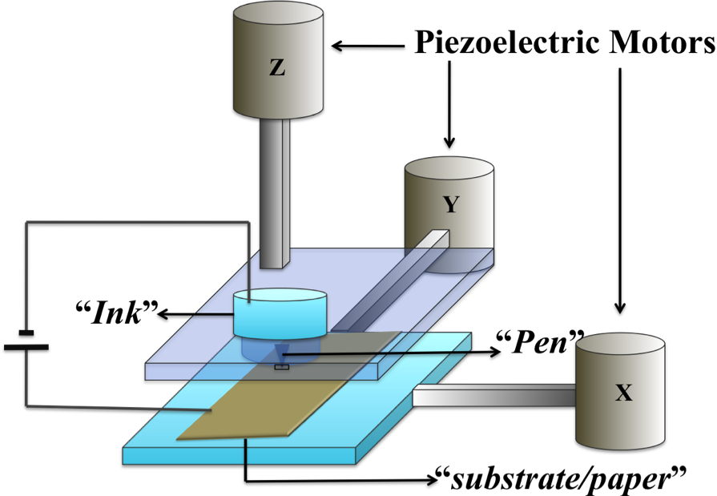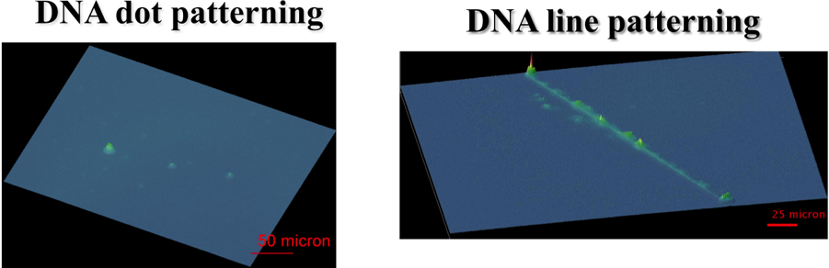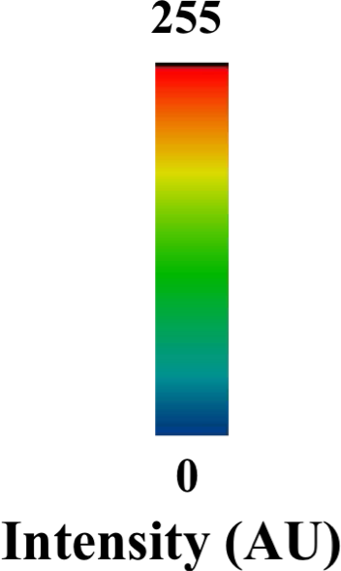
Fig. 1 Schematic of Pen Fig. 2 DNA Patterning
Reference:

- Ho, Andrea M.; Rim, Jee; Kohli, Punit; Patankar, Neelesh; Espinosa, Horacio D. “Electric-field Induced Direct Delivery of Proteins by a Nanofountain Probe” PNAS. 2008. 105. 16438-16443.
- Pradeep, Ramiah Rajasekaran; Wolff, J.; Zakeri, R.; Mitrovic, B.; AouadiS.; Trautmann,C.; Kohli, P. “Lithography using Nanotubes”, JACS (in preparation).
- Mirkin, C. et al. Science, 1999, 283, 661-663.

