NANO HIGHLIGHT
Traveling Nanotechnologies: An Undergraduate Internship Program in Nanotechnology and Society
NSF NSEC Grant 0531184
PIs: Barbara Herr Harthorn, Rich Appelbaum, Bruce Bimber,
W. Patrick McCray, Christopher Newfield
University of California, Santa Barbara

Education and Public Engagement is a critical component of the Center for Nanotechnology in Society at UCSB. This highlight reports on our eight-week Summer Internship Program for undergraduates from UCSB campus as well as California community colleges who are recruited through a partnership with the INSET (Internships in Nanosystems Science, Engineering and Technology) program at the California NanoSystems Institute at UCSB.

In summer 2008, five social science and humanities undergraduates traced the ‘travels of a nanotechnology’ through the Global Value Chain and consumer products’ life cycles at the Center for Nanotechnology in Society (CNS) at UCSB. Mentored by CNS Graduate Fellows in the social sciences and NSE and faculty researchers, one team of interns investigated nanosilver in washing machines, plush toys, and first aid applications, and another team researched solar technology companies in China and Italy. They used a Global Value Chain approach to consider all the inputs and activities that go into creating a product or an industry – from R & D, design, and raw materials, to production, manufacture, marketing and distribution, including all the people or companies involved. At the end of the program, interns presented their results in a poster and presentation, and created information cards for their product. The results of this project were presented to social science community college teachers at a UCSB CNSI-CNS Educators’ Conference in Sept, 2008.

As a model for undergraduate research on societal implications of nanotechnology, this project was successful in three primary ways:
- working with commercial products in everyday use or on the cutting edge of technology motivated students
- interns were able to be self-directed and make research decisions based on a guiding framework and theoretical foundations
- the project integrated nanoscale science and engineering with societal implications, giving students a ‘big picture’ around which they could tell the story of their nanomaterial
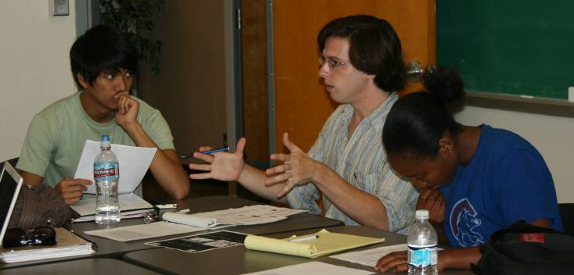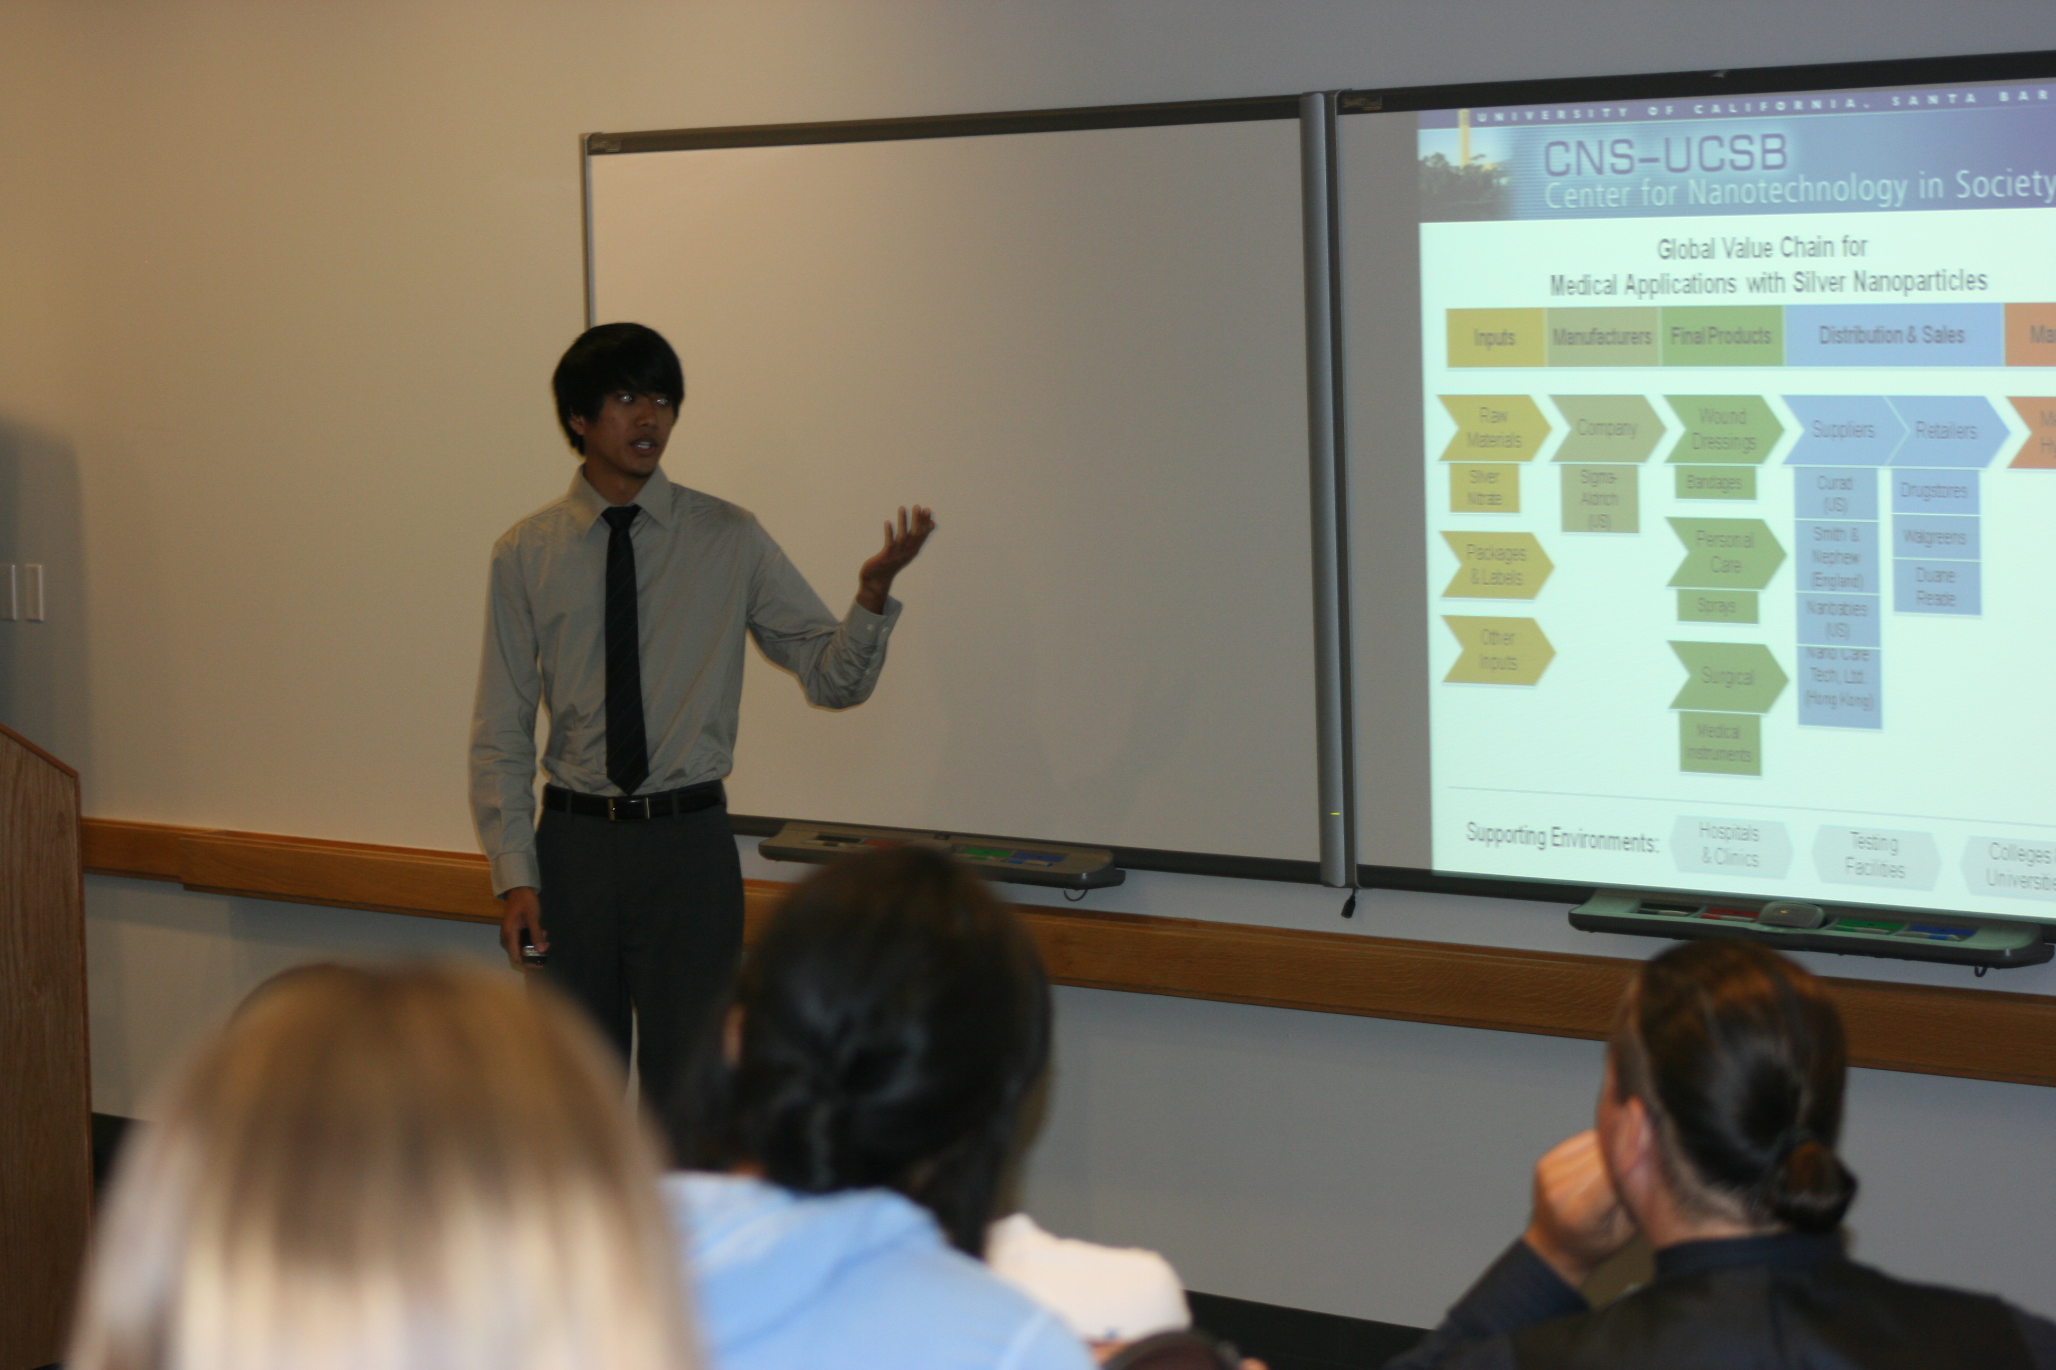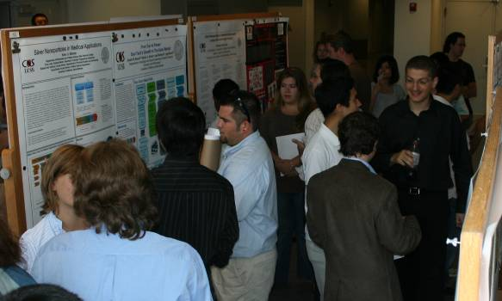
References [1] For further information about this project please see our website at <http:cns.ucsb.edu> or email CNS-UCSB Education Coordinator, Julie Dillemuth <julie@cns.ucsb.edu>

