NIRT: Molecular Spin-Active Nanoelectronics
NSF NIRT Grant ECS-0609469
PIs: M. F. Crommie,ª J. R. Long,^{b} H. K. Park,^{d,e} F. Hellman^{a,c}
ªU.C. Berkeley Physics Dept., ^{b}U.C. Berkeley Chemistry Dept., ^{c}U.C. Berkeley Materials Science and Engineering Dept., ^{d}Harvard Chemistry Dept., ^{e}Harvard Physics Dept.

Introduction: Our research into molecular spin-active nanoelectronics¹ is motivated by current demands for increased miniaturization and higher performance in electronic circuitry beyond CMOS. Possible new technologies must have controllable feature sizes below 10 nm, switching capability (preferably non-charge based) and flexible interface properties. Organometallic magnetic molecules in conjunction with metallic and semiconducting heterostructures potentially meet these criteria. These molecules consist of metal centers surrounded by covalently bound organic ligands that enable controllable feature sizes in the sub-nanometer regime.² The "state variable" describing such molecules is the quantum spin of the metal centers, which can potentially be manipulated in active molecular nanostructures to create new spin-based molecule-scale switches and sensors.

Objective: The objective of this project is to create new nanodevices that utilize molecular quantum spin as the active (i.e., state-changing) element in combined magnetic molecule/inorganic heterostructures. Magnetic molecules offer potential advantages over current device materials due to unprecedented control over their size, spin, and chemical properties. To date, there have been few investigations of magnetic molecules in a device environment, a situation that presents new opportunities for exploring the behavior of active molecular nanostructures at surfaces and buried interfaces. The activities described here represent a new approach to this topic that integrates magnetic molecule synthesis and spin-polarized local-probe characterization with molecule-based nanodevice fabrication and characterization.
Creating this new class of active nanostructures, however, requires an intensive effort to understand and control the behavior of magnetic molecules in a device environment. We are accomplishing this by integrating investigations into molecular surface electronic and magnetic behavior with an intensive molecular device fabrication and characterization program. These efforts allow the optimization of magnetic molecule device properties and the correlation of nanodevice behavior with independently characterized nanostructure properties. Such an undertaking requires coordination between molecular synthesis, organometallic heterostructure fabrication, experimental characterization, and theoretical efforts. We have achieved the right interdisciplinary balance by assembling a team that spans the Chemistry, Physics, and Materials Science departments at U.C. Berkeley and Harvard, as well as the Microscopy group at IBM Almaden Laboratory.

Methods: The following methods are being utilized: New magnetic molecules are being synthesized that have electronic and spin behavior tailored for particular device characteristics. New techniques are being developed to control incorporation of these molecules into surface and interface configurations for device application. Fundamental properties of magnetic molecules interacting with inorganic surfaces are being investigated for different interface environments using scanned probe and magnetization techniques with the goal of understanding how these properties impact nanodevice performance. Different device geometries are being explored that contain magnetic molecules as the nanoscopic active element, and these are being tested for novel magneto-transport behavior. We are working to correlate device behavior with local electronic and magnetic properties of individual and clustered magnetic molecule surface assemblies.

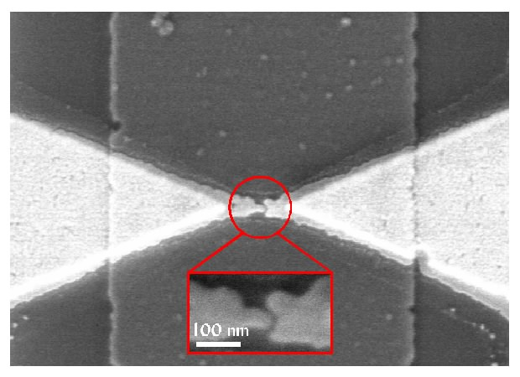
Progress: We have made significant progress in exploring single magnetic molecule systems and organic/inorganic magnetic molecule networks in devices and at surfaces. In the area of single magnetic molecule systems our efforts have recently focused on the molecule Mn₁₂-acetate and related derivatives. This is a significant magnetic molecule system because it has a high magnetic anisotropy energy, and so it is a potential candidate for many device applications in the areas of quantum information, storage, sensing, and nanoelectronics. Our efforts here have been broad-based, ranging from new molecule synthesis to single-molecule device fabrication / characterization and single-molecule characterization by scanning tunneling microscopy (STM). Our molecule synthesis efforts in this area have focused on how to make Mn₁₂-acetate more amenable to device fabrication and surface characterization. To this end we have produced highly purified Mn₁₂-acetate samples that are devoid of extraneous water and acetic acid molecules, as well as new fluorinated Mn₁₂-acetate species that should have enhanced vapor deposition qualities. We have incorporated these molecules into single-molecule field-effect transistors (Fig. 1), as well as onto open-substrate samples. Our single-molecule field-effect transistors incorporating Mn₁₂-acetate show a wide variety of magnetic-field-dependent effects that arise due to the quantum behavior of the magnetic molecule spin. Notably, we see a series of transitions that allow us to extract the magnetic anisotropy of device molecules.
Fig. 1: Electromigration-induced break-junction used to fabricate single-magnetic-molecule field-effect transistor.
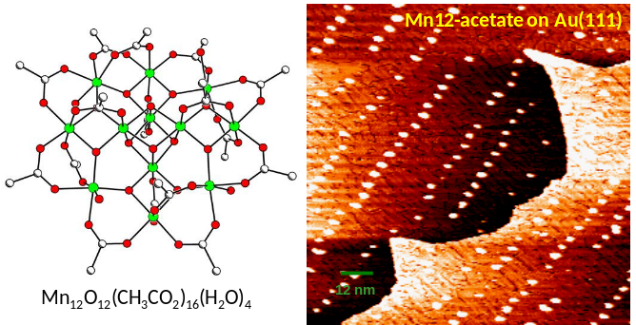
In order to correlate single-molecule device behavior with actual nm-scale molecular structure, we are investigating these same molecules on an electrode surface using scanning tunneling microscopy techniques. This is quite challenging because of difficulties in depositing Mn₁₂-acetate molecules cleanly onto a surface. We have made significant progress in this direction using a new rapid-filament-heating technique that allows Mn₁₂-acetate molecules to be deposited from a prepared filament onto a clean surface without destroying the molecule. This has allowed us to obtain the first images of individual Mn₁₂-acetate molecules showing intramolecular features on a clean electrode surface exhibiting atomic step-edges and well-defined surface reconstruction properties (Fig. 2). This is significant because it opens the way forward for new high-resolution scanned probe studies to examine local atomic and spin structure of individual high-anisotropy molecules.
Fig. 2: Sketch of Mn₁₂-acetate molecule and STM image showing ordered array of Mn₁₂-acetate molecules deposited onto clean Au(111) surface.
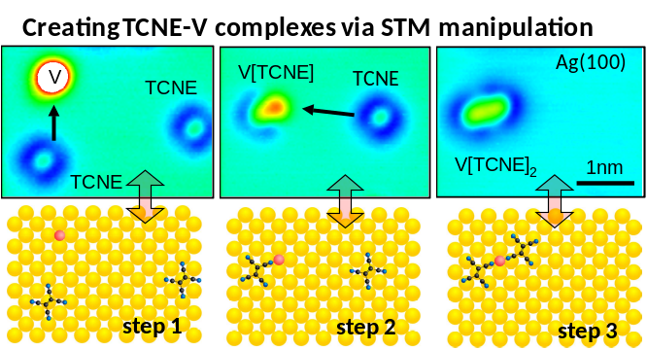
We have additionally made significant progress exploring combined organic/inorganic molecular systems to create locally accessible 2d spin networks. Here we have used tetracyanoethylene (TCNE) molecules combined with vanadium adatoms. TCNE is a flat, sp²-bonded molecule that has an extremely high electron affinity. In bulk this molecule can be combined with transition metal atoms (like vanadium or iron) to create very high Curie temperature ferromagnets. The magnetic coupling properties and structure of the bulk materials, however, is not well understood. In our work we have deposited TCNE molecules and vanadium (V) atoms directly onto a clean surface and investigated their behavior at the single-molecule level with a scanning tunneling microscope. We are able to use atomic manipulation to chemically bond individual TCNE molecules to individual V atoms (Fig. 3). In this way we are able to methodically investigate the coupling between organic linking structures and inorganic spin centers. We are able to deduce TCNE-V bonding properties using single-molecule inelastic tunneling spectroscopy, and we have observed an evolution in TCNE-V magnetic properties by measuring the spectroscopic Kondo resonance for individual TCNE-V complexes.
Fig. 3: STM images showing construction of organic/inorganic magnetic molecule complex using atomic and molecular manipulation (with structural model).

References
[1] For further information about this project link to <www.physics.berkeley.edu/research/crommie/index.html> or email <crommie@berkeley.edu>.
[2] J. R. Long, "Molecular Cluster Magnets" in Chemistry of Nanostructured Materials, Yang, P., ed.; World
Scientific Publishing: Hong Kong, 2003, pp. 291-315 and references therein.

