NIRT: Nano Electro Mechanical Systems (NEMS) using Light-Driven Molecular Shuttles as Active Nanostructures
NSF: NIRT Grant 0609128
PIs. Chung-Chiun Liu ¹, William A. Goddard ², Tony Jun Huang ³
and J.Fraser Stoddart ⁴
¹ Case Western Reserve University, ² California Institute of Technology,
³ Pennsylvania State University, ⁴ University of California at Los Angeles.

This NIRT research project involves researchers from institutions: Case Western Reserve University (CWRU), California Institute of Technology (Caltech), Pennsylvania State University (Penn State) and the University of California at Los Angeles (UCLA). The overall objective of this research is to develop a micro electro-mechanical system using light driven molecular shuttles, specifically, the bistable rotaxane molecules, a means for the shuttle for the active nanostructures.

The synthesis of the functionally rigid bistable rotaxane is the first and foremost initial step in this collaborative research. The research group led by Professor Fraser Stoddart at UCLA has made substantial advancement in this synthesis endeavor. The main challenge is to rigidify the structure of the molecular actuator which can then be directly implemented in the fabrication devices. Research has led to more rigid system and new ways of incorporating rigidity where it is most needed- Figure 1 shows an improved version of the nano-molecular actuator that takes advantage of the click chemistry forming a clicked bistable functionally rigid doubly threaded rotaxane.
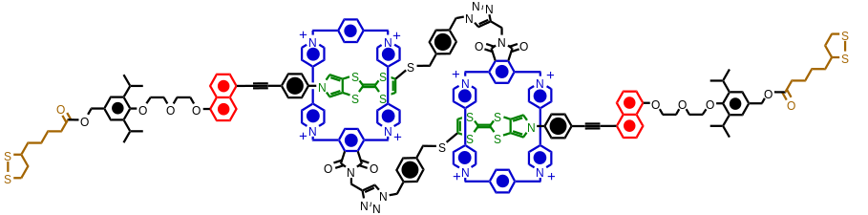
Figure 1. Clicked bistable functionally rigid doubly threaded rotaxane.

In addition to the synthesis of bistable functionally rigid doubly threaded rotaxane, the synthesis of an electrochemical, colorswitchable red-green-blue (RGB) – catenane dye compound has also been carried out.

The use of theory, simulation and modeling is important in prediction and assessment of the performance of this bistable rotaxane aiding the synthesis and characterization of the molecule. The research group led by Professor William A Goddard at Caltech has focused on the use of multi-paradigm, multi-scale simulation as applied to bistable rotaxanes. Specific effort is first focused on single device operations using the theory to make prediction prior to synthesis and characterization. Future efforts will assess the self-assembled systems to determine their response to chemical, electrical and photochemical stimuli.

In this research, the first principles molecular dynamics methods are used to estimate enthalpic and entropic interactions of bistable rotaxanes with their environment. Also, two theoretical models are used (1) Potential of Mean Force (PEM) with constraint sampling and (2) The 2 Phase Thermodynamic Model (2PT). These two different models have different microscopic assumption leading to differing predictions. By comparing the predictions with macroscopically measured data, the validation of models will become feasible.

The research group under the direction of Professor Tony Huang has been carrying out the characterization and fabrication of various nano structure devices. There has been increasing interest in studying plasmonic properties of noble metal nanostructures. These properties are important to the nanophotonic devices and circuits. Metal nanostructures and their plasmonic properties have been widely used in biomedical applications including biosensing and therapeutics. We conducted a thorough investigation of the fabrication and characterization of long-range ordered Au nanodisk arrays. The optical properties of these arrays were investigated both experimentally and theoretically. Specifically, the effects of disk diameter on localized surface plasmon resonance (LSPR) were characterized and compared with results from discrete dipole approximation (DDA) calculations. The effects of glass substrate, Cr interfacial layer, and Au thickness on LSPR were investigated computationally. Furthermore, thermal treatment was found to be essential in improving the nanodisk arrays’ LSPR properties. Using atomic force microscopy (AFM) and DDA calculations, it was established that the improvements in LSPR properties were due to thermally induced morphologic changes. Finally, microfluidic channels were integrated with the annealed disk arrays to study the sensitivity of LSPR to the change in surroundings’ refractive index. The dependence of LSPR on surroundings’ refractive index was measured and compared to calculated results. Figure 2 shows Plamofludic chip to tune plamonic resonance.
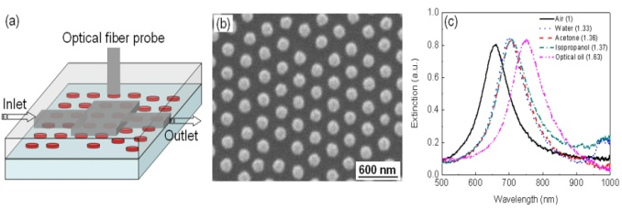
Figure 2. Plasmofludic chip to tune plasmonic resonance

The sensing and monitoring of biological molecules such as proteins, enzymes, and DNA are of tremendous importance in applications such as gene mapping, clinical diagnostics, and drug discovery. Ideal biosensing methods have to be sensitive, selective, rapid, cost-effective, and label-free. Specifically, a label-free biosensor eliminates the need for tedious fluorescence or radioactive labeling processes, while providing rapid and convenient signal transduction by converting the molecular-recognition events into electrochemical, optical, acoustic, or calorimetric signals. We have developed a label-free biosensing method for creating periodic nanopores encased within polymer matrices by modifying the traditional holographic, polymer-dispersed liquid crystal (H-PDLC) system.

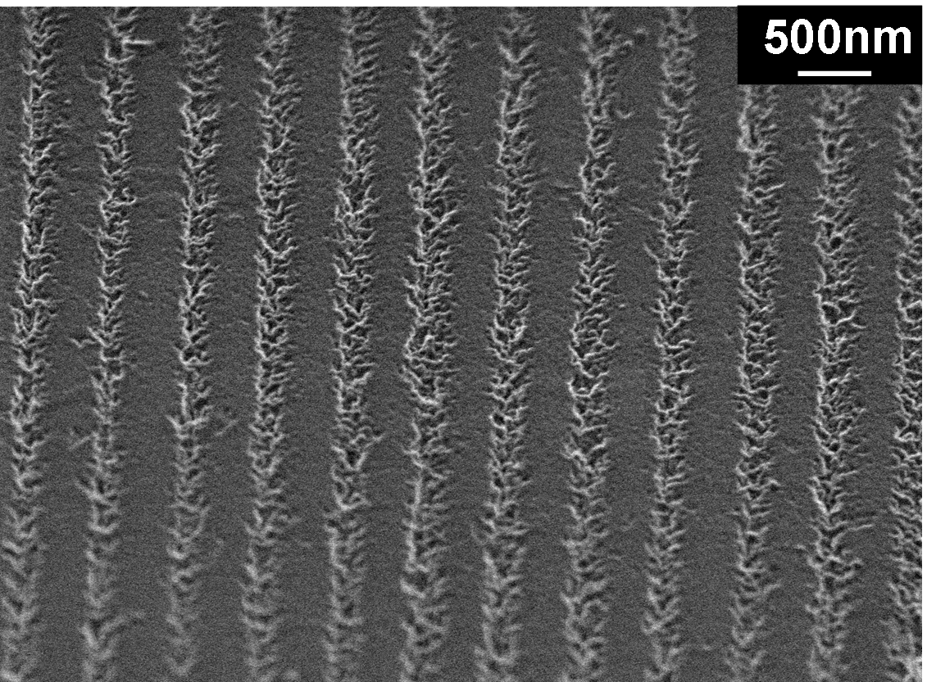
Figure 3. A nanoporous polymer grating-based optical biosensor is fabricated using a holographic interference patterning method.

Other potential energy storage devices and chemical and biological sensors using the light activate bistable rotaxane molecules are being considered. This includes the fabrications of a micro-solid oxide fuel cell and an iridium tin oxide (ITO) based supercapacitor as the basis for comparisons. These activities are undertaken in the researcher group of Professor Liu.

Education and Out Reach

Education and outreach activities are consider an essential and important aspect of this program. Post-doctoral research fellows, graduate and undergraduate students are participating in this NIRT and related research activities with all the PIs of this project. Oral and poster presentations in professional societies and joint publications with the students are encouraged and carried out through the year. Each PI is also dedicated to mentoring of high school students and K-12 outreach activities. As an example, on April 4th, 2007, a science fair at Margaret Duff Elementary School in Garvey Elementary School District, 7830 Dorothy St., Rosemead, CA 91770, was organized. Over 100 students in the 5th and 6th grade participated. Twelve judges from the Materials and Process Simulation Center at Caltech participated (graduate students, post-doctoral researchers and staff) under the direction of Prof. William A. Goddard III to evaluate more than 40 science projects, on the basis of originality, use of the scientific method and subject understanding. The first eight projects obtained honorable mentions and the first three places were awarded diplomas. Two pictures of the event are shown below. Duff Elementary is a diverse school with a student population that includes 57% Hispanic, 40% Asian students. We are continuing these important education and outreach activities in the nano sciences and nano technology.


Figure 4. Students in the science fair in the Margaret Duff Elementary School

