Molecular and Electronic Devices Based on Novel One-Dimensional Nanopore Arrays
NSF NIRT Grant# 0609064
PIs: Zhi Chen¹, Bruce J. Hinds¹, Vijay Singh¹, and Mark C. Hersam²
¹University of Kentucky, ² Northwestern University

Introduction
Most nanowires and nanotubes are grown as random or entangled strings on substrates, which are of little interest to engineers (See Figure 1) [2]. Well-aligned nanowires and nanotubes grown on substrates are imperative for electronic device applications. Self-organized anodic aluminum oxide (AAO) with a honeycomb nanostructure of columnar hexagonal cells and nanopores, has attracted considerable interest (See Figure 2a). Because of its high aspect ratio (~1000), high pore density (~10¹¹ pores/cm²), and high level of ordering and uniformity, it has been used as a template for fabrication of numerous nanoscale structures [3-5]. Although it has demonstrated potential for nanofabrication, it is still difficult to utilize AAO for fabrication of nanoelectronic devices and nano-electromechanical systems (NEMS). This is because nanopores in all the AAO templates are formed vertically on substrates in two dimensions (2-D), not compatible with the mainstream planar processing technology. Recently, the PI [6,7] successfully fabricated an AAO template with a one-dimensional (1-D) array of nanopores horizontally aligned on a silicon substrate as shown in Figures 2b and 2c. This novel structure provides a great potential for fabrication of molecular and electronic device compatible with the planar processing technology.
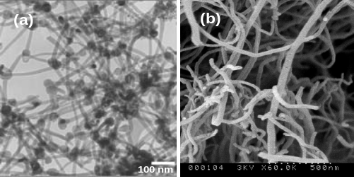
Fig. 1 (a) Entangled nanowires [2] and (b) entangled carbon nanotubes .

Project Objectives
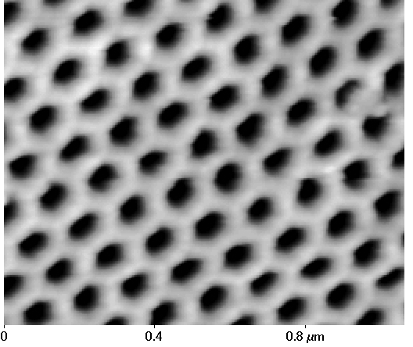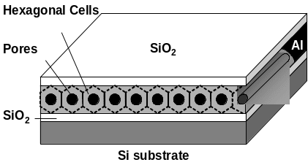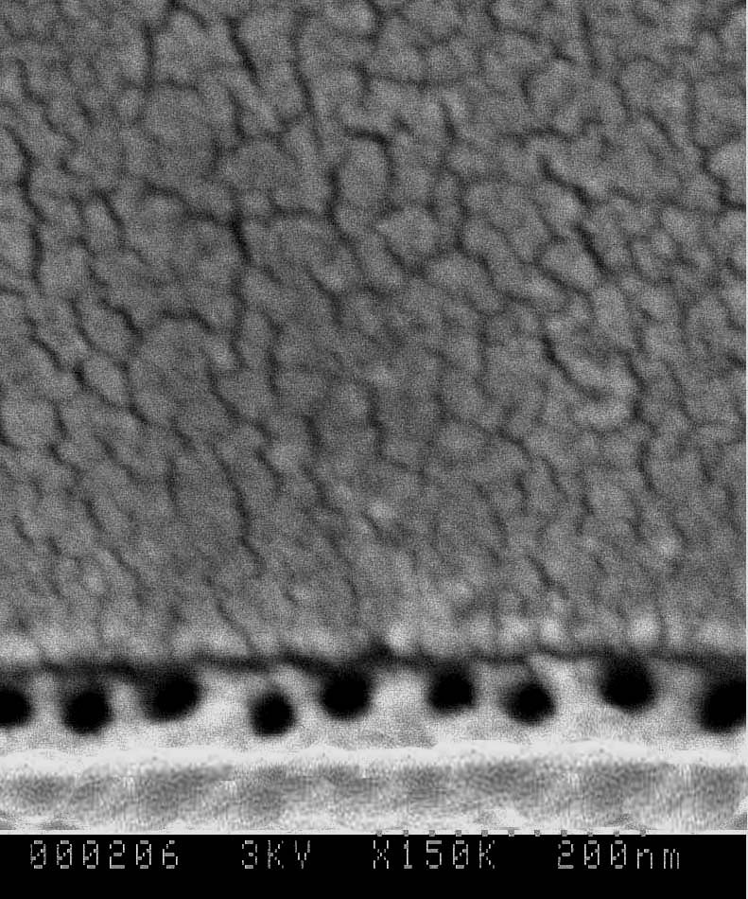
(a) (b) (c)
Fig. 2 (a) 2-D AAO pore arrays formed by anodization of aluminum film [3-5]; (b) Schematic of a novel 1-D AAO pore array (c) A 1-D AAO pore array fabricated at University of Kentucky [6,7].
In this project, we will use the novel horizontal 1-D AAO array nanotemplate to develop innovative processes for fabrication of quantum and molecular devices. We aim to pursue research in four main thrusts. In the first thrust, building upon our success, we continue to refine the process for improving the 1-D horizontal nanostructure, to reduce the pore size of the 1-D nanotemplate down to 1 nm using atomic layer deposition, and to grow a 1-D array of carbon nanotubes and nanowires aligned horizontally on the silicon substrate. In the second thrust, we will fabricate single-electron transistor (SET) arrays based on the horizontal 1-D array of nanowires. In the third thrust, we aim to utilize the horizontal 1-D nanpore array for fabrication of in-wire molecular junction arrays and to use the horizontal 1-D array of CNTs for fabrication of nanoscale electrodes to isolate single molecules. In the fourth thrust, we will characterize the horizontal 1-D array of nanopores and individual in-wire nanodevices using conductive AFM.

1-D Co Nanowire Array
Co nanowires are grown by eletrodeposition of Co²⁺ from an electrolyte as shown in Figure 3. Deposition is performed at 7V of DC mode. The growth of Co nanowires includes 4 steps: (1) In the initial deposition, the current decreases due to mass transport limitation. (2) Co is growing in the pores. (3) Co nanowires fill up the pores. (4) Some of Co nanowires merge on the top of the pores and change the effective electrode area. It results in the rapidly increasing deposition current. Figure 3(a) shows the schematic of 1-D multi-layer structure after Co nanowires electrodeposition. Figure 3(b) shows the SEM image of side view of pores array after Co electrodeposition. The diameter of Co nanowire is about 50nm. To facilitate observation of the 1-D horizontally aligned Co nanowire array, the top SiO₂, the wall of pores, and the bottom SiO₂ on the surface of the Si substrate were dissolved in a mixture of 6:1 buffered oxide etch (BOE) solution. The SEM micrographs show several important features of the Co nanowire array (See Figure 3c). Co nanowires are parallel to each other and on the silicon substrate with good alignment and uniform diameter. The wire diameter distribution throughout the array is narrow with a mean diameter of 35-45 nm.
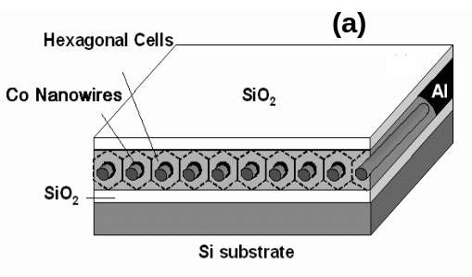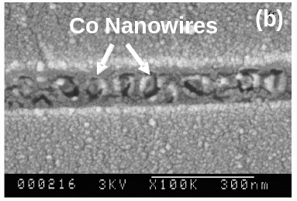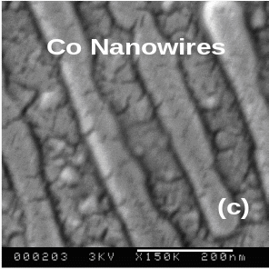
Fig. 3 Electrodeposition of Co Nanowires: (a) Schematic diagram, (b) Cross-sectional view of Co nanowires inside the 1-D AAO pore array, and (c) Co nanowires after dissolving the AAO template.

1-D CNT Array
We also successfully fabricated 1-D carbon nanotube arrays using the 1-D AAO templates (See Figure 4a) [8]. Figures 4b and 4c show SEM micrographs of the grown 1-D CNT array, where the bright stripes are carbon nanotubes and the black strips are substrate. The surrounding silica and alumina were dissolved by buffered oxide etch solution (6:1 BOE for 10minutes) from the silicon surface. The SEM micrographs show several important features of the CNT array produced by this technique. First, all of the nanotubes are parallel to each other and to the silicon substrate. Second, the individual nanotubes are of uniform length and diameter. Nanotubes have uniform lengths of ~3 μm corresponding to the dimension of the 1-D AAO array template, and the tube diameter distribution throughout the array is narrow with a mean diameter of approximately 50-60 nm.
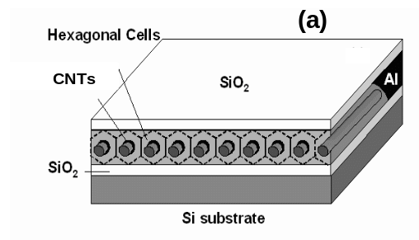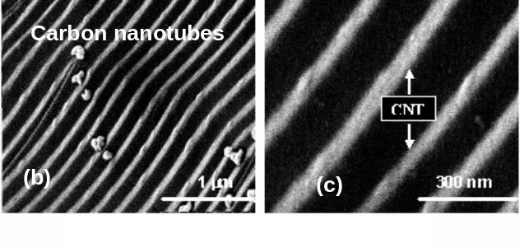
Fig. 4 (a) Schematic of 1-D CNT array and (b) (c) SEM images of a 1-D CNT array made from the 1-D AAO nanopore array template. The CNT array was obtained after dissolving all surrounding oxides.

AFM Characterization
We have performed contact mode atomic force microscopy (AFM) characterization of nanoporous AAO membranes. Pore sizes down to 40 nm in diameter are easily detected as shown in Figure 5. In parallel with these efforts, conductive AFM probes have been fabricated by coating silicon probes with doped ultra-nanocrystalline diamond (UNCD). The UNCD coating was chosen due to its exceptional wear resistance and high electrical conductivity. To verify the performance of the UNCD conductive AFM probes, they have been employed for atomic force electroluminescence microscopy (AFEM) and atomic force photovoltaic microscopy (AFPM) characterization of organic light-emitting diodes (OLEDs) and organic photovoltaic devices (OPVs) respectively. In line with expectations, the UNCD conductive AFM probes possess reduced contact resistance and longer lifetimes than alternative conductive coatings. These results set the stage for efficient characterization of nanowires embedded in AAO.
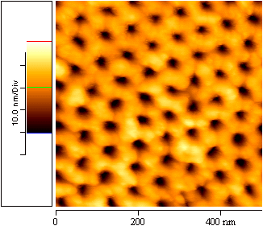
Fig. 5 Atomic force microscopy (AFM) characterization of 2-D AAO pore arrays in the Hersam Laboratory at Northwestern University.

References
- For further information about this project, email <zhichen@engr.uky.edu>
- A. M. Morales and C. M. Lieber, “A laser ablation method for synthesis of crystalline semiconductor nanowires,” Science 279, 208-211 (1998).
- W. C. Hu, D. W. Gong, Z. Chen, L. M. Yuan, K. Saito, P. Kichambare and C. A. Grimes, “Growth of well-aligned carbon nanotube arrays on silicon substrate using porous alumina film as nano-template,” Appl. Phys. Lett. 79, no. 3083-3085 (2001).
- W. C. Hu, L. M. Yuan, Z. Chen, D. W. Gong, and K. Saito, “Fabrication and Characterization of Vertically Aligned Carbon Nanotubes on Silicon Substrates Using Porous Alumina Nanotemplates,” J. Nanosci. & Nanotechnol. 2, 203-207 (2002).
- L. Yuan, K. Saito, W. Hu and Z. Chen, “Ethylene flame Synthesis of well-aligned multi-walled carbon nanotubes,” Chem. Phys. Lett. 346, 23-28 (2001).
- H. Zhang, Z. Chen, T. Li, and K. Saito, “Fabrication of a one-dimensional array of nanopores on a silicon substrate,” J. Nanosci. & Nanotechnol. (Rapid Communication) 5, 1745-1748 (2005).
- Z. Chen and H. Zhang, “Mechanisms for formation of a one-dimensional array of nanopores by anodic oxidation,” J. Electrochem. Soc. 152, no. 12, D227-D231 (2005).
- H. G. Zhang and Z. Chen, “A Horizontally Aligned One-Dimensional Carbon Nanotube Array on a Si Substrate,” J. Electrochem. Soc. 154, H124-H126 (2007).

