NANO HIGHLIGHT
NIRT: Actively Reconfigurable Nanostructured Surfaces for the Improved Separation of Biological Macromolecules
NSF NIRT Grant 0608978
PIs: Ravi S. Kane¹, Steve Granick², Sanat Kumar³
¹Rensselaer Polytechnic Insitute, ²University of Illinois at Urbana-Champaign, ³Columbia University

The goal of our project is to contribute the fundamental underpinnings that are required to design actively reconfigurable nanostructured surfaces for the separation of biological molecules. Our central idea is biologically inspired, specifically by rafts – domains that form in cell membranes. We are combining theory and experiment to study the adsorption and transport of biological molecules on reconfigurable nanostructured surfaces. To date, we have fabricated substrates made up of phase-separated lipid bilayers, and have demonstrated the ability to restrict DNA adsorption to the regions surrounding the domains (Fig. 1a). We are currently investigating how these domains influence the transport of adsorbed DNA. We have also recently demonstrated that the clustering of peptides into “raft-like” membrane microdomains significantly enhances the efficiency of recognition of proteins (Fig. 1b-c). Furthermore, the ability to induce phase separation in membranes could be used to actively modulate the protein-binding capabilities. We have also met with encouraging success in using phospholipid bilayers to explore the access of biomolecules to liposome-immobilized ligands (biotin) in cases where the liposomes are stabilized against fusion by allowing nanoparticles to adsorb (Fig. 1d). It was found that biomolecule binding persists over a range of nanoparticle surface coverages where liposome fusion and large-scale aggregation is prevented. This indicated that liposome outer surfaces remain biofunctionalizable in the presence of stabilizers, a result that may be important for drug delivery applications. Nanoparticles may also be used as obstacles to control the diffusion of the adsorbed biomolecules on surfaces.
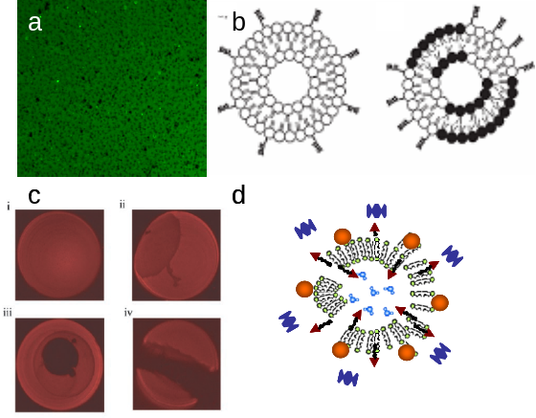
Figure 1. a) Controlling adsorption of fluorescein-labeled DNA on domain-containing lipid bilayers. b) Scheme depicting Homogeneous liposomes(left) and peptide clustering in heterogeneous liposomes (right). c) Micrographs of giant unilamellar vesicles containing i) 5% cholesterol and ii-iv) 20% cholesterol. Domains formation in vesicles containing 20% cholesterol increases the efficiency of biomolecule recognition. d) Scheme illustrating the binding of biomolecules to nanoparticle-stabilized liposomes.
References (10 point font)
[1] For further information about this project email Ravi Kane (kaner@rpi.edu), Steve Granick (granick@mrl.uiuc.edu), or Sanat Kumar (sk2794@columbia.edu).
[2] Rai, P. R.; Saraph, A.; Ashton, R. ; Poon, V. ; Mogridge, J. ; Kane, R. S. “Raft-inspired Polyvalent Inhibitors of Anthrax Toxin: Modulating Inhibitory Potency by Formation of Lipid Microdomains”, Angewandte Chemie International Edition, 2007, 46, 2007.
[3] Zhang, L.; Dammann, K.; Bae, S. C.; Granick, S. “Ligand-Receptor Binding on Nanoparticle-Stabilized Liposome Surfaces, ” Soft Matter 2007, 3, 551.

