NANO HIGHLIGHT
Field Gradients Can Control the Alignment of Nanorods
NSF NER Grant 0608819
PIs: Benjamin Yellen, Ashutosh Chilkoti
Duke University, Department of Mechanical Engineering and Materials Science, and
Department of Biomedical Engineering

Researchers at Duke University have discovered the magnetic field strength is not the only factor influencing the alignment of colloidal nanorods. In some cases, field gradients can dominate the alignment process. This finding may come as a surprise to those in the magnetic separation community, where the conventional belief is that magnetic field is responsible for aligning nanorods and magnetic field gradient is responsible only for positioning the nanorods. However, this discovery can be explained in terms of the competition between positional and orientational energy of a nanorod in inhomogeneous magnetic field. On the one hand, nanorods prefer to situate their volume in the regions of maximum (or minimum) magnetic field, depending on the magnetization mismatch between the rod and the surrounding fluid. On the other hand, nanorods prefer to align their major axis along the direction of the external field. The competition between these two effects can lead to bi-stability for nanorods assembling onto patterned magnets. Recently, Duke University researchers discovered that in low external field strengths the nanorods prefer to align perpendicularly to the external field, whereas in high external field strengths the nanorods prefer to align parallel to the external field. The transition between perpendicular and parallel orientation has been recently mapped out and is presented as a stability phase diagram, as presented in the accompanying figure.

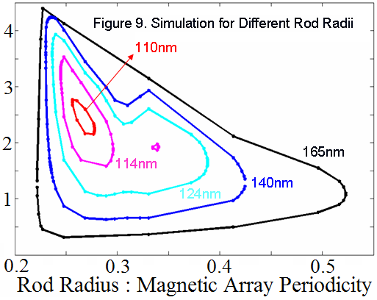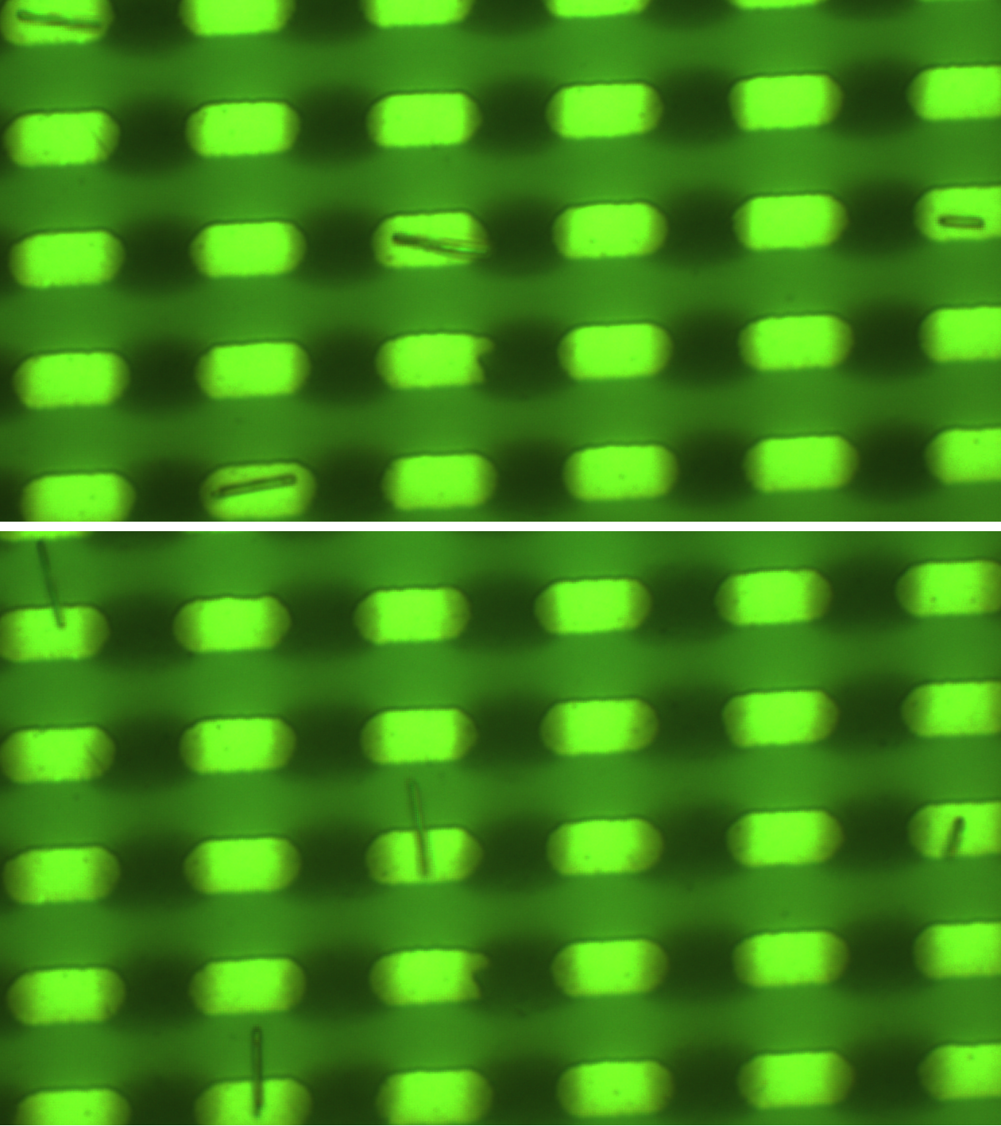
(Left) Computational phase diagram of the expected orientation of nanorods in a combination of uniform external magnetic field and the spatially periodic magnetic field from an array of micro-magnets. The “pockets” denote the conditions which lead to an expected orientation which is orthogonal to the external field direction. Outside the “pockets” the nanorods align parallel to the external field direction. (Middle) Nanorods aligning parallel to the external field. (Right) The same nanorods aligning perpendicular to the external field.

References (10 point font)
[1] For further information about this project link to http://yellen.mems.duke.edu or email <yellen@duke.edu)>

